Table of Contents

Angular +2 Principles

Using the Angular CLI

The Anatomy Of An Angular +2 App

To start working with Angular 2, you need to get the following key components installed.

Developing Steps of Angular2 Application :-

Angular 2 Modules

Angular 2 Components: -

Angular 2 nested components :-

Angular 2 Template :-

Angular 2 Template vs Templateurl

Angular 2 Interpolation :-

Angular 2 Property Binding :-

Angular 2 class binding:-(Not Done)

Angular 2 HTML attribute and DOM property :-

Angular 2 Directive :-

Angular 2 Metadata :-

Angular 2 Data binding

Steps to import a file and used it in entire application

Angular 2 Routing:-

Angular 2 Route Parameters: -

Angular 2 ngfor :-

Angular 2 ngFor trackBy

Angular 2 Pipes

Angular 2 Custom Pipes :-

Angular 2 Container And Nested Components :-

Angular 2 Component Input Properties:-

Angular 2 Component Output Properties: -

Difference Between Angular JS, Angular 2 , Angular 4 :-

Angular Component Lifecycle Hooks:-

Angular 2 Services: -(Not Done)

Angular 2 http service: -

Angular 2 http error handling: -

Why Dependency Injection: -

Angular dependency injection: -

Angular Singleton Service:-

Angular Injector: -

Angular Root Injector: -

Promises in Angular 2: -

Angular 2 Promises Vs Observables

Angular JS 2 Observable Retry On Error

Angular 2 Observable Unsubscribe

Angular 2 Interfaces: -

Using Bootstrap With Angular 2: -

**Angular +2**

Angular 1 was released in October 2010.

Angular +2 was initially introduced in 2015 and final version released in 2016.

In order to know Angular +2 we need to have knowledge in HTML, CSS, Java Script.

Angular +2 framework is builts on javascript framework.

While developing applications, it’s a wise advice to use Angular as front end and Node JS as backend.

Visual studio code will be the editor to be followed to execute code for Angular +2.It comes with buld-in support for java scripts , type scripts , and node js and has a rich ecosystem for extensions for other languages (such as C++ , C# , Java , Python , PHP , Go) and runtimes (such as .Net and Unity ).

Note :- Visual studio code build in Git extension.

Angular +2 is a framework for building desktop and mobile web applications.

Some of the features of Angular +2 while building up a web application: -

1 > Angular +2 repeater

2 > Single page application framework

3 > Repeater which is very common in single page application which takes a list of data and provide a single template it and thus list out that data on screen.

4 > Use of Angular +2 forms

5 > Pipes gives us the ability to arrange our data in certain ways and to going to a modify it in certain ways and when it get displayed on screen.

6 > Angular +2 http implementation

7 > Structure Angular +2 apps

8 > How to use components , services

9 > Bring about Angular +2 type scripts and observables while building application in general.

Angular 2 provides component-based development. Its advantage is that it facilitates greater code reused. In case of unit testing point of view, Angular 2 is more testable.

**Advantages of Angular 2 :-**

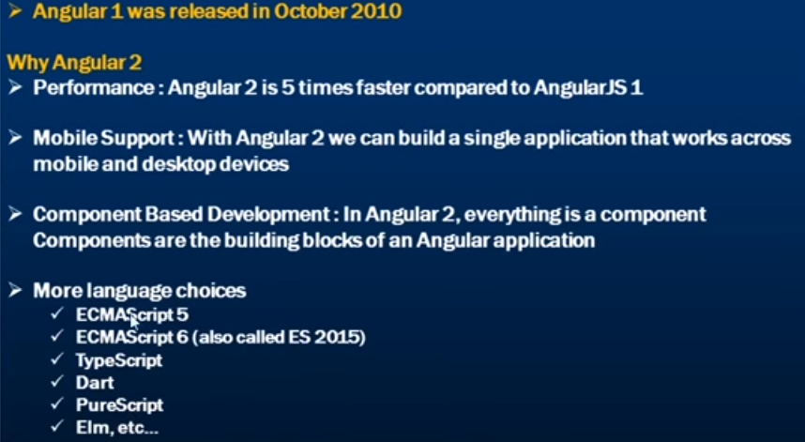

Note :- Among , all these languages, TypeScript is the most popular language.

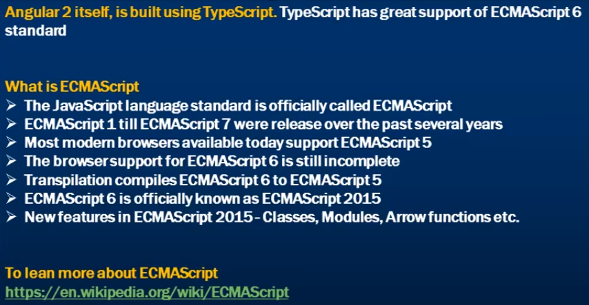

**Angular +2 Principles**

**Typescripts**

Angular +2 uses typescript and was developed my Microsoft. Its a whole process of converting typescripts to java scripts.

While compile the code to java scripts it is going to give error

If we want to create a variable we only describe a

Typescripts uses some safety checks in our application. It is easier to debug and allows us passing correct argument in the function. While defining functions and variables it shows us error explicitly while we do mistakes. It gives lot more information about how to use libraries and various pieces of code while actually creating applications. For example , the time we add multiply function with two arguments i.e. numbers and if we don’t know what the function expects the number of arguments and type of arguments then the typescripts helps us to know actual meaning of function definition.

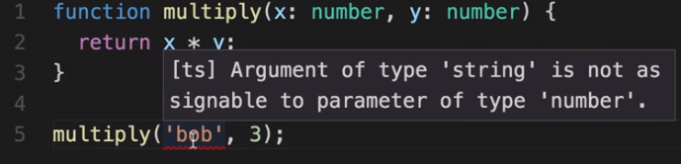

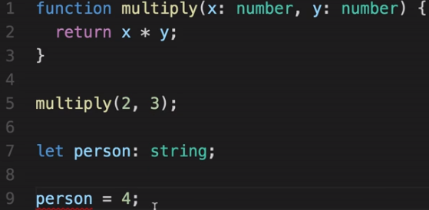

Error we get

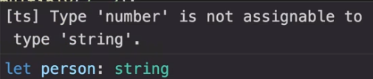

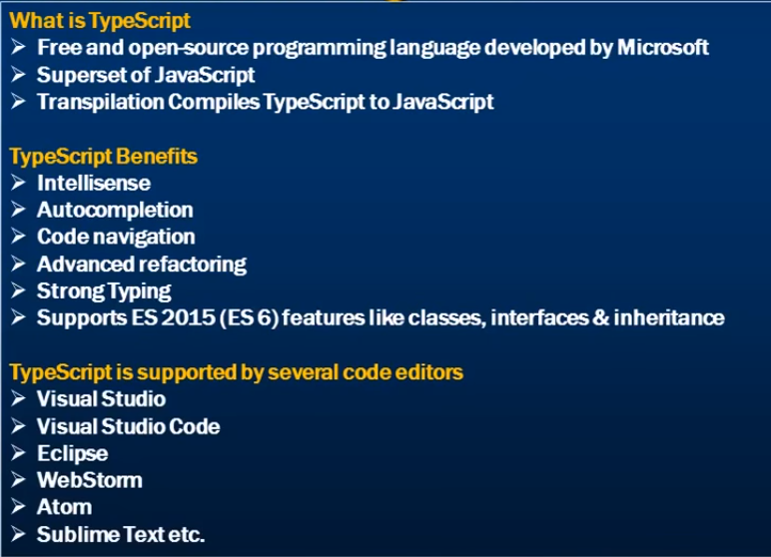

**Using the Angular CLI**

Angular +2 applications is written in typescripts. Generally, we use Angular +2 application we write them in typescripts as well.

Lot of libraries used for Angular +2 themselves written in typescripts.

When we write the application in typescripts we mean that some kind of intermedeol step happen before we actually run the application in browser. Web browser don’t understand typescripts they do receive regular java scripts to render pages in browser.

There are several typescripts files/ libraries that that the browser don’t understand .It supports Angular +2 which converts typescripts files to java scripts files.

Typescripts is very useful because it gives us the warning while building our applications.

Angular +2 CLI is the command line interface which runs on Node JS.

Angular CLI is a command line tool that allows you to create a working Angular +2 application out of the box without a massive amount of manual work - and also allows you to generate Angular +2 components , services , etc.

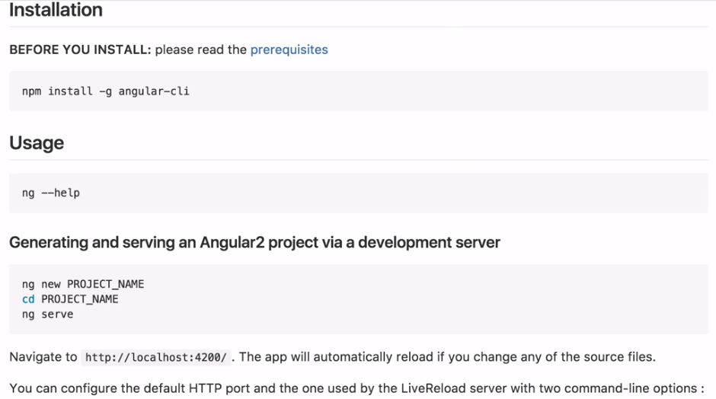

While to run CLI in your system , first installed Node JS.

Then, run the following command to installed Angular CLI as shown in the below screenshot



Here , in the above command , “g” flag says that to install the package globally i.e. make it available anywhere in the machine.

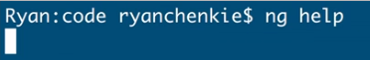

The above command is used to tell us the list of different commands we can use with the CLI.

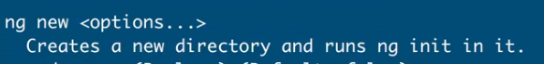

This command helps to open a new application and used to pass a name to the application.

The below command shows , how to go the desktop

cd negation_symbol/Desktop -🡪Enter

Now , we can create new application as shown in the below screenshot



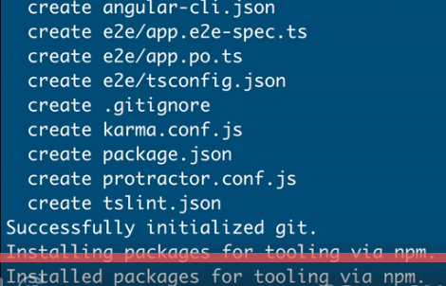

Here , the Angular CLI has created bunch of files created based on a template i.e. standard template for any new Angular application and installed all the packages that we need from npm to make our application run.

Going forward , going to the folder of the application as shown in the below screenshot

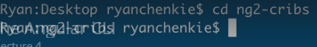

CLI gives us the sensible project directory structure which includes all the pieces that we might want for a basic application and also provides stubs like testing code. Here , also a default component is also present which is going to give us a title and title get set in the inner app component.

To run the application type the following command as shown in the below screenshot

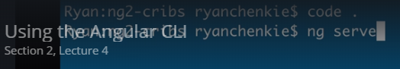

This command issued this instructions to take all these files that we need for application i.e. all angular js library files and all of the code for our application take those and translate into regular java scripts in which the browser can understand and then put it together in a bundled that server with the application. Moreover , the application is available in localhost 4200.

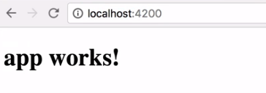

**The Anatomy Of An Angular +2 App**

Angular +2 is very much a component driven.App component in which various things associated with it.So , one of those thing is the typescript file i.e.app.components.ts and within the typescript file we find app component class.Class here allows to define the component or make use of it.With this component we also have a template i.e. app.component.html and also we got some styles i.e.app.component.css.Angular 2 is all about components based where each component do have different piece of functionality , different processes and at the end assembling them all together and also module based.Angular +2 has all types of modules brining in and all modules have distictive functionalities , purposes and finally assembling them all together.So Angular +2 are very much component and module based.All modules bringing in isolated blocks and they can be brought together to build applications.

However , every Angular +2 application must have one root module which is going to bootstrap the application or gets the application goining i.e. app.module.ts file

How we are declaring module for an application

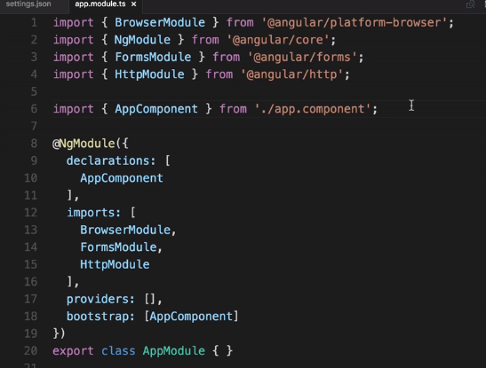

NgModule decorator.Decorator are language feature which they gives us a way to modify a behaviour of a class or a property.The decorator is defined above the class that we want to apply to.Angular +2 use extensive use of decorators.Any time we need to add component we need to put it in the declaration list of NgModule decorator.It every time tells us the number of components the application do have.If any number of modules we are going to use then it should add those in the import list of application.Now , providers used for any injectable services if any and bootstarp tell us the main component of application.In the above case , it is the AppComponent which is created when we started new application.Finally , NgModule decorator is going to tell Angular how our application fits together, how these various blocks and fucntionalities fits together to build app.This is more of configuartion area.

Now , moving to app component i.e.app.component.ts , another decorator add play here i.e.component decorator.This decorator has some objects that has some configuration values for us and one of them for our selector that we want for our component.In our case , its app-root.Views of compoent i.e.templateUrl and styleUrls are coming from another files of the application.

Index.html is loaded when our application starts and defines one element app-root of compoent file.

Generate a new compoent in the application , please see the below screenshot

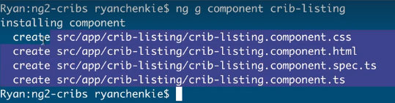

As we know , every new component will be created in the declaration of Ng Module decorator and like wise the above new component created and added in the Ng module decorator.It automatically created in that which is a cool feature of Angular +2.When a new compoent is added ngOnInit() method is created which is a life cycle method of it.

**To start working with Angular 2, you need to get the following key components installed.**

Npm − This is known as the node package manager that is used to work with the open source repositories. Angular JS as a framework has dependencies on other components. And npm can be used to download these dependencies and attach them to your project.

<https://www.npmjs.com/> (npm installation)

Git − This is the source code software that can be used to get the sample application from the github angular site.

The official site for Git is <https://git-scm.com/> (Git intallation)

Editor − There are many editors that can be used for Angular JS development such as Visual Studio code and WebStorm. In our tutorial, we will use Visual Studio code which comes free of cost from Microsoft.

The official site for Git is <https://git-scm.com/> (Download Git)

**Developing Steps of Angular2 Application :-**

Step 1 :-

Go to the command prompt and Install command line interface i.e.CLI

npm install -g angular-cli --🡪Enter

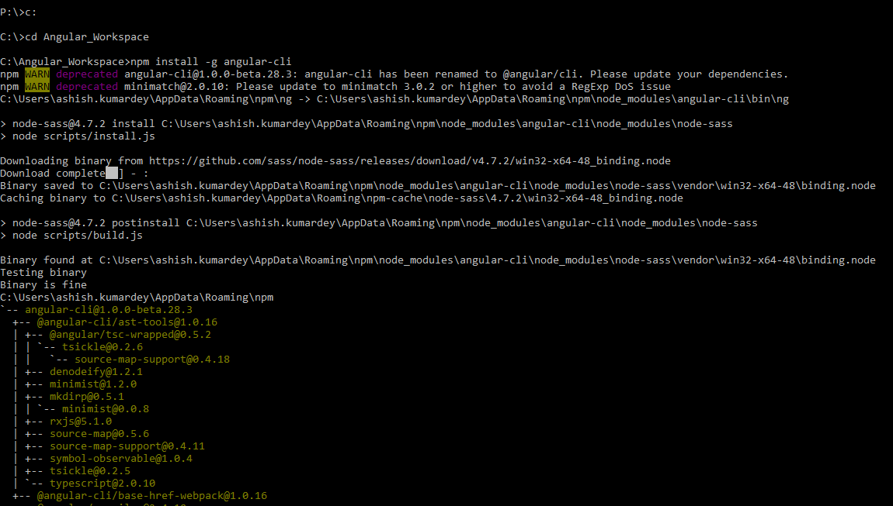

Step 2 :-

Create a new project .In order to do this type the command in the cmd i.e

ng new project_name(Name of the project should be in alphanumeric)

Note :- Go to the folder where you want to develop your new project by cd command and type the above command.It will create default structure in that folder.

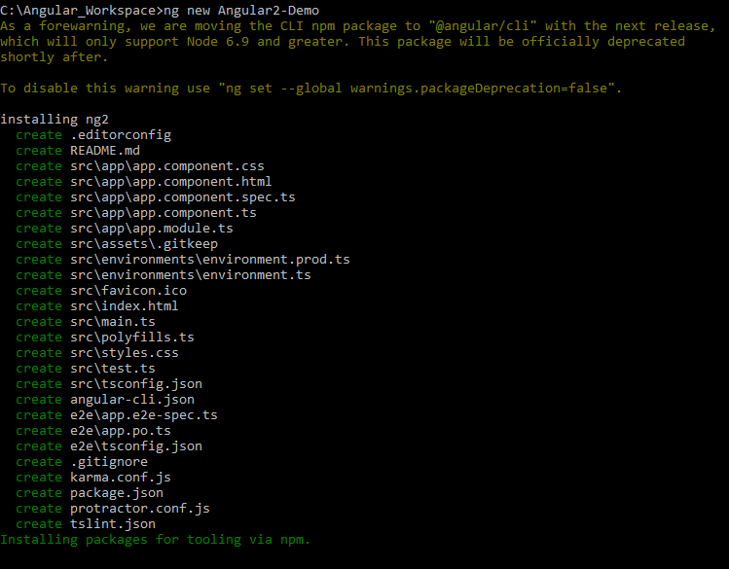

Step 3 :-

Run the newly created project and to achieve this type cd newly_created_project_name

npm start -🡪

This will cause the Node package manager to start a lite web server and launch your Angular application.

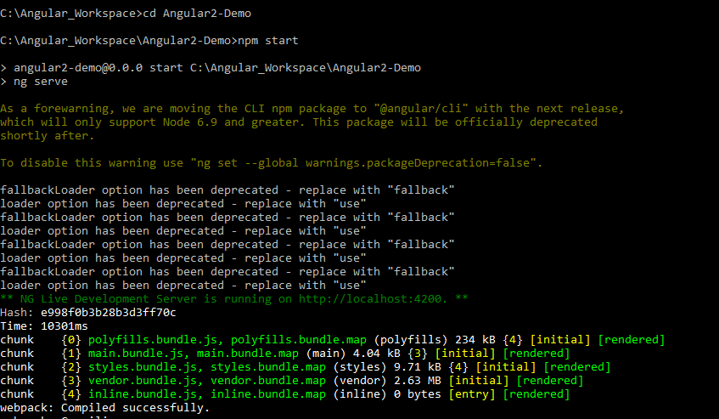

**Angular 2 Modules**

Modules are used in Angular JS to put logical boundaries in your application. Hence, instead of coding everything into one application, you can instead build everything into separate modules to separate the functionality of your application.

The following code will be present in the app.module.ts file

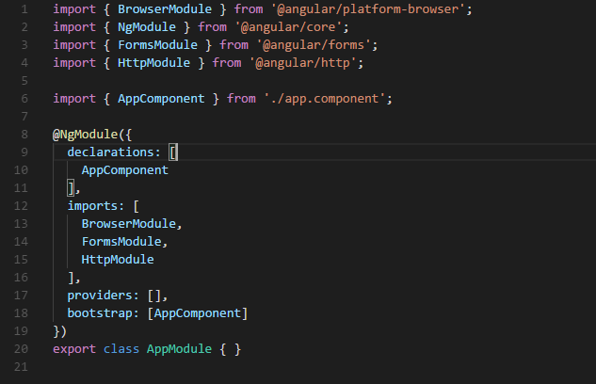

Let’s go through each line of the code in detail.

>> The import statement is used to import functionality from the existing modules. Thus, the first 3 statements are used to import the NgModule, BrowserModule and AppComponent modules into this module.

>> The NgModule decorator is used to later on define the imports, declarations, and bootstrapping options.

>> The BrowserModule is required by default for any web based angular application.

>> The bootstrap option tells Angular which Component to bootstrap in the application.

A module is made up of the following parts −

**Bootstrap array** − This is used to tell Angular JS which components need to be loaded so that its functionality can be accessed in the application. Once you include the component in the bootstrap array, you need to declare them so that they can be used across other components in the Angular JS application.

**Export array** − This is used to export components, directives, and pipes which can then be used in other modules.

**Import array** − Just like the export array, the import array can be used to import the functionality from other Angular JS modules.

**Angular 2 Components: -**

Components are the basic building blocks of angular application.

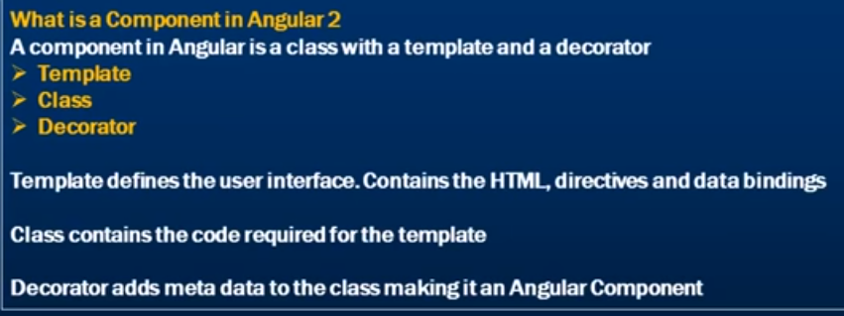

Components are a logical piece of Angular JS application. A Component consists of the following: -

Template − This is used to render the view for the application. This contains the HTML that needs to be rendered in the application. This part also includes the binding and directives.

Class − This is like a class defined in any language such as C. This contains properties and methods. Property contains the data for view template and methods contain logics for view template.This has the code which is used to support the view template. It is defined in TypeScript.

Metadata − This has the extra data defined for the Angular class. It is defined with a decorator.

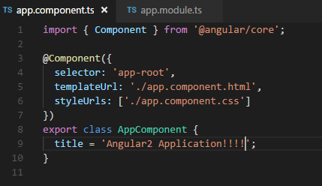

Note :- export keyword is used before class because this keyword allows this class to be exported , so other components in our application can import it and use this component if required.A selector within our component i.e. my-app becomes a directive in out html page index.html page.

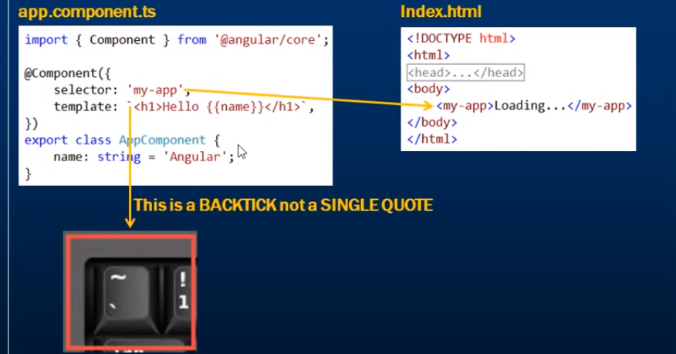

**Angular 2 nested components :-**

Including a component inside another component.Angular 2 is all about components.

A component can be used by another component.Lets understand it by taking an example.

Please see the below screenshot which says a Employee Details table comes from root component and Employee Details table comes from EmployeeComponent.

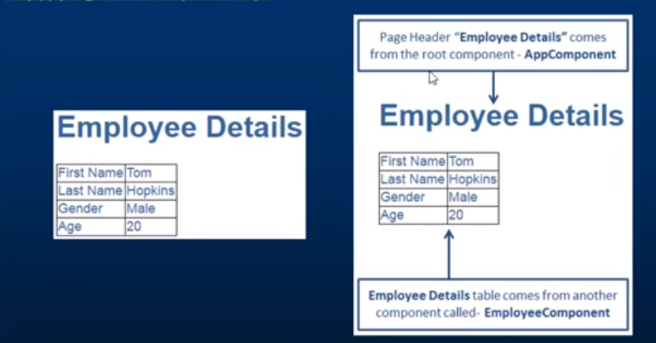

Let’s create employee.component.html in the employee folder of employee component.

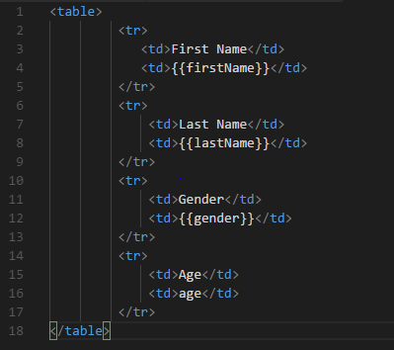

In the above screenshot , in every <tr> we have two td’s.In first td we have field names and in the second td we have data binding expressions.

Now , lets create employee.component.ts file to view template

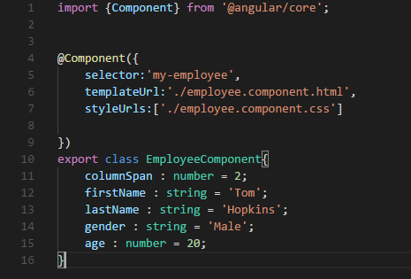

In the above screenshot, we cannot use EmployeeComponent from root component i.e. application component unless until we use export keyword which allows other components to import and use this component if required. In this class, we have these properties that we are referencing in the corresponding view template.

The next step is to decorate the EmployeeComponent class with the component decorator provided by Angular to add metadata.For us to do that , first import the component decorator and use the component decorator using the @ symbol.In addition to this , we can use the selector as the directive where we want to use this component.

Now , lets create root component i.e.app.component.ts

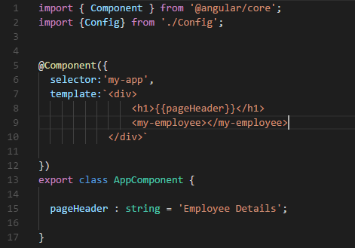

In the above screenshot , the view template HTML is just three lines , so we have used an inline template instead of an external template.

Note :-



Now , in order to nest employee component , first import and declare employee component to app.module.ts file just like app component .

Please see the below screenshot for your reference

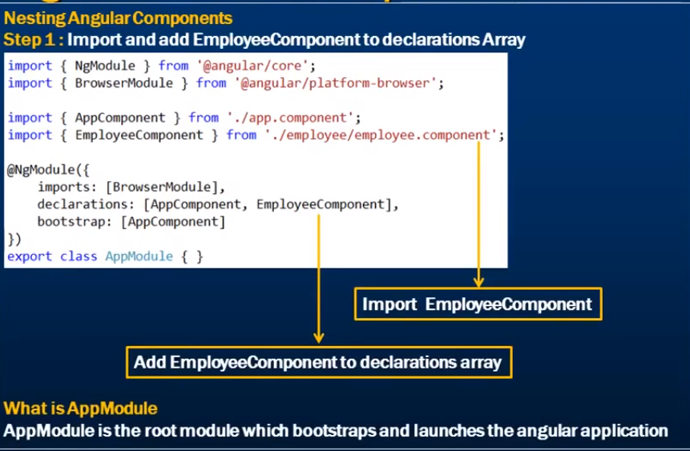

NgModule and BrowserModule are two system modules.

Browser Module is required by all angular applications that run in a web browser. In addition to this , this module also provide ngif and ngfor directives.

NgModule is required to add metadata to an angular module .

Remember if a class is decorated with NgModule component then that class becomes an angular component.

In the second step , add my-employee selector as a directive within app.component.ts file

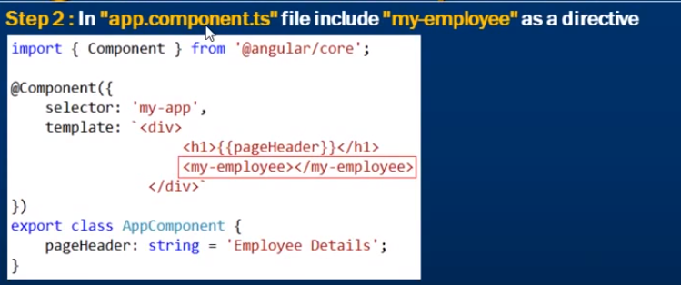

Lets reload the web page to see the output in the web browser

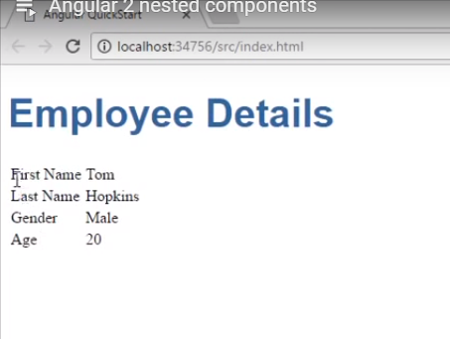

In the above screenshot, the Employee Details table is not styled . So to style the table, include the following styles in the employee.component.css

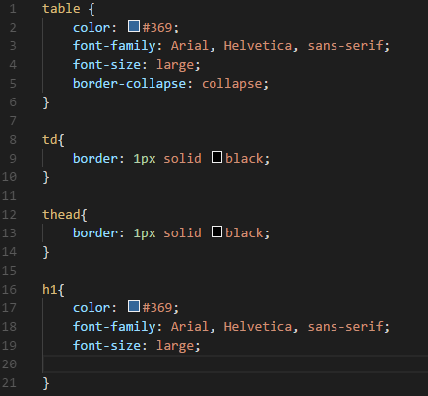

Call this employee.component.css file in the employee.component.ts file of style URLs directive.

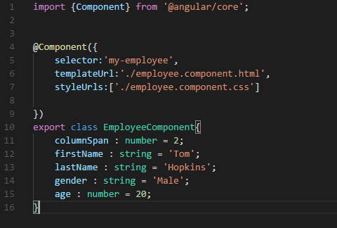

Finally, reload the web browser to see the output as shown in the below screenshot.

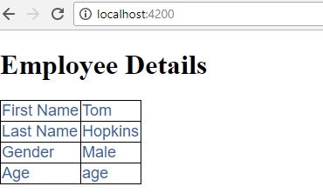

**Angular 2 Template :-**

In app.component.ts template is defined in app.component.html as mentioned below.

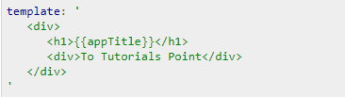

This is known as inline template. This defines a simple div tag and references the appTitle property from the app.component class.

The other ways to define a template and that can be done through templateURL command defined in app.component.ts



i.e.viewname.component.html

viewname is the name of the app component module.

**Angular 2 Template vs Templateurl**

In case of Templateurl

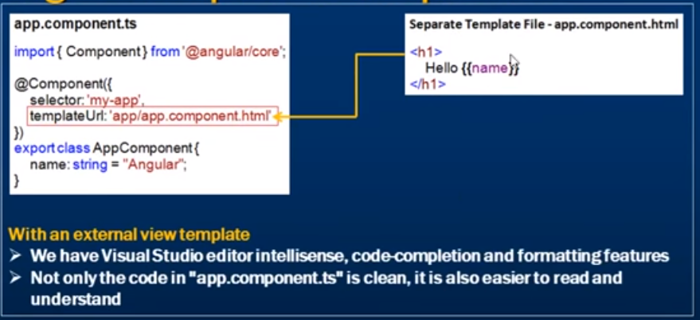

In case of template

We can use pair of back characters and single coats or double coats for inline HTML codes but if the HTML codes lies more then one line then single coats will not support , only pair of back characters supports.

If singles coats are used in HTML codes

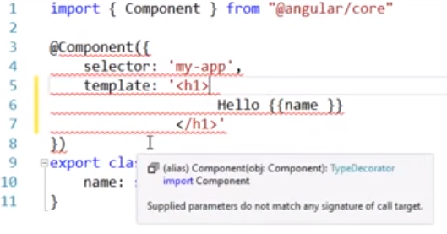

Advantages and drawbags of inline Template as shown in the below screenshot.

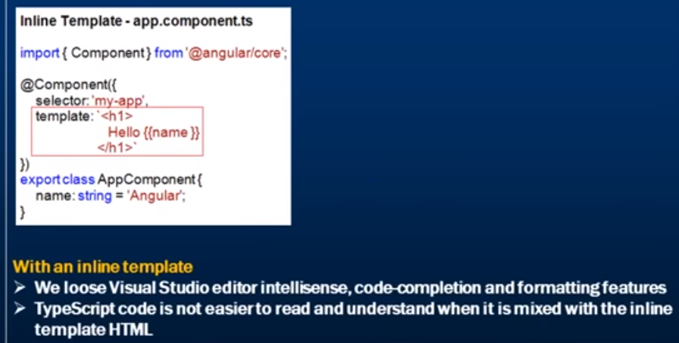

**Angular 2 Interpolation :-**

In Angular 2 , data binding can be classified into three catagories

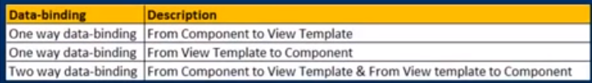

So , databinding is all about moving class property values to its corresponding view template and back i.e.again from view template to its corresponding class properties.

Binding component class properties to view template is achieved using interpolation.

Lets take few examples of interpolation

Case 1 :- Within our class , we have a property called pageHeader and the property is placed inside double curly braces and this is called interpolation.Moreover , the expression is called template expression.So , Angular 2 when it looks pageHeader expression its going to retrieve its property value which is converted to a string and then replace this data binding expression with that value and we view this value in the browser .

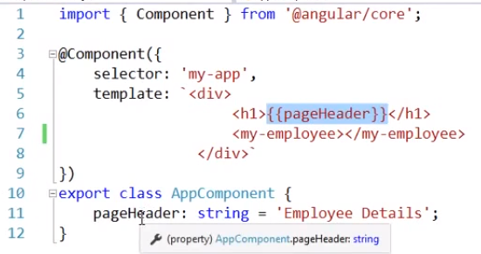

So , notice on the page we see value Employee Details.

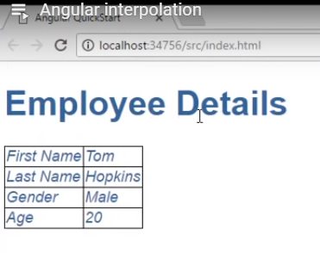

Case 2 :-With interpolation , it is possible to concatinate a string with the property value.For ex :- we want to display pageHeader equals Employee Details on the web page and to achieve this we need to hardcode a string within our template expression

Please see the below screenshot for your reference

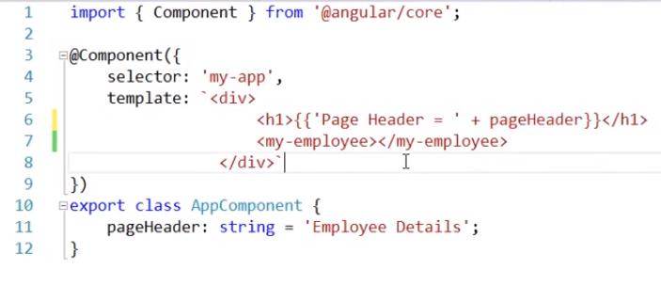

Then save our changes and repload our web page to see our changes as shown in the below screenshot

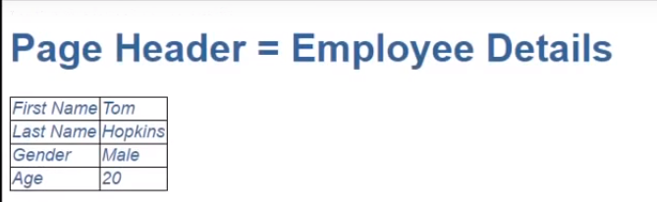

Case 3 : - We can also specify calculations as shown in the below screenshot

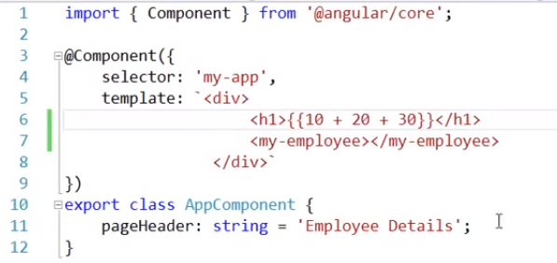

Lets check the result in the webpage

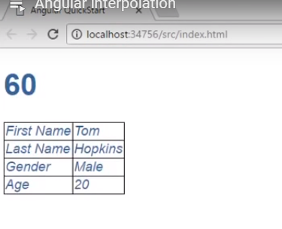

Case 4 :- Using ternary operator we can acieve the interpolation.If we have a value for the page header property then we display the value and if the paheHeader property is null then we display no header.

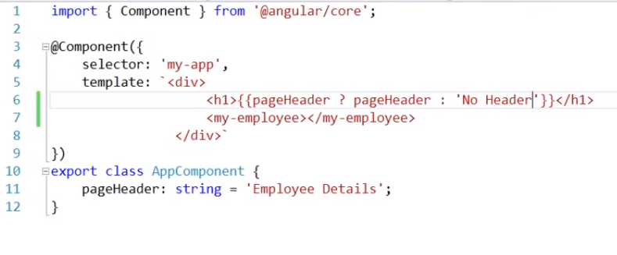

Lets save our changes and reload the webpage

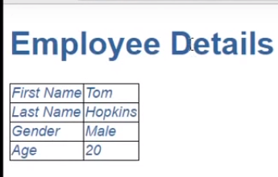

If the pageHeader property value is null

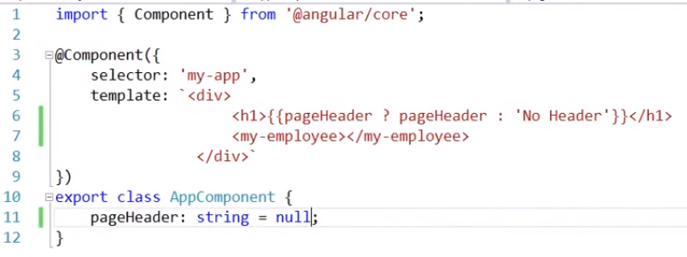

Lets save the changes and reload our webpage

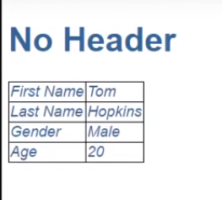

Case 5 :- Interpolation can also be used to bind component class property to HTML element property.Lets understand this with an example

Lets , use an image template within our view template and set the src property and don’t hardcode the value here and within our app component class lets add a property i.e add image path with a URL as shown in the below screenshot

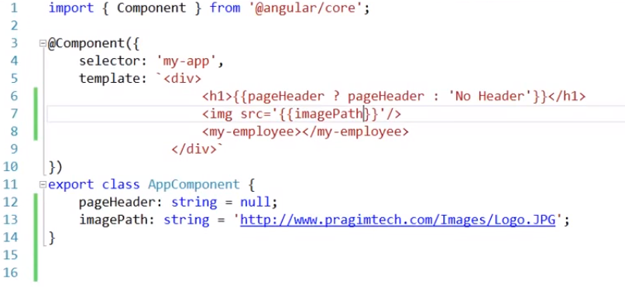

Lets save our changes and reload the web page to see the effect

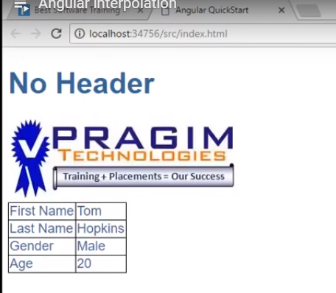

Case 6 :- Using interpolation , we can call class methods .Lets check with an example

Create two properties in app component class and create a function of type string and define the body of the function and finally call the function in the view template as shown in the below screenshot.

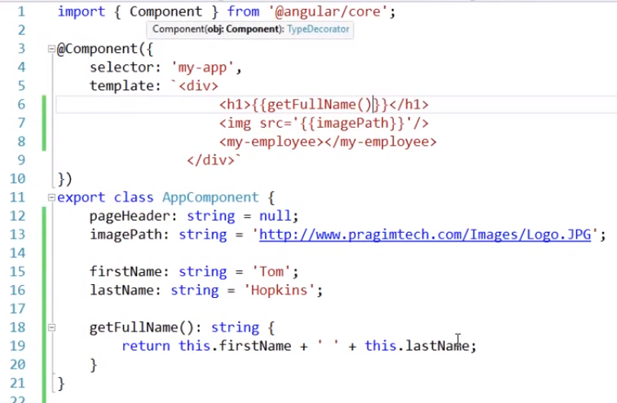

Lets save the changes and reload the web page

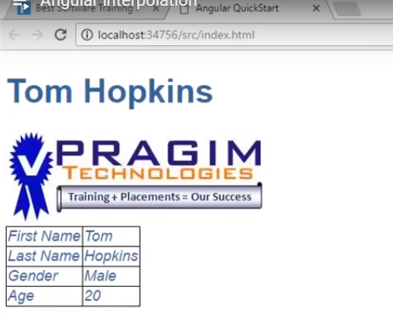

At the end , we have all interpolation examples

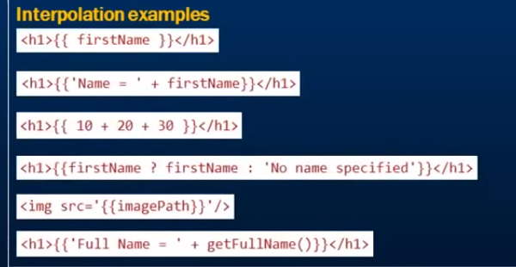

**Angular 2 Property Binding :-**

Property binding is all about moving data from component class properties to HTML element properties.Lets take an example.

Enclosed the HTML element property name within the pair of square bracket followed by a equal to sign and the name of the property within a name of single or double coats.

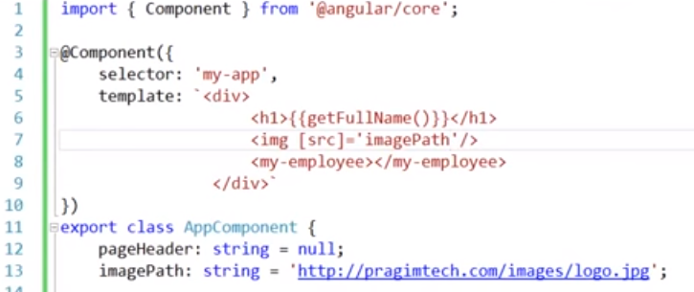

Lets save our changes and reload the web page to see the effect as shown in the below screenshot



Note :- Both interpolation and property binding flows the data value in the same direction i.e.the component class property to HTML element property.

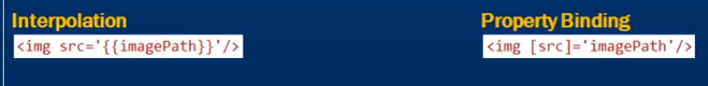

**When to use interpolation and property binding**

**1 .**



**2 .**



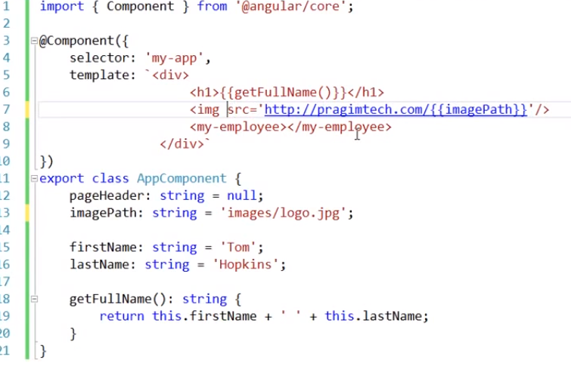

**3 .**

Use property binding instead of interpolation



Within our view template , lets include the button element and we wont bind disabled property of this button.So , within our component class lets include a property of type boolean and include a default value be true.

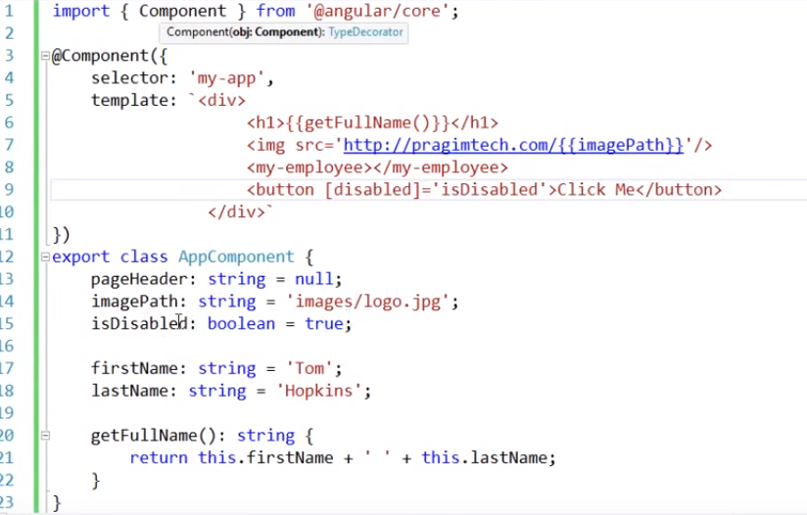

Lets save our changes and reload the webpage to see the effect as shown in the below screenshot

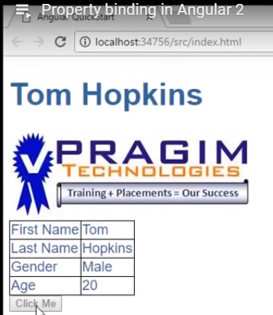

In the same case , if we use interpolation instead of property binding then button value is always disabled and its not working as expected.

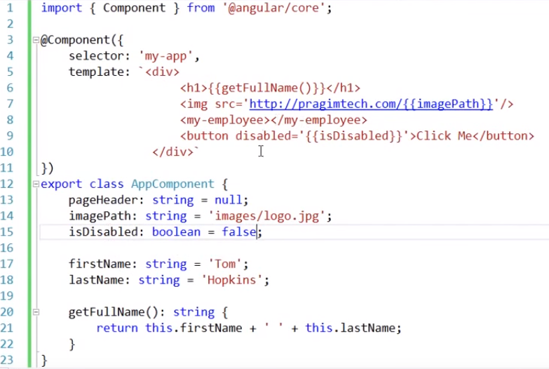

Below screenshot codes for Button disbled for interpolation and property binding

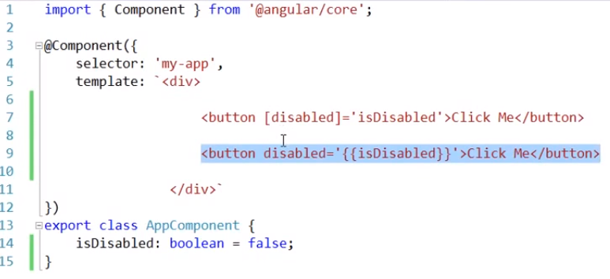

Note :-



In case of property binding , we can also use canonical variation as shown in the below screenshot



**Angular 2 class binding:-**

**Angular 2 HTML attribute and DOM property :-**

When a web browser loads the below html structure then it is called DOM.

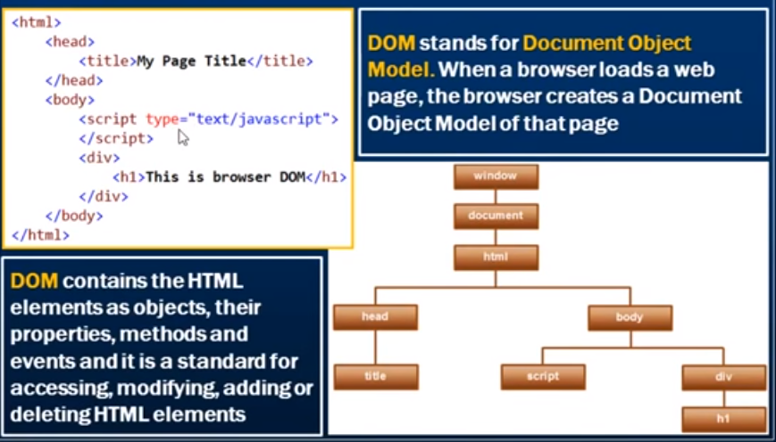

In angular 2 , it looks like we are binding to disabled attribute of button element but that’s not true.

Where actually , we are binding to disabled property of the button object in the DOM.



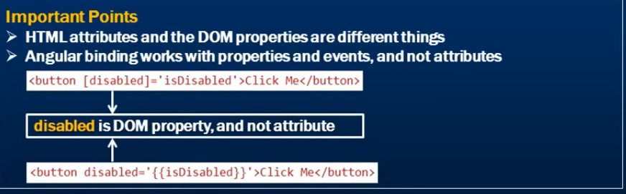

s

**Angular 2 Directive :-**

A directive is a custom HTML element that is used to extend the power of HTML.Angular 2 has following directives that get called as a part of BrowserModule module.

>> ngif

>>ngfor

View app.module.ts file to see the following code defined .By defining this module , we will have access to the above two directives.

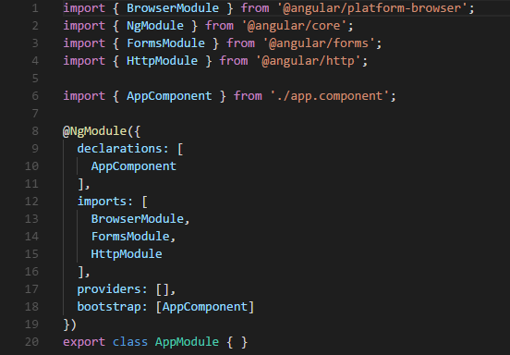

>> ngif element is used to add the elements to the HTML code if it evaluates to true , else it will not add elements to the HTML code.

**\*ngif = ‘expression’**

If the expression evaluates to true then the corresponding gets added , else the elements not added.

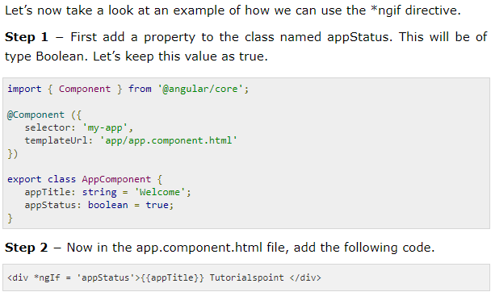

In the above code, we now have the *ngIf directive. In the directive we are evaluating the value of the appStatus property. Since the value of the property should evaluate to true, it means the div tag should be displayed in the browser.

>>ngfor:- This element is used based on the condition of for loop.

Syntax :- *ngfor = ‘let variable of variablelist’

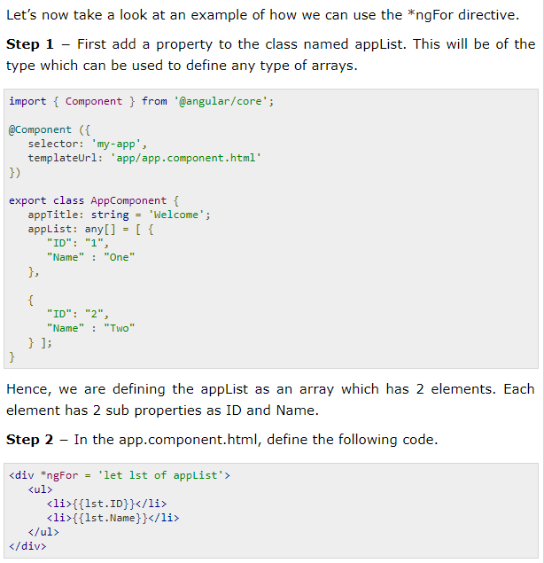

In the above code, we are now using the ngFor directive to iterate through the appList array. We then define a list where each list item is the ID and name parameter of the array.

**Angular 2 Metadata :-**

Metadata is used to decorate a class so that it can configure to get the expected behaviour of the class.

**Annotations:-** These are decorators at class level. Decorators and metadata together forms component.

In app.component.ts file , component is imported , so module name is component and decorator formed from module name i.e. @Component.

Metadata is a way to process the class because it informs angular how to do it.In other words metadata tells angular that a class is a component (class becomes component when we inform angular) . In typescript , you attach metadata by using a decorator. Being @Component is a decorator , which informs angular how to create and present the component and its view.

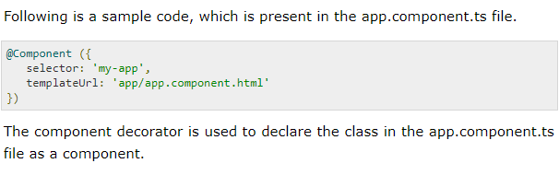

**Angular 2 Data binding**

There is two-way data binding in Angular2

>> Property Binding :- The square brackets on the outside are for property binding .

Within a App component class lets include a property

i.e. name (variable) : string(datatype) : ‘Tom(default value)’;

And in the view template lets include literal text with input element and we want to bind to this value property of the input element using property binding i.e. name of the property that we have in app component and display the value that user entered in the textbox.

Please see the below screenshots for your reference

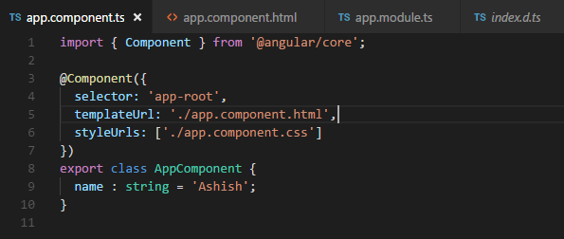

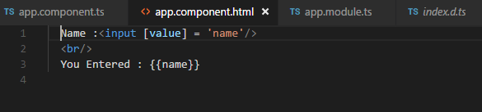

This is one way data binding that is from our component class property to html element property.

The default value that we have displayed both in the text box and on the web page.

Here , the data doesn’t flow in the opposite direction.

>> Event Binding :- The parentheses on the inside are of event binding. This is to achieve to flow data in opposite direction i.e. HTML element property to class property.

$event is an object exposed by Angular data binding contains event data.In this case , we have value that we types into the text box and to get that value we are using $event object .target .value and that value is going to update in the name property .In addition to this , the value that we are typing into the text box we are using that value to update the name property within our component class then the expression{{}} here bind it to this.

Please see the below screenshots for your reference

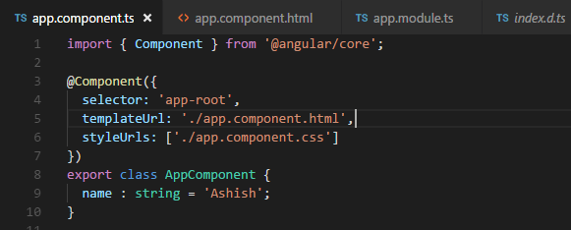

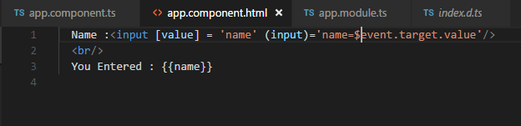

Angular has given ngModel directive and we can write the above code as mentioned in the below screenshot.

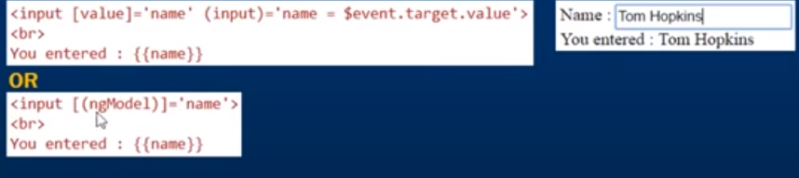

In the above screenshot , we are affectively replacing property binding and event binding using ngModel directive .

Note :- () :-Used for event binding

[] :- Used for property binding

If we simply write the code of ngModel directive then we will get Loading AppComponent page followed by an error as shown in the below screenshot.

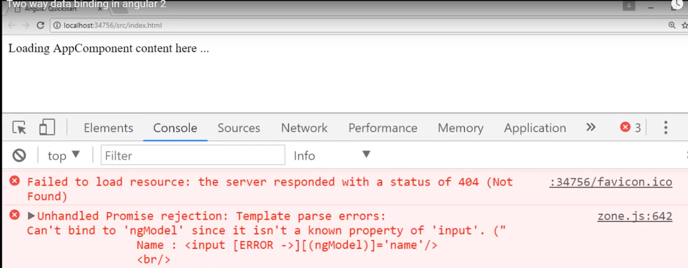

Basically , Angular is complaining that the Angular cant able to find the directive ngModel because ngModel directive present in system Angular module called forms module.Inorder to achieve this , we need to import forms module and to do that we need to import in core module i.e. app.module.ts file , just like we have imported NgModule and BrowserModule.

After we import forms module in app.module.ts then we reload our web page then we get the output as expected.

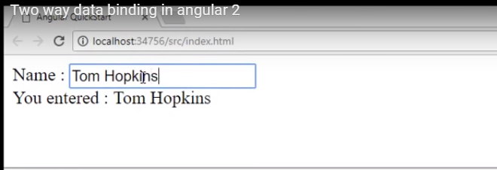

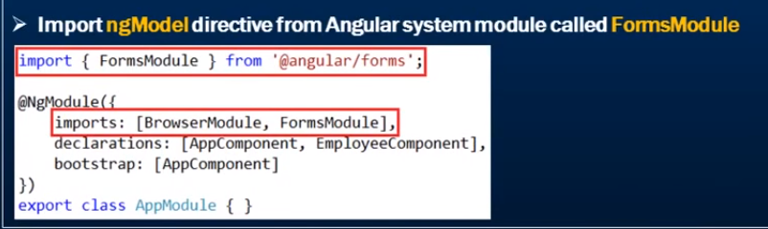

**Steps to import a file and used it in entire application**

Step 1 :-

Create a ts file i.e.config.ts as shown in the screenshot

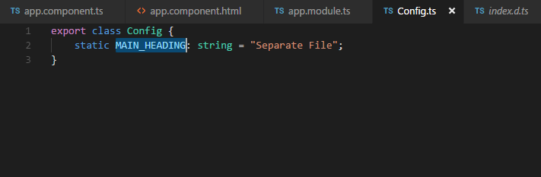

Step 2 :-

Import Config.ts file in the app.component.ts file and call MAIN_HEADING static variable as shown in the screenshot.

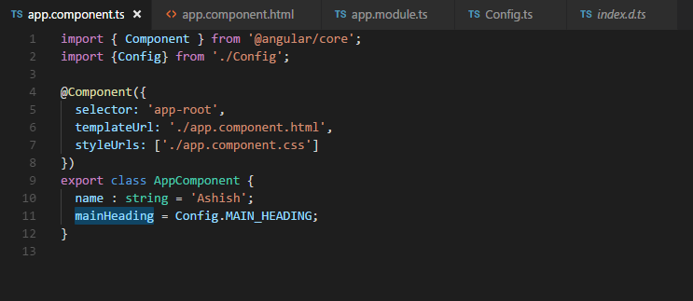

**Angular 2 Routing:-**

Routing allows us to navigate from one view to another view.

Lets understand with an example

Add a new folder i.e. home in app folder and place a new component in the folder i.e.home.component.ts.

Every component does have selector property as directive and this component don’t have selector property. Moreover, selector property is used to embedded one component to another component as directive.

In addition to this , we are going to route the compoenent i.e.home.component.ts using angular router and this the reason we have omitted the selector property for this component.

Now , lets register this component in a module where we want to use it.In app.module.ts file which is called the root module of the application register the home component by import statement and declare the home component.

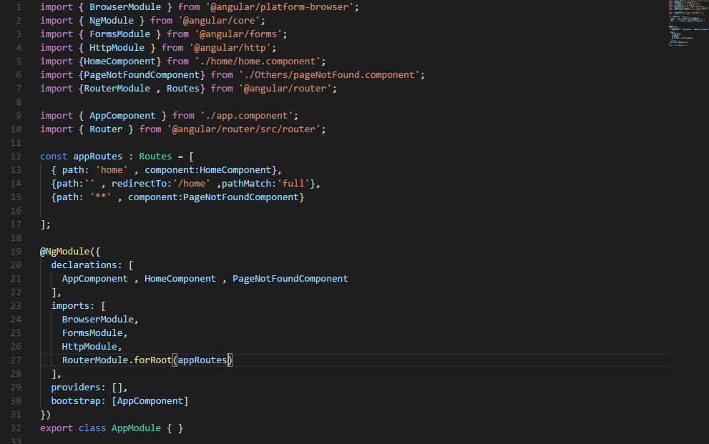

Now , if we tries to navigate to a component which is not exists the we want to route the user to page not found component. We don’t have that page not found component , so lets create that component.

Lets create that file in the others folder i.e.pageNotFound.ts file

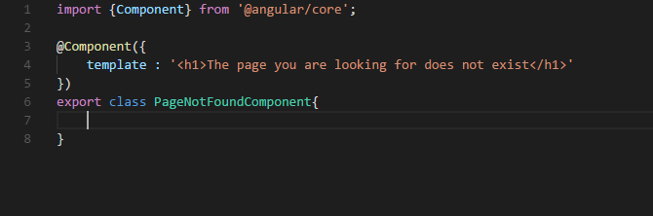

Lets , register this component as well in the application module like home component.



So , at the moment we have two component i.e home component , page not found component.

Now , how to use routing to navigate between these components.

Steps required to navigate :-

Step 1 :-



Set base href element in the application host page of the application i.e. index.html

This base href element tells Angular how to compose navigation URLs.

Step 2 :-

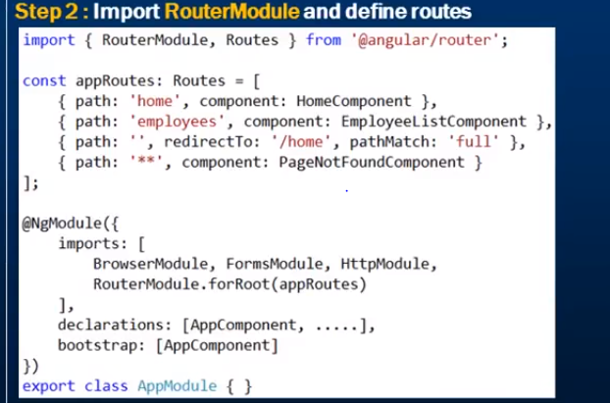

In application root module import Router module.In addition to Router module we are also importing Routes and it is nothing but an array of routes objects and make this part of import array.

Now , lets define our application routes.

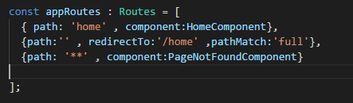

In the above code , it is telling Angular Router if it sees the path home appended to the base URL the navigate the user to home component.

What if the user navigate to the root URL i.e.localhost/src which is the base URL then we want to redirect user to home that we usually do in any web application and path match is kept as full.

Finally , specify the wild card route which is the route that does not exits at all for ex:- abc and we don’t have route called abc , in that case we want to route the user to page not found component.

We have created the all the routes objects as shown in the above diagram.Now we need to tell the AngularRouter about these routes and how we do that by defining root method of the route module.



Note :- Order of the Routes is very important.The most specific route should be at the top and most general or common route should be at the bottom.

Step 3 :-

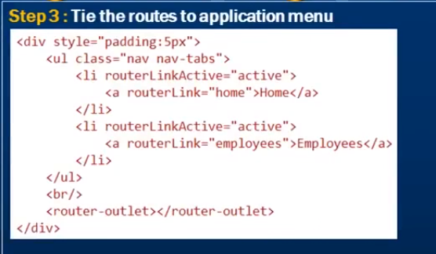

Users can click on the application menu and navigate around.

Here , in the above diagram the router link directive is provided by router module that we have imported within our root application module. Hence , the router link directive tells the Angular Router to navigate the user to home path when they click on the home link.When angular sees the path home which is defined in the root module then we are asking Angular Router to redirect the user to home component and that’s how the home component is displayed when the user clicks on the home link.

Display router component view template to be displayed just below the menu which tell Angular to use router-outlet directive. This directive is provided by the router module which is imported in our root application module. Basically , router-outlet directive tells angular router to render the router component view template at the location where we have this directive.



Now , we click on the home tab and employee tab we navigate to defined template.

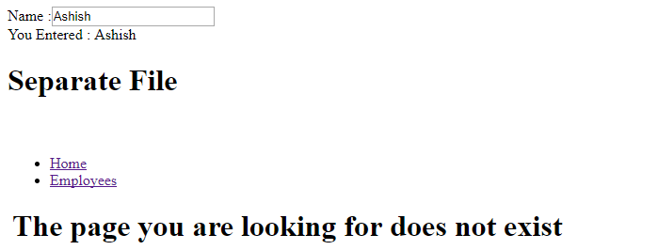

If we want to use hash style routing please see the below screenshot for your reference.



**Angular 2 Route Parameters: -**

We want to make Employee Code on Employee List component clickable.

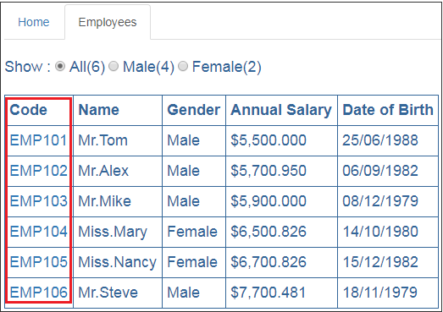

When we click on an Employee code , we want to redirect the user to Employee Component which displays the specific employee details. In the URL we will pass the emploee code as a parameter. So clicking on **EMP101** will redirect the user to URL (http://localhost/employees/emp101). The Employee component will then read the parameter value from the URL and retrieves that specific employee details by calling the server side web service.

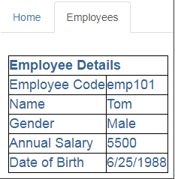

In our previous video we have modified the code in **app.module.ts** file to use hash style routing. Let's remove useHash property, so we are using HTML5 style routing instead of hash style routing. Notice from the forRoot() method I have removed useHash property.  
RouterModule.forRoot(appRoutes)

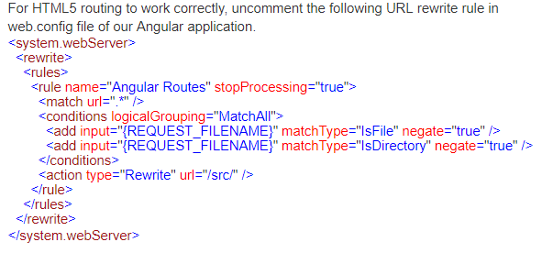

In the root application module (app.module.ts), include the following route. When the user navigates to a URL like (http://localhost:12345/employees/EMP101), we want to display EmployeeComponent. Notice the code parameter specified using colon (:).

{ path: 'employees/:code', component: EmployeeComponent }

Include the above route in appRoutes collection in app.module.ts file as shown below. Remember the order of the routes matter.

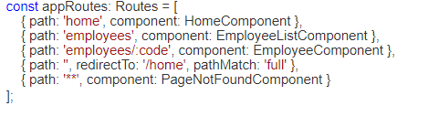

Next, in EmployeeListComponent, modify the <td> element that displays employee code to bind it to the route we created above using the routerLink directive as shown below.

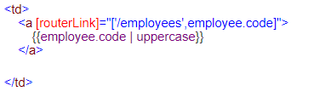

**Explanation of the above code:**

* Notice in this example we are binding routerLink directive to an array.
* This array is called link parameters array.
* The first element in the array is the path of the route to the destination component.
* The second element in the array is the route parameter, in our case the employee code.

In the Angular EmployeeService (employee.service.ts), introduce the following getEmployeeByCode() method.

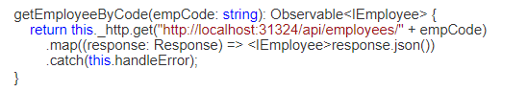

**Explanation of the above code:**

* This method takes employee code as a parameter and returns that employee object (IEmployee).
* This method issues a GET request to the Web API service.
* Once the Web API service returns the employee object, this method maps it to IEmployee type and returns it.

In one of our previous videos we have created EmployeeComponent to display employee details. When we created this component, we have hard coded employee data in the component itself. Now let's modify it

* To retrieve employee details by calling the Angular EmployeeService method **getEmployeeByCode()** we created above.
* This method calls the server side Web API service which retrieves that specific employee details from the database.
* The employee code parameter is in the URL
* To retrieve the parameter from the URL we are using the ActivatedRoute service provided by Angular
* Since ActivatedRoute is provided as a service inject it into the constructor just like how we have injected EmployeeService

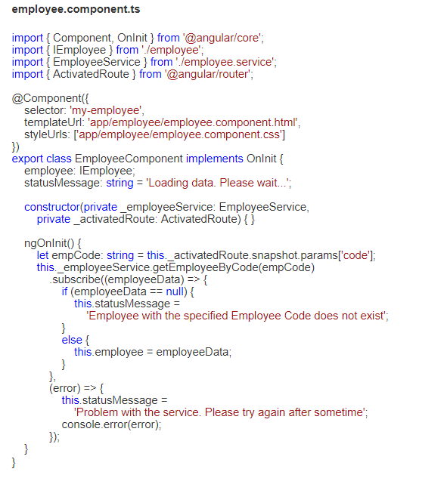

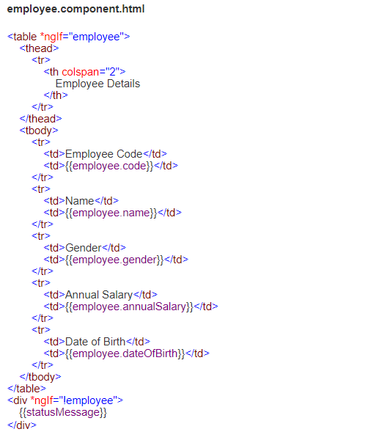

There are different approaches to retrieve route parameters values. We will discuss all the different approaches and when to use what in our upcoming videos.  
  
Since we need EmployeeService both in EmployeeListComponent and EmployeeComponent, let's register it in the root module so we get a singleton instead of multiple instances of the service.    
  
We will discuss what is a Singleton in Angular and why is it important in our next video. For now, let's remove the EmployeeService registration from EmployeeListComponent by removing the following providers property in employeeList.component.ts file   
  
providers: [EmployeeService]  
  
Now regsiter the EmployeeService in application root module (app.module.ts) by including it in the providers property of @NgModule decorator as shown below

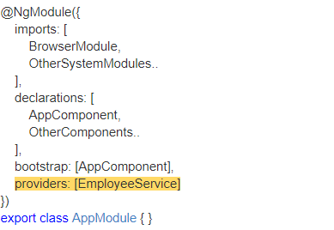

**Angular 2 ngfor :-**

In Angular 2 , ngfor is structural directive.

Lets take an example , we have list of employee objects.Each employee object has got employee code,name,gender,annual salary and date of birth.We want to display employee objects in an HTML table.

Please see the structural screenshot that we will develop.

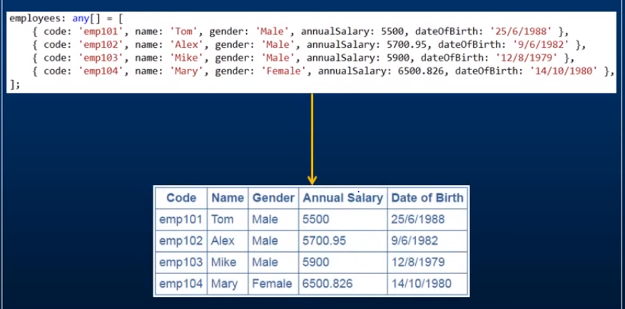

We will achieve this by ngfor structural directive.

Lets create employeeList.comonent.html in employee folder as shown in the below screenshot

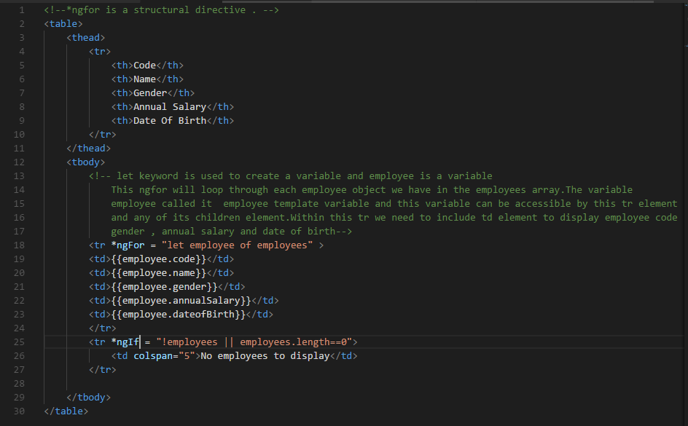

Create a employeeList.component.css to capture the style of the table

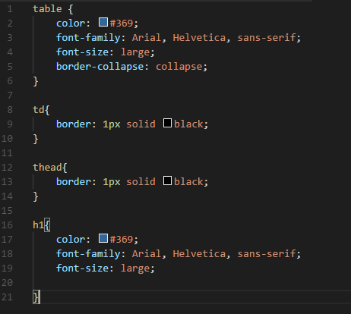

Now , create employeeList.component.ts file to view employee table register in the template directive and selector directive

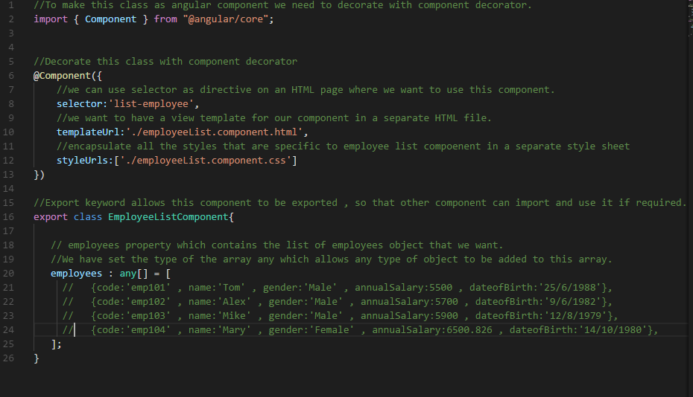

Import and declare EmployeeListComponent in the root angular module i.e.app.module.ts

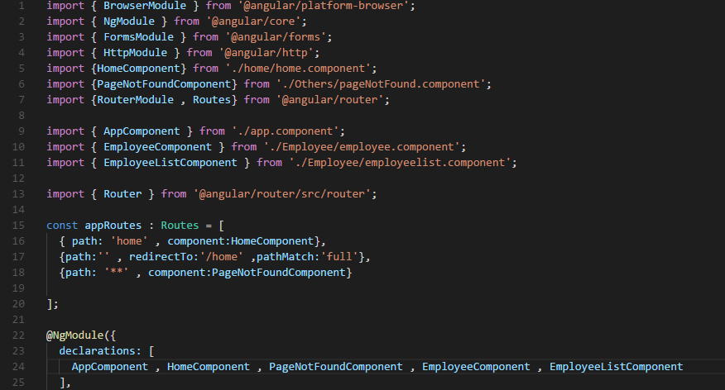

Finally , call the selector directive i.e.list-employee in the root component app.component.ts file.

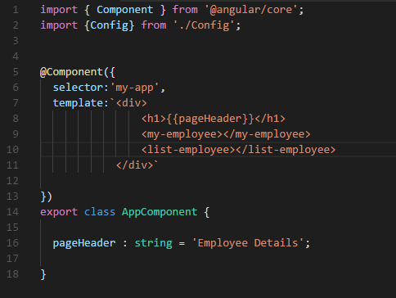

At the end , reload the browser to see the output as shown in the below screenshot

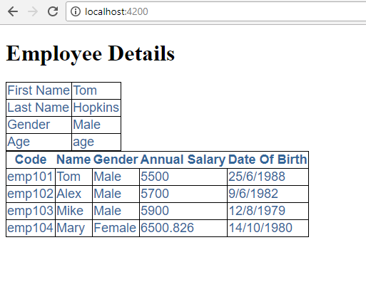

**Angular 2 ngFor trackBy**

Below screenshot add the points which are to be develop with an example.

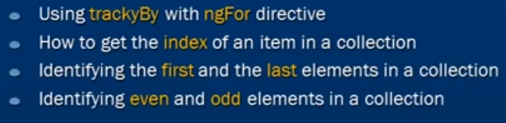

ngFor directive is typically used to iterate over a list of items.If that list is small then we are okay if we don’t use trackBy.With large list ngFor directive may perform poorly. A small change to the list like adding a new element or removing existing element may trigger a cascade of DOM manipulation and lead tp preformance problem.



This will lead to performance issue.

Create a constructor of employee of objects and set the employee properties to an array of employee objects in a method which is created in employeelist.component.ts as shown in the below screenshot

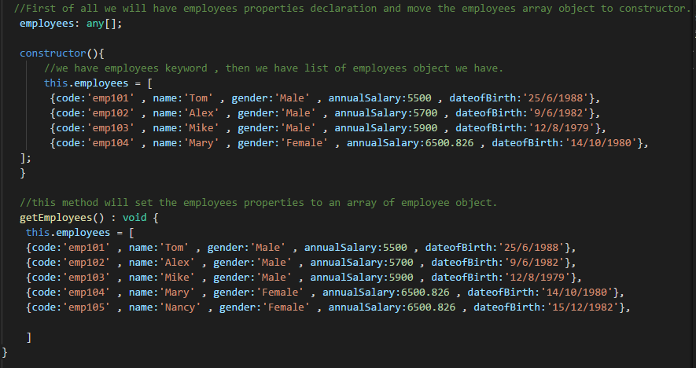

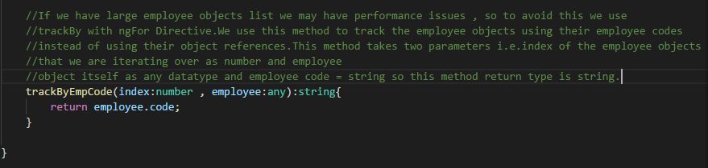

Now , create the Refresh Button to tear down and recreate employee objects every time we click and trackBy property for ngFor is applied for long list where there wont be any changes in the DOM.

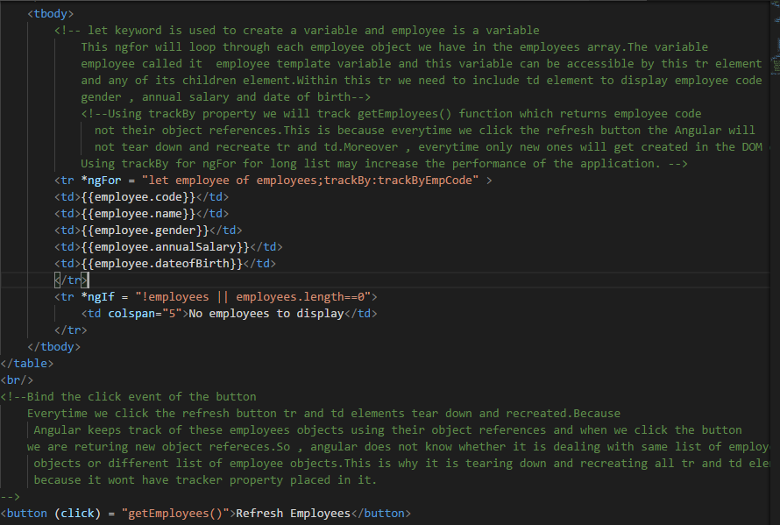

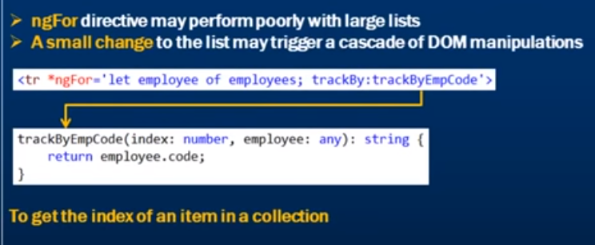

Lets get the index of an item in the collection

We want to display every employee items in the table with index in employeelist.component.html

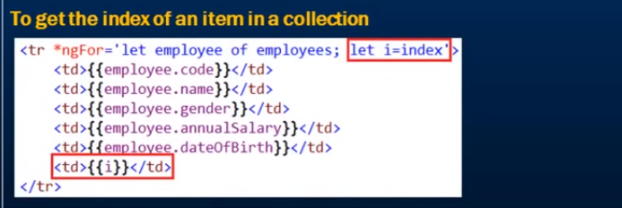

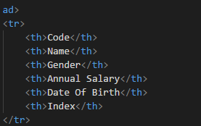

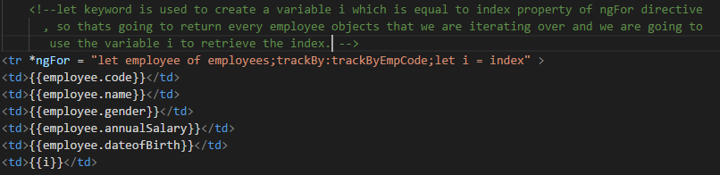

Identifying first and last element in the collection.

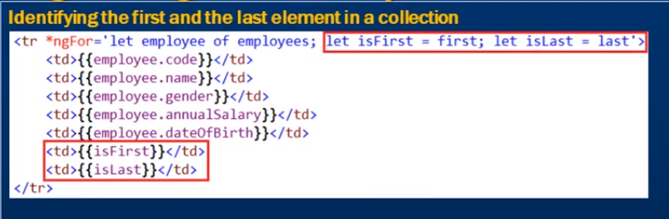

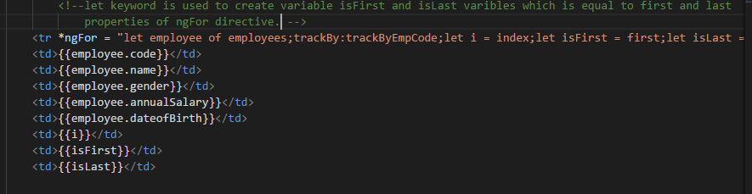

Finally , after reload the web page , please see the below screenshot for your refrence

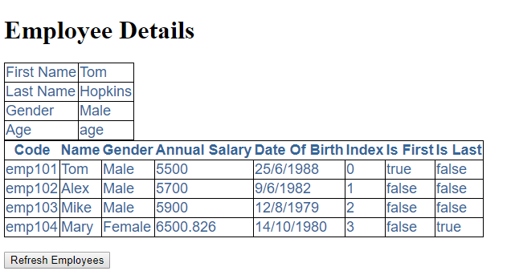

Identifying even and odd elements in the collection

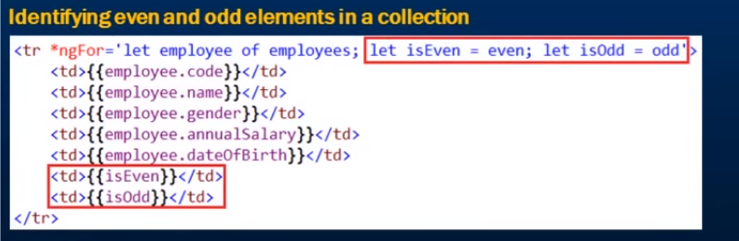

After, reloading the web page , please see the below screenshot

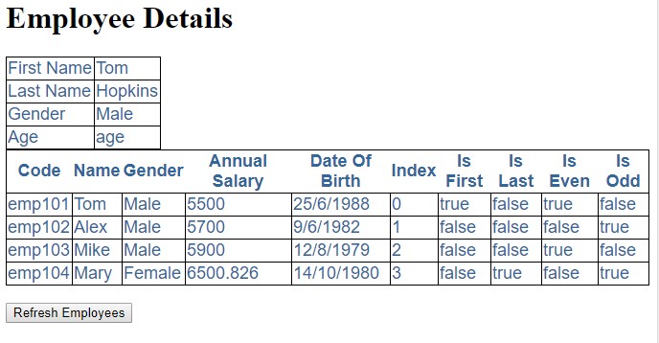

**Angular 2 Pipes**

Pipes transform data before display. There are several build in pipes provided by the Angular like lower case ,upper case , decimal , date , currency etc.

Please see the below screenshot for the understading of pipes

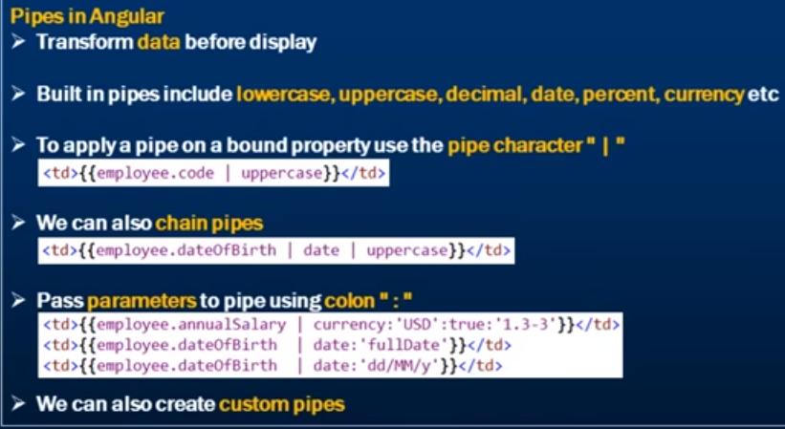

Lets take few examples.

Add pipes to different properties of the table in the employeeList.component.html as shown in the below screenshot.

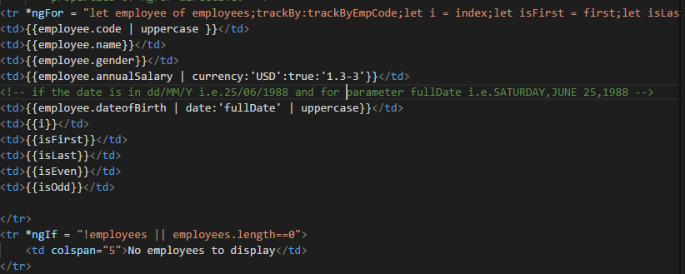

Please see the below screenshot which shows the output in the browser

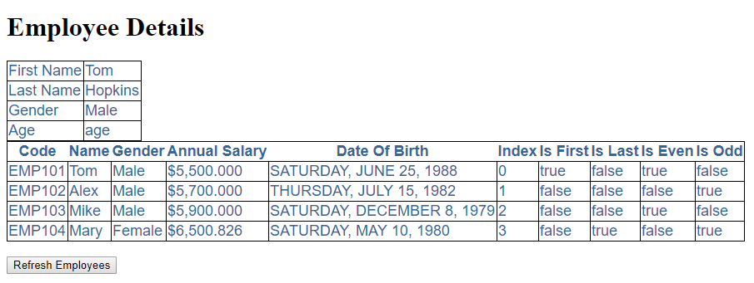

The below link consists of the possible values of the date parameters



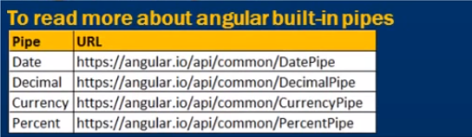

**Angular 2 Custom Pipes :-**

Please see the below screenshot where we are going to achieve the custom pipes by adding Mr in male and Miss in Female of Gender column.

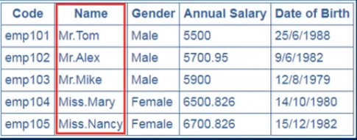

The first step to create the custom pipe is to create a type script file which is going to contain the code for the custom pipe.Type script file is placed inside the Employee folderi.e.employeeTitle.pipe.ts

Step 1 :-

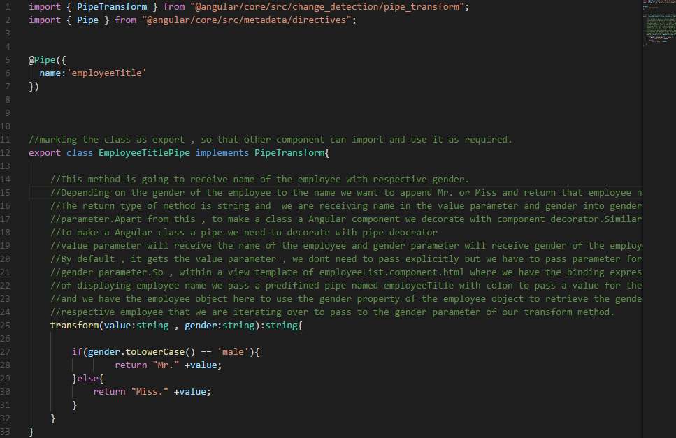

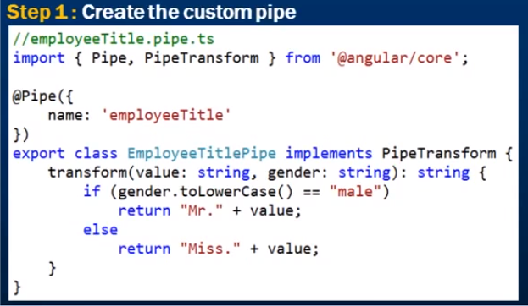

Step 2 :- Declare the custom pipe in the module where we needed.

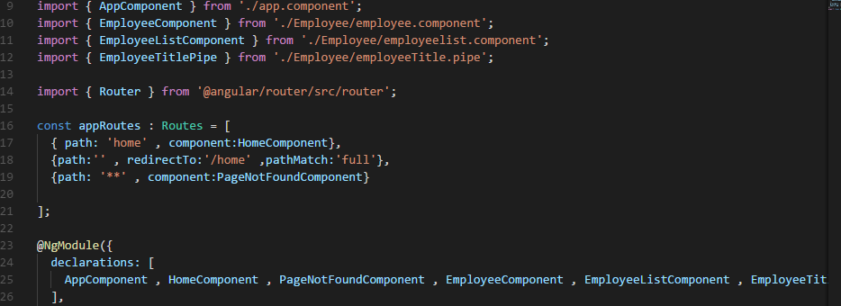

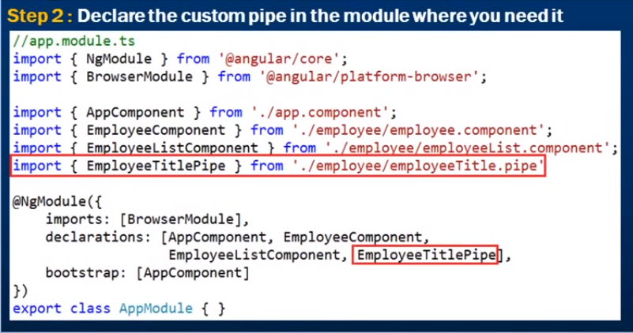

Step 3 :-

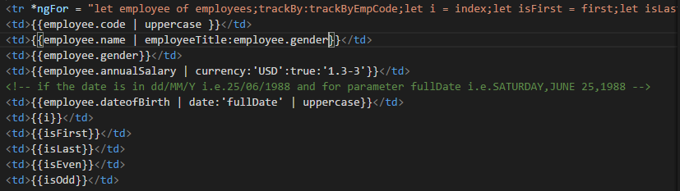

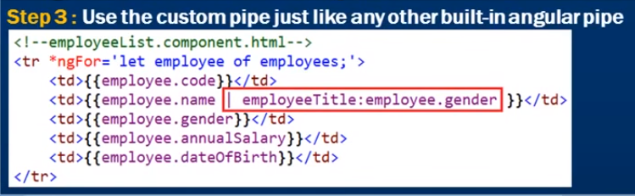

**Angular 2 Container And Nested Components :-**

We will develop the below screenshot to fulfill our requirement.

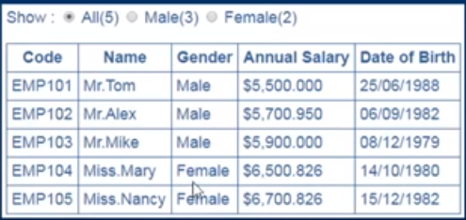

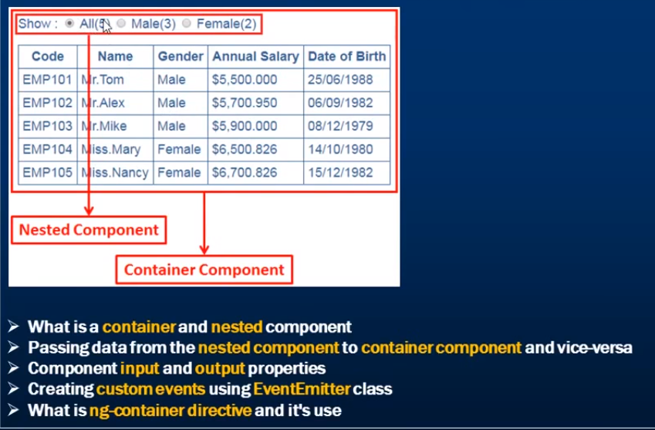

Step 1 :- Create the employeeCount.component.ts file as shown in the below screenshot

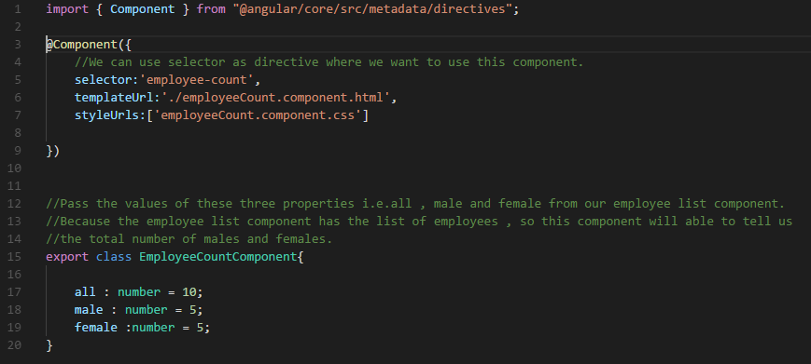

Step 2 :- Create the css file for the radio buttons i.e.employeeCount.component.css file as shown in the below screenshot.

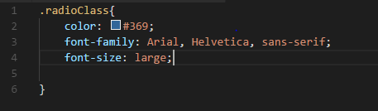

Step 3 :- Create the view template i.e.employeeCount.component.html as shown in the below screenshot

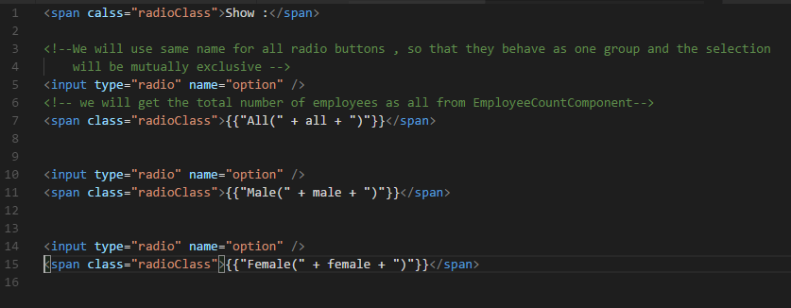

Step 4 :- Register the EmployeeCountComponent class in the root module i.e.app.module.ts as shown in the below screenshot

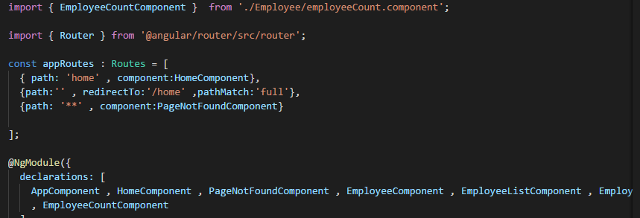

Step 5 :- Next , we have our EmployeeCountComponent created which is need to nest within our EmployeeListComponent.So for that we are going to use selector ‘employee-count’ as the directive as shown in the below screenshot.

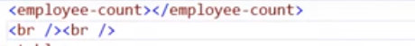

Step 6 :- Now we reload the web browser to see the output as shown in the below screenshot.

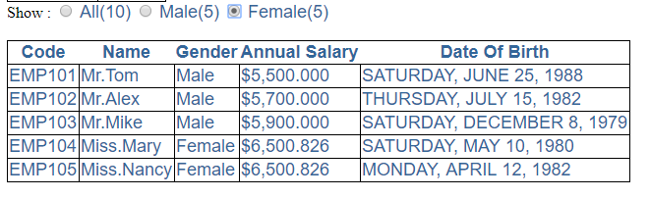

**Angular 2 Component Input Properties:-**



Here , in the above screenshot we will discuss , how to pass data from the employee list component to the nested component i.e. Employee count component using input properties.

Employee list component is the parent component which is having information about the counts and this component should be able to pass values for these three properties i.e. all, male and female.

In addition to this , the parent component to do that we have to convert our properties within our child components to input properties and decorate input properties with input decorator.

Please see the below screenshot for your reference

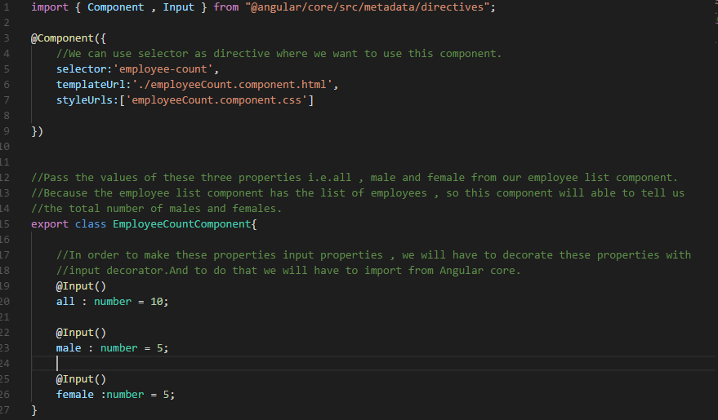

Now , input properties are going to receive the values from parent component which is our employee list component and there is no need to specify any default value.

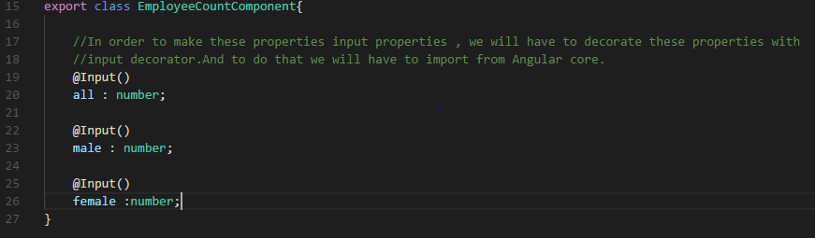

Then , pass the values from the parent component i.e. employee list component to child component i.e. employee count component.

Note :- Use of single , double and triple equals to in typescript

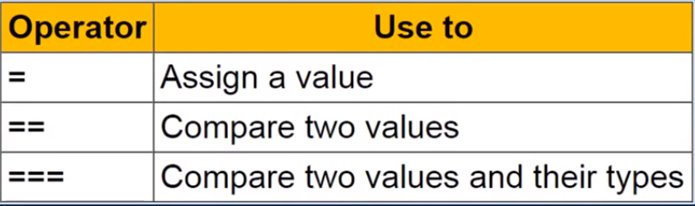

Let change the type script file of employee list component i.e.employeeList.component.ts file which return total number of employees in the employee list , total male and female employees.

Please see the below scrrenshot for your reference.

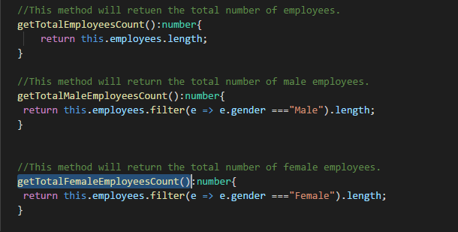

Finally , the change required in the view template of employeeList.component.html file.It will bind the input properties of employee count component to the methods of the parent component i.e.employeeList.component.ts file.

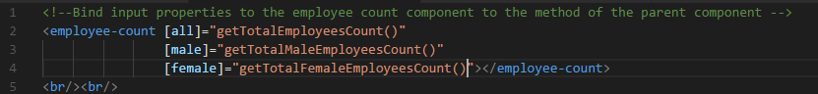

At the end , reload the web browser to see the correct set of employees to each radio buttons.

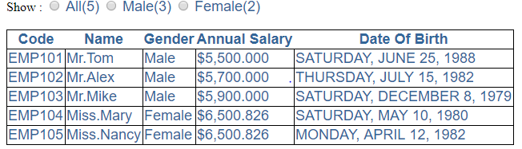

**Angular 2 Component Output Properties: -**

In the below screenshot , if we click all radio button then entire employees list will be available , if we click male then only male employees list will be available and if we click female then only female employees list will be available. To achieve this we are going to use the output properties. So we have employees count component which is our child component and the table is present within the parent component which is employee list component. Whenever we have to make selection in the child component i.e. Employee count component then we have to pass the user action to parent component i.e. employees list component using output properties.

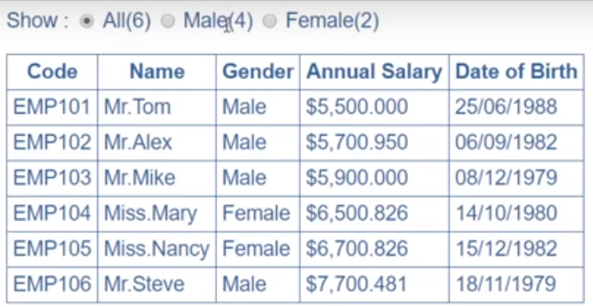

Let’s do the changes required to do in the employee count component i.e.employee count component. Whenever a user selects a radio button we want to raise a custom event from our child component which is our employee count component , so that the parent component can be notified about that event and the parent component can decide which employees to display in the table. To raise the custom event from child component we have to make use of output properties.

To be able to use output properties , we have to import inside Angular/core just like we have imported for input properties.

**Difference Between Angular JS, Angular 2 , Angular 4 :-**

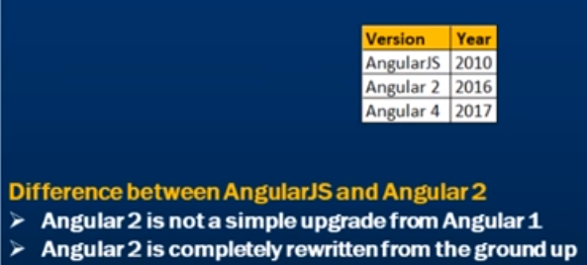

Angular JS application revolve around the controllers.To glue a controllers and view in Angular JS we use $ scope.

In Angular 2 , both controllers and $ scope are gone.Angular 2 is entirely component based that means we create a set of loosely coupled components and put them together to create an Angular 2 application.So , components are the building blocks of Angular 2 application.The advantage of component based approach is that it facilitates greater code reuse.For example :- if you have a rating component you may use it on an employee page to rate an employee or an product page to rate an product.From unit testing end point , the use of Angular 2 application more testable. From performance end point , Angular 2 is five times faster then Angular JS.Angular JS was not build for mobile devices , where as Angular 2 on the other hand is designed from the ground up with mobile support in mind.Angular 2 we have more language choices like java script , type script , dart , pure script etc and among all these languages type script is the most popular language.

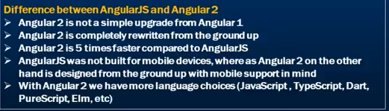

Angular 4 released in 2016.

Angular 4 is backwards compatible with Angular 2 for most applications.

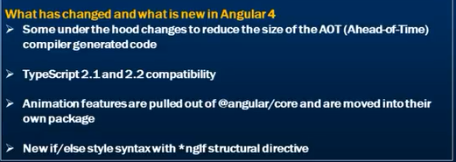

Why the Angular 3 skipped from Angular 2 to 4 ?

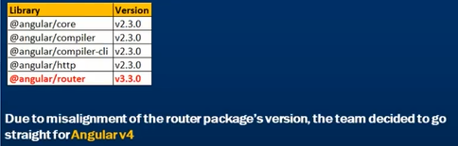

Note:- Angular JS and Angular 2 are two different frameworks. If you are well prepared with Angular 2 then you can easily switched to Angular 4.Angular 4 is simply the next version of Angular 4 .

**Angular Component Lifecycle Hooks:-**

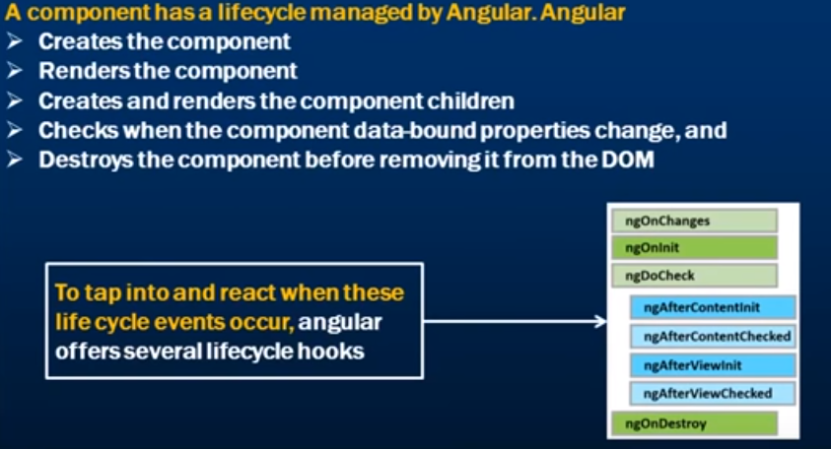

The order in which the life cycle hooks specified is the order in which they execute. As we can see there are lot of them , out of all of them three most commonly used hooks ones are ngOnChanges , ngOninit , ngOnDestroy.

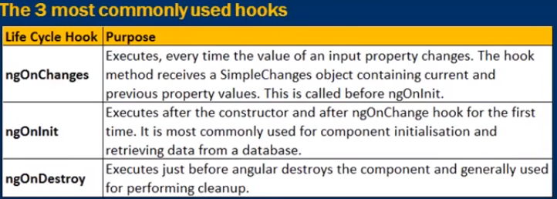

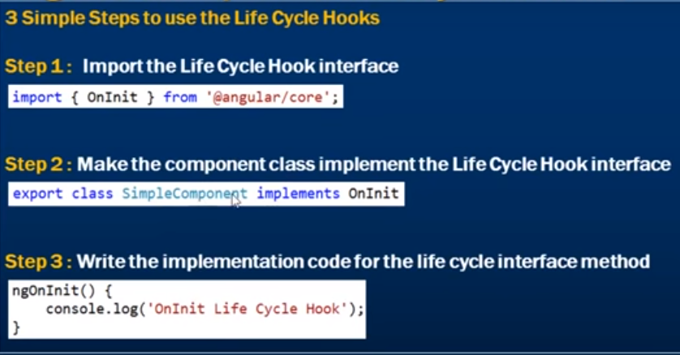

Lets check ngOnChanges hook as shown in the above screenshot:

**1>ngOnChanges**

Whatever we write in the text box , we want to capture the current and previous value and log it to the browser console as shown in the below screenshot.

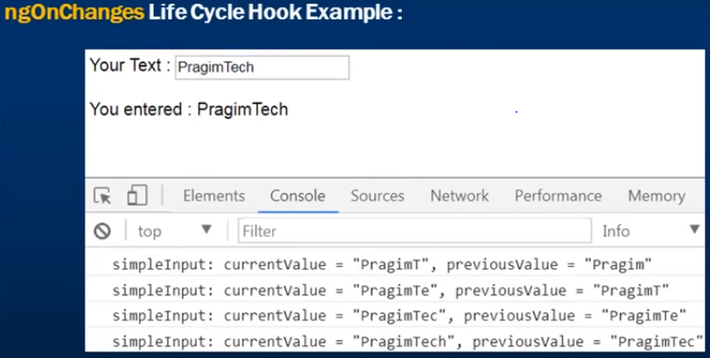

Lets create a new typescript file i.e.simple.component.ts

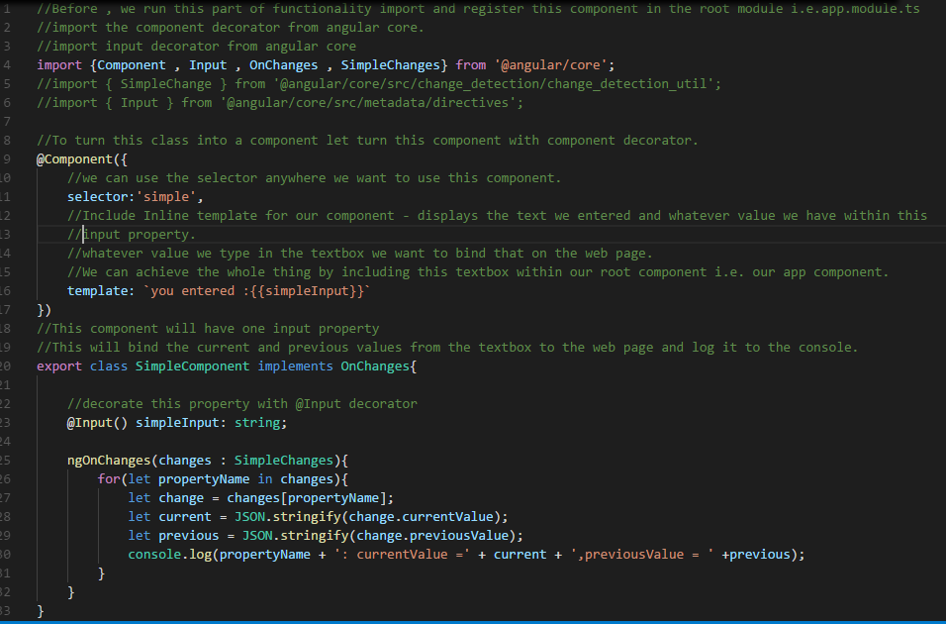

Now , the whole thing can be achieved by including simple component textbox within root component i.e.app.component.ts

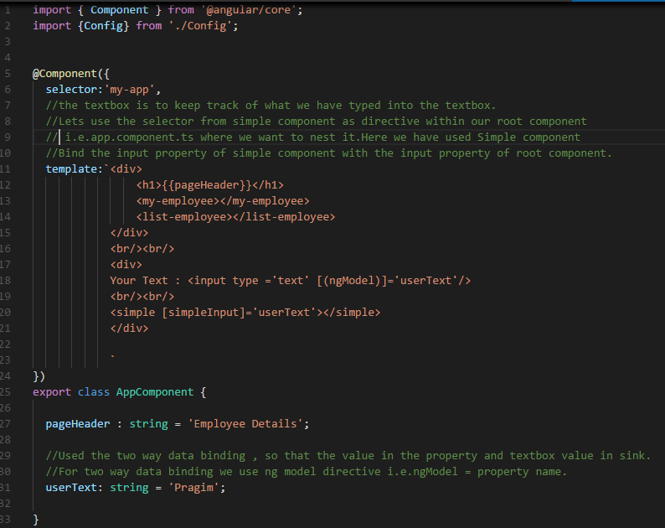

Before , we run our project we need to import and register our simple component within the root module i.e.app.module.ts

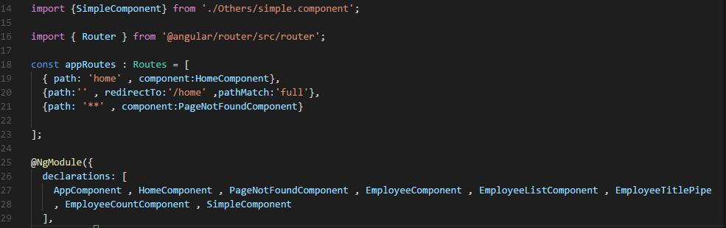

Then , running the application in the browser as shown in the below screenshot

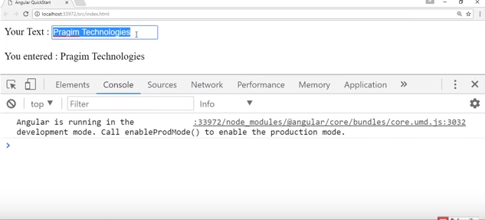

Now , capture the current and previous values from the text box and log it to the console. While , we execute this we will use ngOnChanges life cycle hook.

At first step , import the interface Onchanges of ngOnChanges hook which also receives a object called SimpleChanges as the parameter. Now , override a method called ngOnChanges lifecycle hook method.This method is called everytime the value of input property changes i.e.simpleInput property.

Simple.component.ts

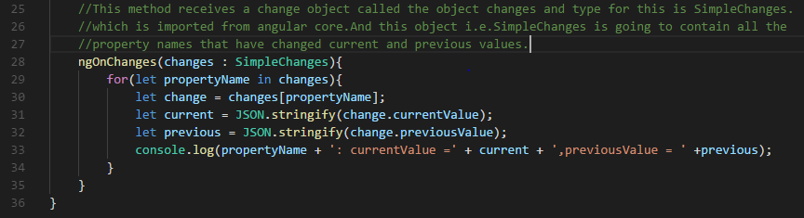

Now , everytime the value in the textbox changes it also changes the input property of the nested component.When the input property of the nested component changes it automatically calls ngOnChanges lifecycle hook method passing it to the SimpleChanges object which contain the names of the properties current values and previous values. In the ngOnChanges method we are logging the current and previous values to the console.

**Angular 2 Services: -**

**Angular 2 http service: -**

Service to call Web API service which in turn use data from the database table .

Steps involved for calling a server side web API service using the Angular build in http service.

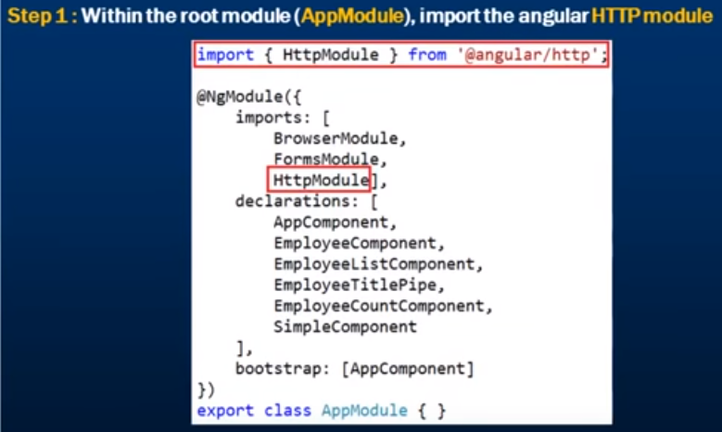

So , with this change now we are able to use the build in angular http service to issue web service calls over http.



The first step is to inject Http from angular http. Now make use of this service to issue web service calls over Http inject Http dependency by constructor.

i.e.constructor(private _http: Http) {}

Now , use this private field _http to issue web service calls over Http.

If in a service class we have any injected dependency then @Injectable() decorator is mandatory.But angular always recommend to use this @Injectable decorator over service class for consistency and future proof.

We can use _http private field to issue web service calls.

_http.get() method returns Observable of response. Also , change the return type to Observable of IEmployee [] array. So , to convert response to IEmployee[] array .To do that transformation we are going to use an operator provided by rxjs and that operator is map operator. Then change the map operator to get method .get() method is giving us the observable of response and that response we are passing to the map operator .After that arrow function is going to convert the response to an array of IEmployee objects.

First , get the json out of the response .So the map operator right here taking in the response and transforming it to IEmployee array which satisfy the Observable of IEmployee the return type we have specified for our getEmployee() method.

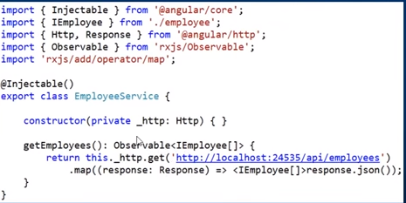

So , our service returns an observable.

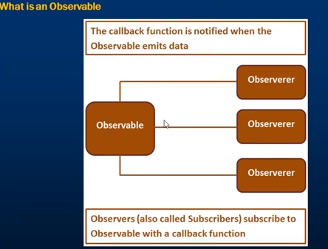

Observable is an synchronized pattern. In this pattern, we have an observable and an observer. Observable emits data items and notifications over a period of time .Observerer called subscriber can subscribe to the observable.When subscribing the observerer specifying the call back function and that call back function of the observerer also called as subscriber is notified when ever this observable emits data items and within that function we write codes to handle the data items by the observable .In this above diagram , we can see an Observable can have multiple Observerer i.e. subscriber.Anybody who is interested in the data emitted by the Observable can Observer the Observable meaning subscribe to the Observable.Let specify the call back function where we have code to handle the data emitted by the Observable .So , if we relate this in our example , EmployeeService returns an Observable and any component which needs this Employee data is going to be Observerer which is also known as subscriber.

Within our Employee List component we need Employees data, so that is going to be Observer /subscriber and that component is going to subscribe to the Observable return by this service. When we are subscribing from our Employee list component to this service we are going to specify call back function and whenever this function returns an Observable of an IEmployee object the subscriber i.e.the Observer in our case the EmployeeList component is going to consume that and we have an call back function which is going to handle the data returned by this Observable.



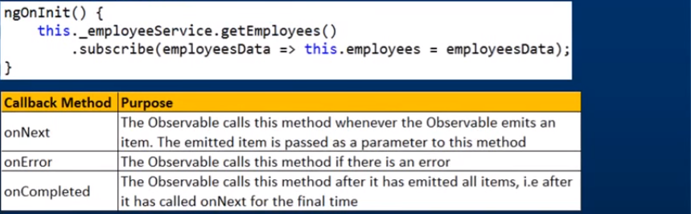

Now , open the EmployeeList component which is going to be the Observerer i.e. subscriber .Notice , ngOnInit() method issuing a request to EmployeeService which returns the Observable and if we look into the intelligence of getEmployees() method then it returns Observable of IEmployee .So , we cant bind the Observable of IEmployee directly to this property like this because this service returns an Observable and we have to subscribe to the Observable.In order to subscribe to the Observable we use the subscribe method().

Notice , we are chaining the subscribe() method to get employees method which returns an Observable.And remember , when we subscribe to the Observable we also specify callback() method.We specify the callback() function as a parameter to this subscribe method.So , we can specify that as a arrow function or regular function .So , this arrow function is going to receive employee data .And we are going to use that employee data populate employees properties.

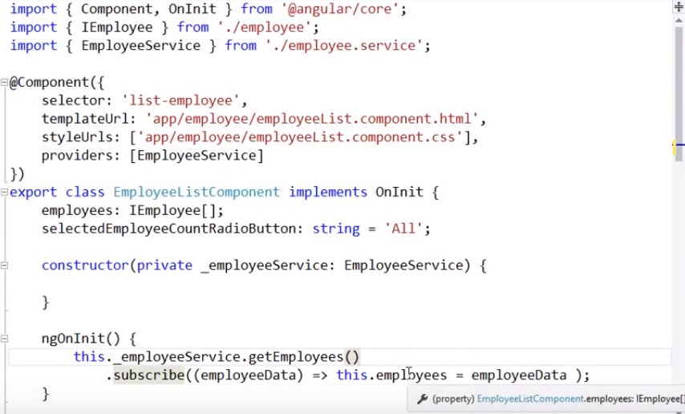

Here, we specify the callback() function as a parameter to that subscribed method. That callback() function receives data from the Observerer and within that callback() function in our case we are binding it to employees property. At the moment we only pass the one argument to the subscribe method. If we look it at subscribe method, it actually has three parameters.

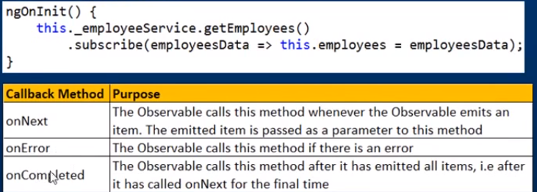

With , all these in action , Lets run our application by pressing ctrl+F5

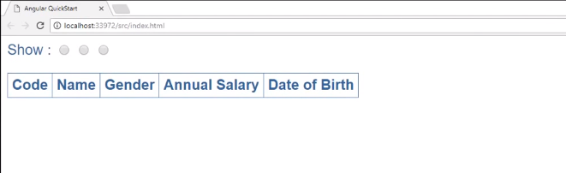

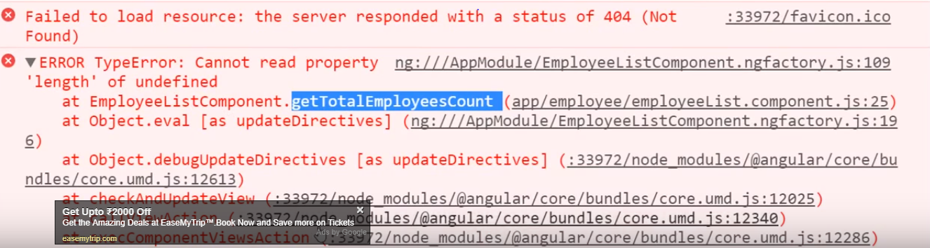

Here , length is undefined of getTotalEmployeesCount() method of EmployeeListComponent.

By the time , the service has the opportunity to initialize this i.e.employees property , we are trying to read the length property of employee object. So , that’s why we get this error.So , we want to delay the call to this method i.e. getTotalEmployeesCount() and ngOnInit() has the opportunity to initialize this property.We want to delay the getTotalEmployeesCount component and to do that we can use structural directive i.e.*ngIf=”employees” until this property is not null or not defined.Save thsese changes and reload our web page. Now we encounter a different error.

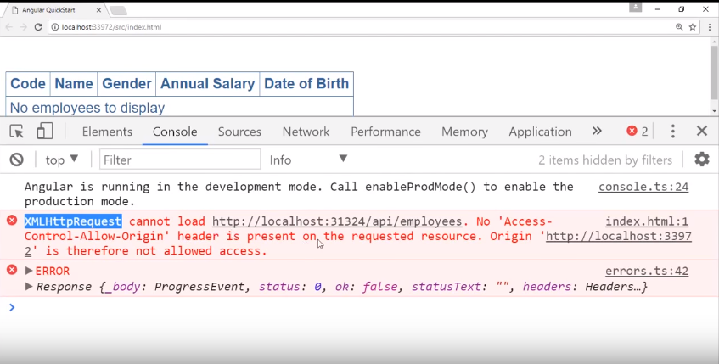

We get this error because our angular application and our we api project are present in two different project. So, they are hosted at two different port numbers i.e.31324 and 3397(angular application).Hence the browser block this request for security reasons. In order to make this work include a setting in web.config file of our web api service. Under system. web server lets include the settings.

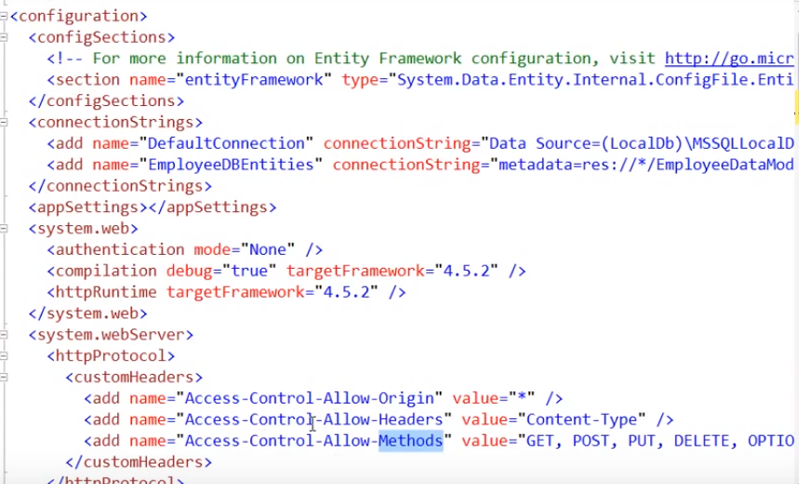

Note :- When said this Access-Control-Allow-Origin request to “*” then any application can issue a cross domain request to this web api service. So if we want to restrict only your application to issue a cross domain request then you should specify the port number on which your application is running i.e.the domain at which the application is running.In our case , angular application domain is

<http://localhost:33972/src/index.html> which we can specify in value of Access-Control-Allow-Origin.

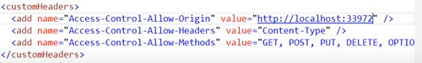

Lets save all these changes and reload our web page and now we see all data as expected and the application also works as before.

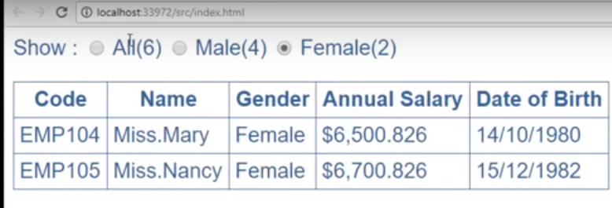

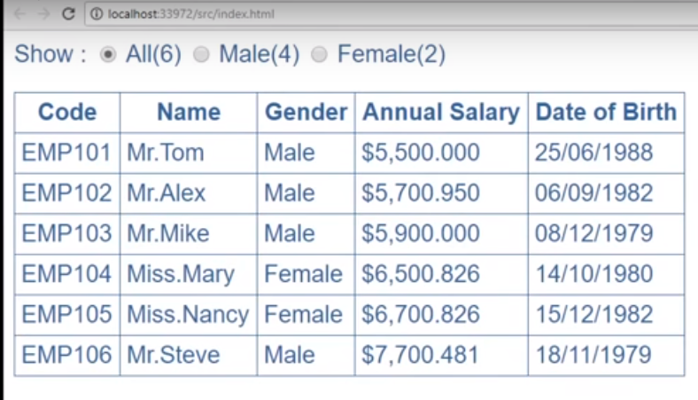

Just, rebuild our application and see the result as shown below which shows we are waiting for the service to load data.

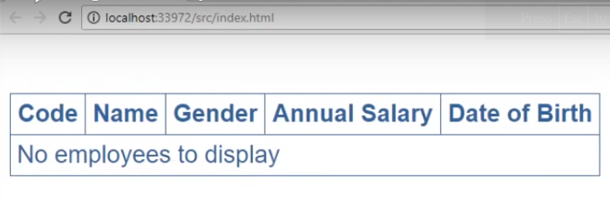

Modify code in employeeList.component.html

**employeeList.component.html**

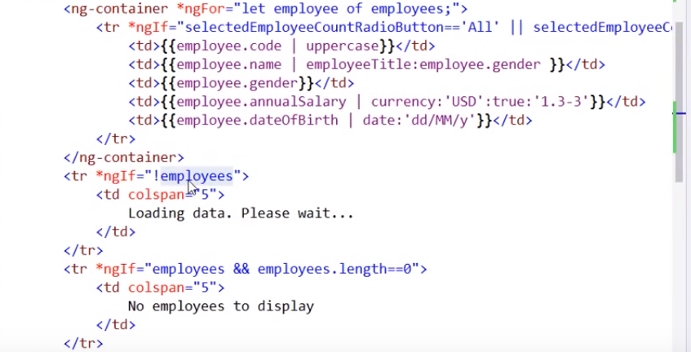

In the above code, If the employees properties is null or undefined i.e.*ngIf=”!employees”. That means we are waiting for the service call to return the data and initialize with this property. So during that wait period we return this wait message to be displayed. When the service call returns the data this service call dissapers and the employees data showed up.

When we don’t have any employees to be displayed then use *ngIf=” employees && employees. length==0”.

So, with all these solution let give your application another rebuild then the service being busy with jitcompile.

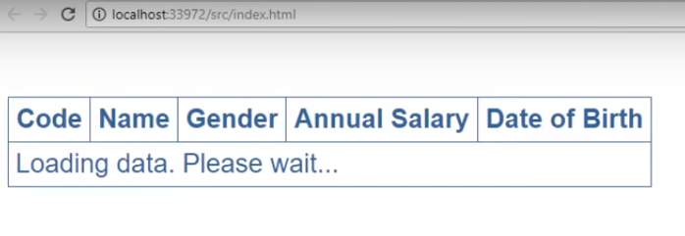

When the data is available that message dissapers

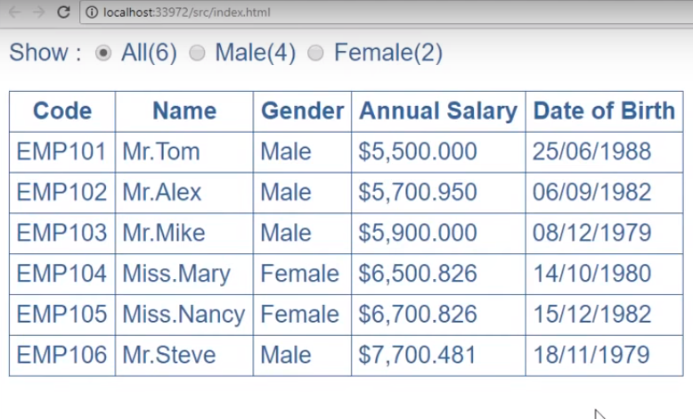

Now, truncate the employees table as shown in the below diagram and we don’t have any employees in the Employees table.

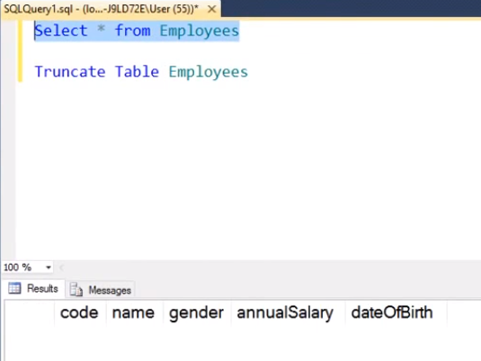

Then re-issue the request to the browser then the message would be no employees to displayed as shown in the below diagram.



**Angular 2 http error handling: -**

When using http angular service to call a remote web service variety of things can go wrong and errors may occur. When errors occur, we need to handle those errors. To handle errors we need the catch operator. First import catch operator from rxjs .Next change the catch operator to the map operator using dot (.).Let pass another method as a parameter .We call this method handleError.Now create this new method handleError().This method will be called whenever there is an error and the error object will be passed as an parameter to this method.Let’s set the type of this error parameter to response.In the real world application error object will be passed to the logging service to log to a database table or file.So that the development team can review them and fixed them if required.

We want to display a meaningful error message to the end user .Now this is a service , usually the service doesn’t have user interface element associated with them , so there is no way to display meaningful message to end users directly from the service .Instead of what we can do is throw the error bag , so that any component subscribe to this service are notified by this error and that respective component can handle the error and display meaning message to the end user.Lets throw the error bag.So to throw the error bag we are going to use Observable.throw(error);.This is going to throw the error bag.We are calling this employee service from our employee list component.So , within our employee list component we need to handle the error that we are throwing from this service then display a meaningful error message to the end user.

**employee.service.ts**

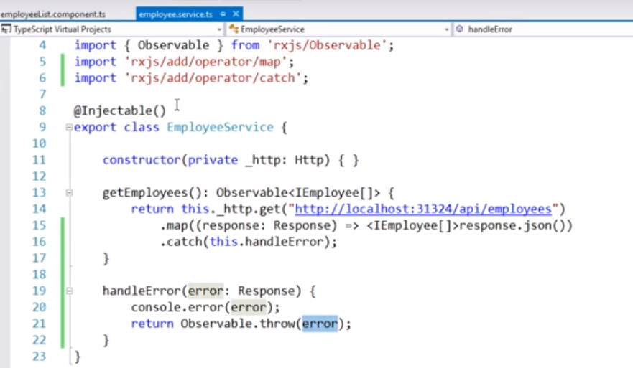

Notice, in the ngOnInit() we are subscribing to the employee service and notice the first parameter to this subscribed method.This method is called whenever the service successfully emits an item.When ever there is an error we can specify the second function and that function is called whenever there is an error.Lets pass the error object as a parameter to the second arrow function.Now , lets create another variable called as statusMessage and this is going to be of type string.And within this error function lets set the variable with the message.Within the view template of employee list component we have this tr right here which displays the message loading data please wait.So , with the help of interpolation let bind the variable which populates the error message.

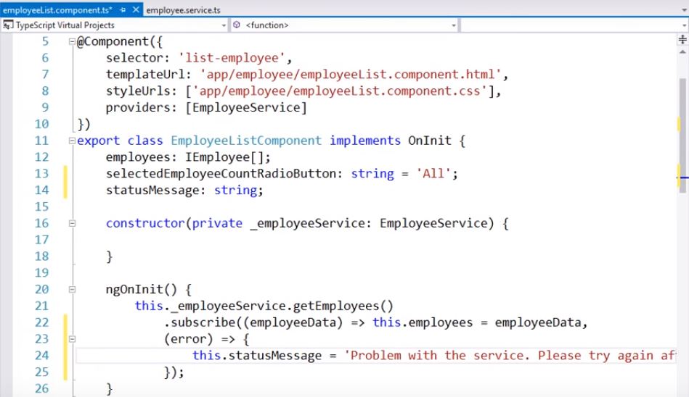

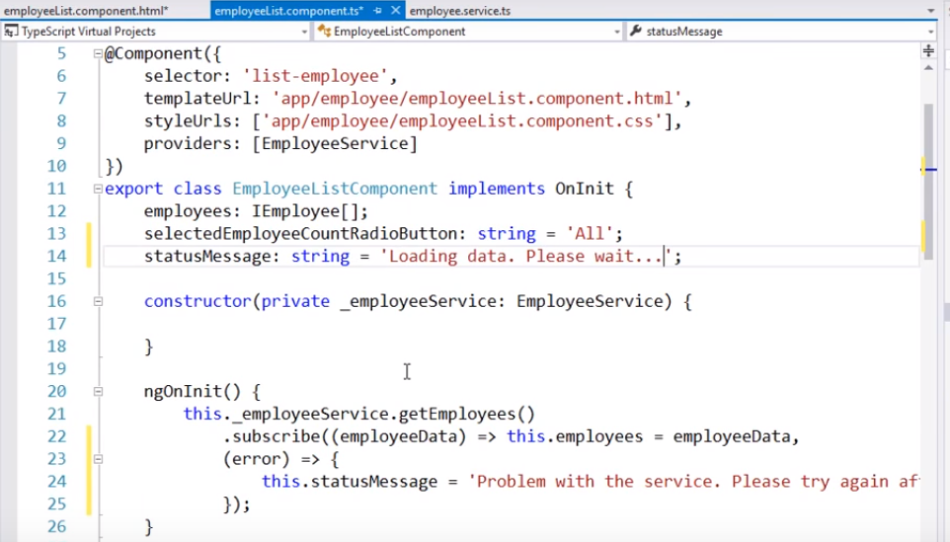

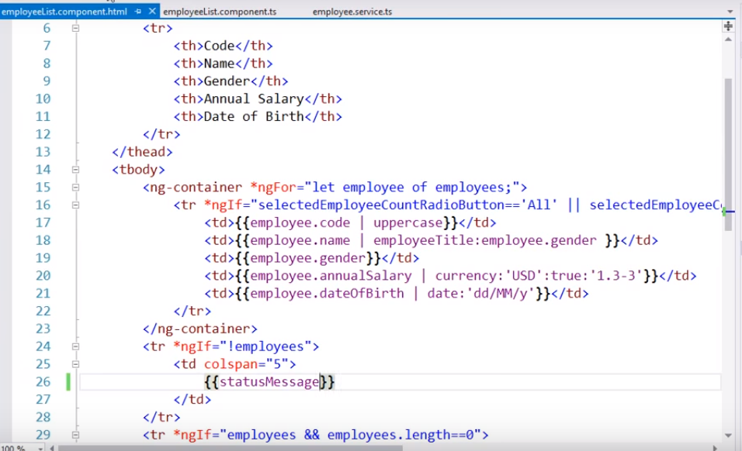

Now, reload our web page and we get the output without any error because data loads fine and the application is running as expected.

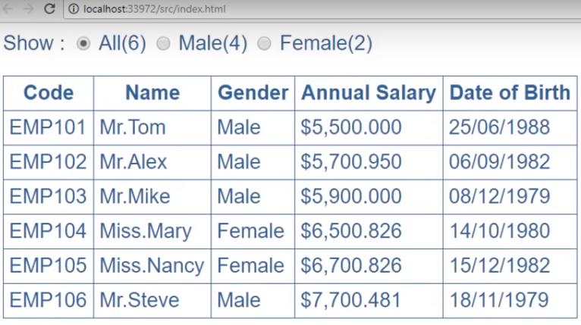

Lets change the service to include extra s in the URL and save our changes and then reload our web page.

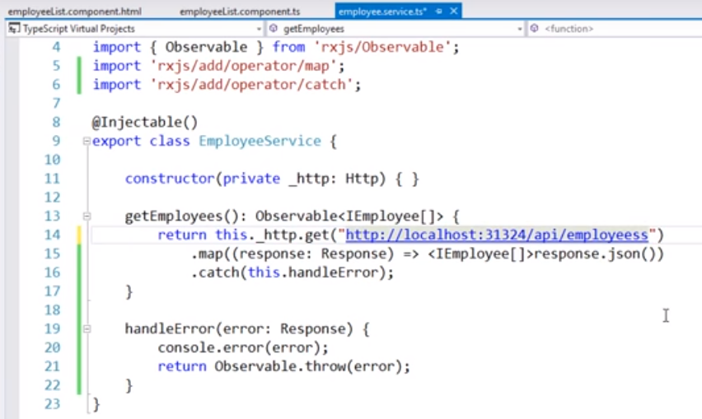

Once the web page is reloaded and refreshed please check the below screenshot which reflects the message i.e.“Problem with the service >please try again sometime”.

Notice, with in the service we are logging error to the console. Let’s launch browser developer tool which shows details about the error as shown in the below screenshot.

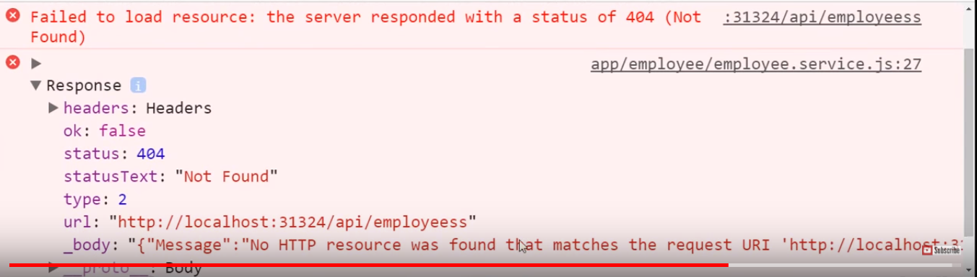

We are throwing the error from the service area. But, we are not doing anything in the employee list component. Simply setting the variable i.e.statusMessage = “Problem with the service.”

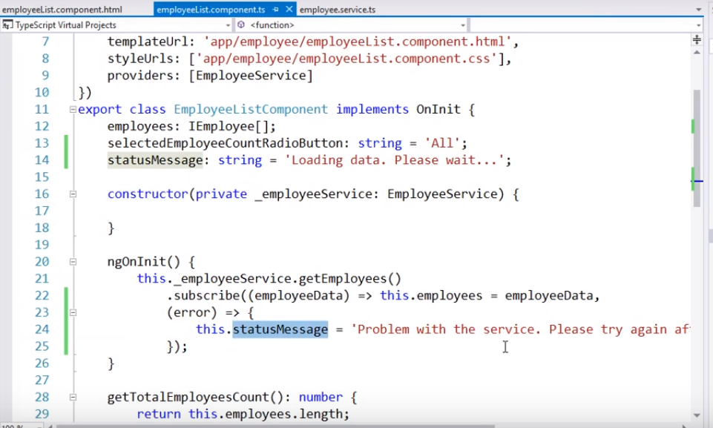

Now , within our employee list component also lets logged the error object to the console.So lets use console.error(); and pass our error object i.e.console.error(error);

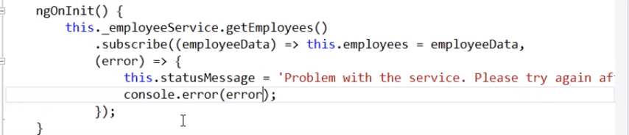

Lets save our changes and reload our web page and we get completely different error message.

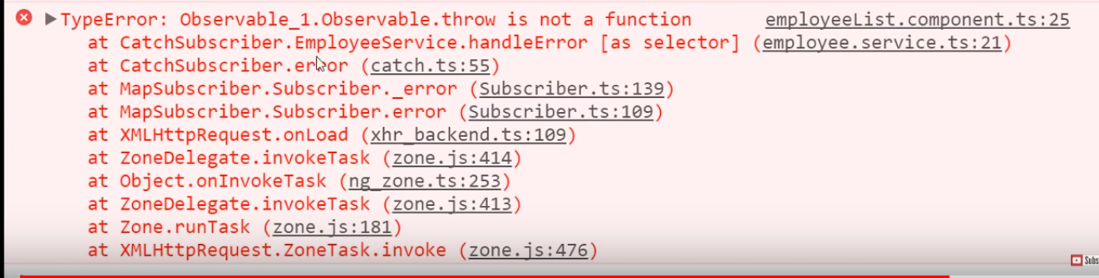

To fix this error import observable in employee.service.ts

**employee.service.ts**

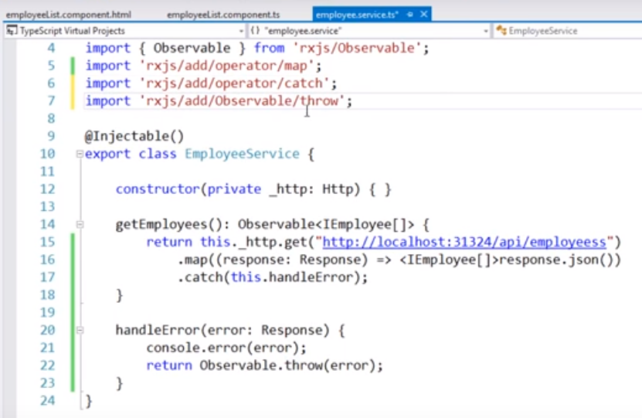

**Then , save the changes and reload our web page .Notice now the error response is logged to the console twice one by the service itself and one by the employee list component.**

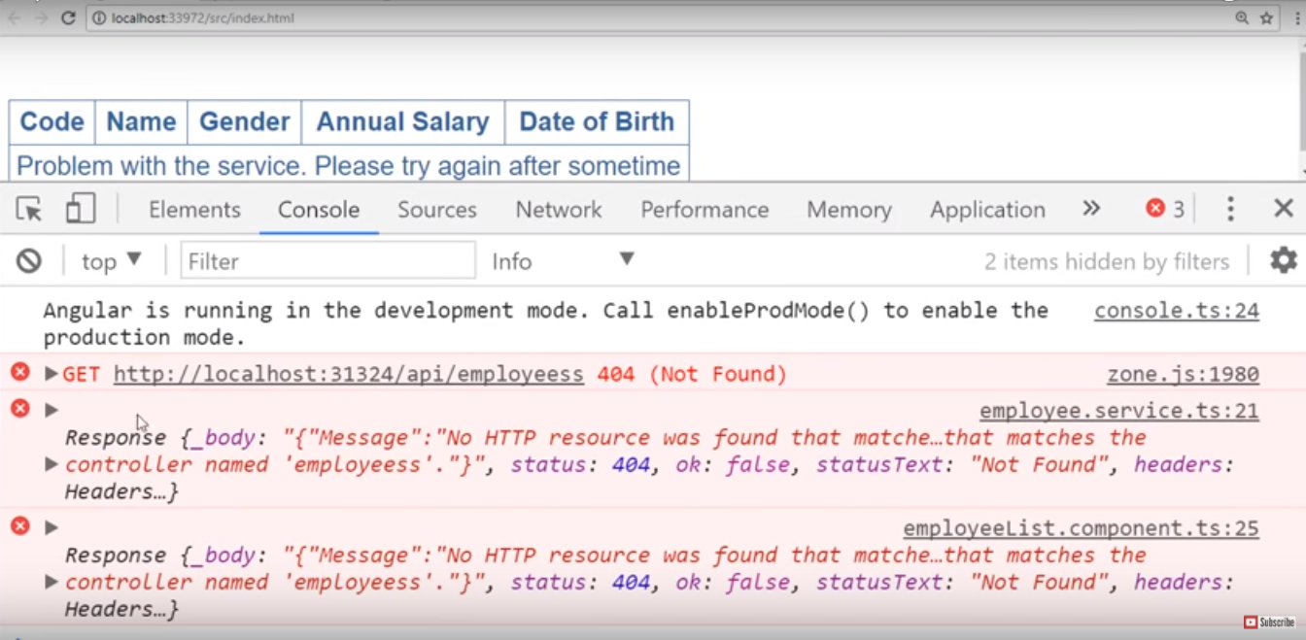

**So , to handle errors we have did changes within our employee service.**

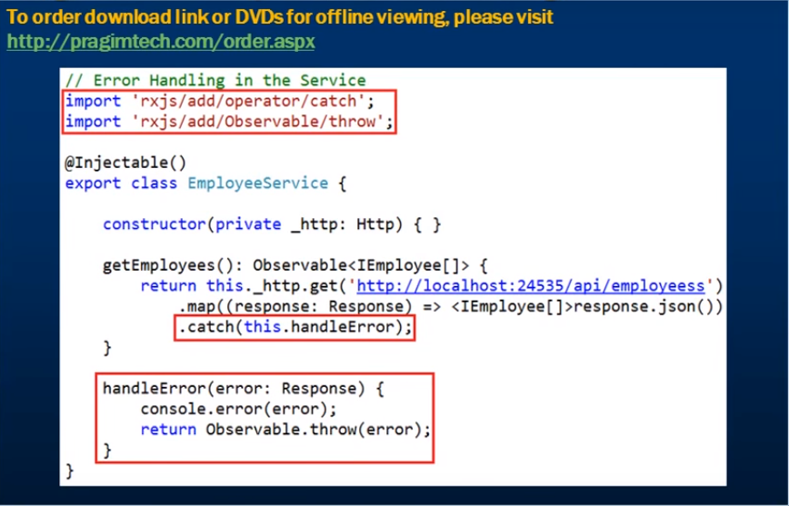

**Below are the changes for employee list component.**

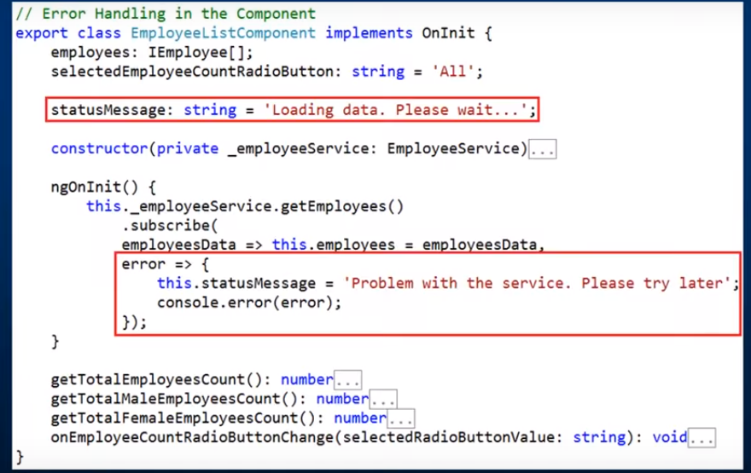

**Why Dependency Injection: -**

Let’s say to build a computer, we might need several objects processor, ram , hard disk drive etc. To keep our example simple, we need a processor object to build a computer. So, our computer and processor classes shown in the below screenshot.

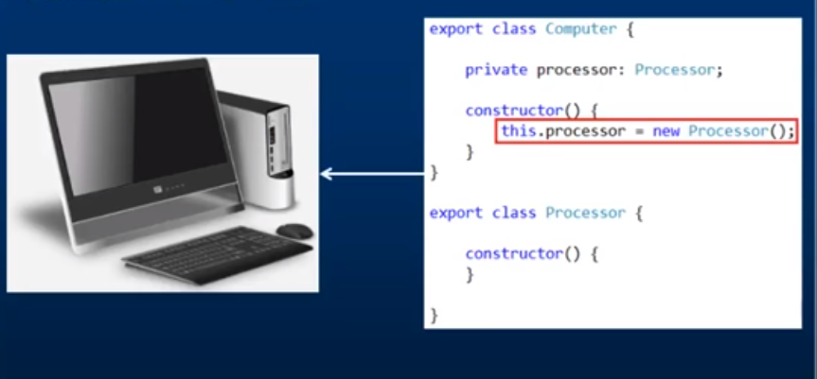

From the above screenshot, we are not using any dependency injection. Here, computer class has a dependency on a processor class. So, to build a computer we need processor object and computer class itself is creating a processor object using the new keyword. But there are few fundamental problems with the above piece of code , so let’s understand what are the problems are and how dependency injection solves the problem. This code is difficult to maintain overtime and why this code is difficult to maintain lets check.



If we look at the computer class has the dependency on processor class and here the computer class creating the instance of this dependency i.e.the instance of the processor class itself. Now, this processor instance is the local to this computer class .So ,we can not use this the processor instance data and logic to other objects.Finally , this piece of code is hard to unit test.

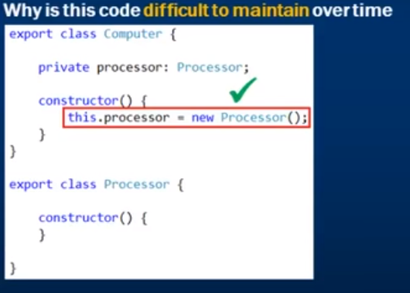

Notice, from the above screenshot the processor class constructor does not have any parameter and within the computer class to create an instance of processor class we are using its empty constructor. So, everything works, and no compilation error occurs. Now, we changed our requirement and add parameter to the processor class constructor. The moment we make this change the computer class breaks because we are creating an instance of a processor class using its empty constructor and at the moment the processor class does not have any empty constructor. To create an instance of a processor class we suppose to provide a value other wise we will get error. So, every time the processor class changes the computer class also need to change. And, here we have shown dependency on one object i.e. processor. However , apart from processor object there are other objects where the computer class do have dependency. If anytime this dependency change computer class may also need to change. Hence this code is difficult to maintain over time as shown in the below screenshot.

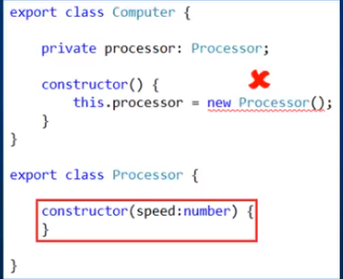

Note :- If any external source can create instance of processor class and give it to computer class then the problem can be resolved .This is what exactly what dependency injection does.

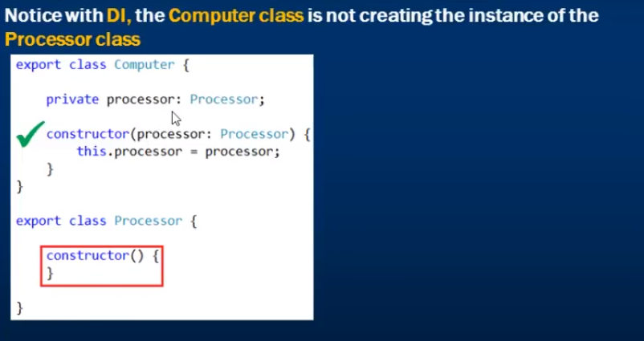

In the below screenshot, when the dependency changed the computer class did not changed. This is what dependency injection does.

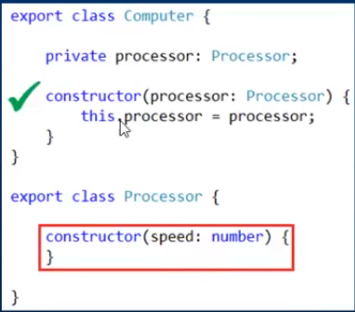

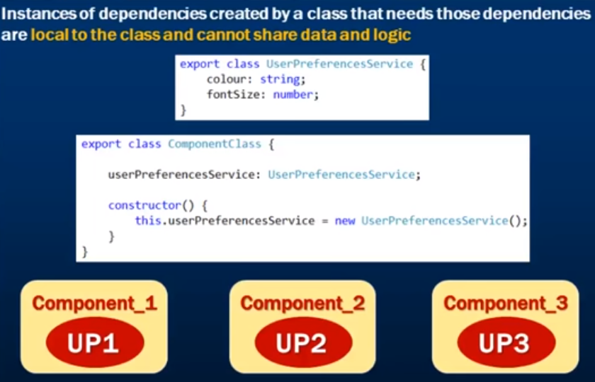

In the above screenshot, if we have 10 components we end up creating 10 instances of the service i.e.one for each component. That instance is local to that component which has created it. The data and functionality cannot be shared by other components.

However, Dependency Injection is going to solve this problem.

Now, Let’s have a component called component_1 which needs an instance of user preference service. Now the component itself is not going to create the instance of that service because we are using dependency injection. So, the angular injector is going to create and inject the service instance into component_1. So the first thing the angular injector is going to do is that you need a user preferences service and let me check if we have already instance .In this case , it doesn’t because this is the first component that has requested it.So the angular injector is going to create an instance of user preferences service and inject that into component_1.We have another component i.e.component_2 which needs an instance of user preference service. So, the angular injector does the same check to eye already have an existing instance. In this case, it does which going to provide that existing instance to component_2.Along the same lines if another component requires the user preference service instance its going to inject that same existing instance into that component as well. The same service instance is being shared by all the components. So, sharing data and logic becomes much easier.

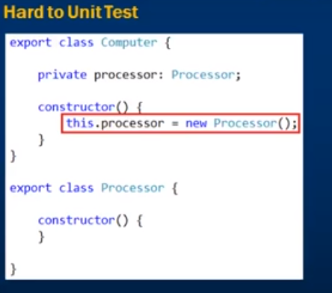

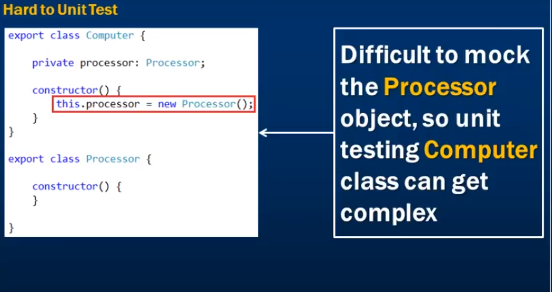

However, in real world, a dependency can have many other dependencies, so its very difficult to mock these dependencies for unit testing. But with DI it’s very easy to mock these dependencies. This is one of the greatest benefit of dependency injection.

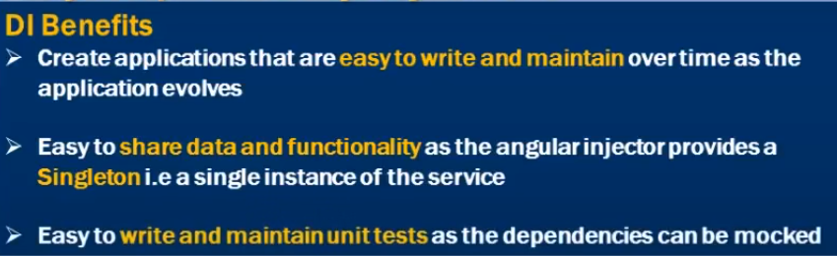

**Angular dependency injection: -**

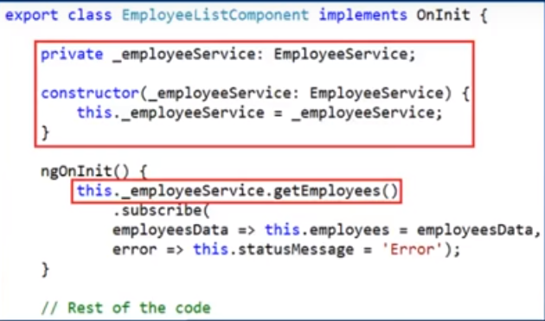

In the above screenshot , we can reuse employee service to get employee data from another component.Now , to be able to use this employee service within our employee list component we need an instance of this service , so we can use this instance to call get employees method os this service which returns the list of all employees.But if we see the above piece of code we are not creating instance of employee service anywhere.All we are doing here is created a private variable of type employee service and in the constructor we have a type employee service parameter and then we are initializing the class private field with the constructor parameter which we are using that private field as an instance to call the getEmployees() method of the service .We are not using the new keyword anywhere here to create an instance of the employee service.So , naturally , how we are getting instance of this employee service.Now , one thing we can be sure EmployeeListComponent itself is not creating instance of this employee service.By looking at the code we can understand is the constructor is being with the employee service instance and using that instance of assigning private field and we are using the private field to call the getEmployees() method.We know when the instance of EmployeeListComponent is created its constructor get called .So , someone at the constructor is creating and injecting an instance of this employee service and that instance is being used to assign its private field and we are using this private field to call the getEmployees() method of this service.

So the queston is who is creating and providing that instance to the constructor of our EmployeeListComponent .The answer is the angular injector.When the EmployeeListComponent is created angular injector creates an instance of this employee service and injects that into the constructor and within that constructor we are assigning this injected instance to this private field and we are using this private field to call the service.

So , how the angular injector know about the employee service.The answer is shown in the below screenshot.

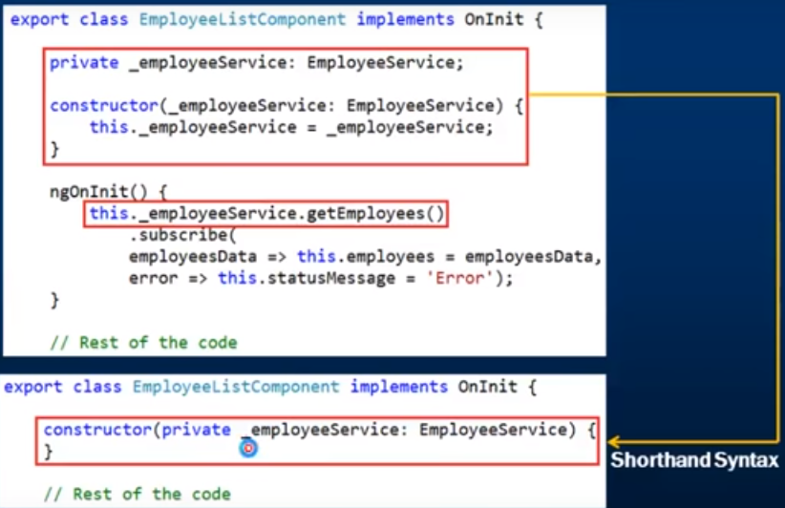

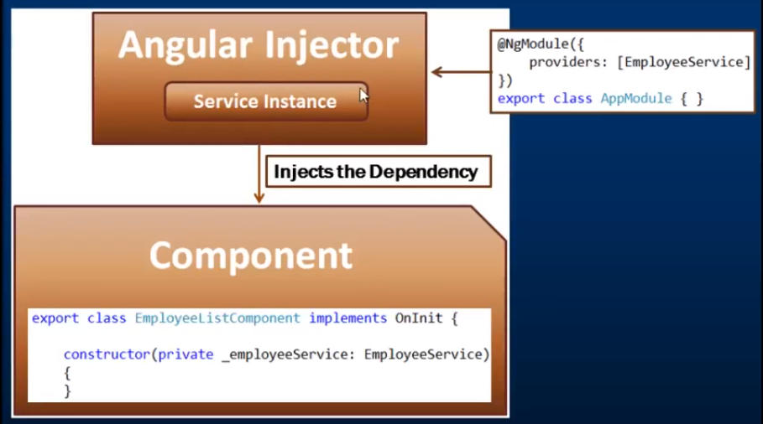

How , does angular injector know about employee service.

We need to register our service with the angular injector . In order to register we either provide providers property of ngmodule decorator or component decorator.This means we can register a service with the angular injector at a component level or module level.

If we comment the provider property the angular injector does not know about our employee service .So it will not able to create instance and inject that into our employee list component.The error message that we receive as shown in the below screenshot.

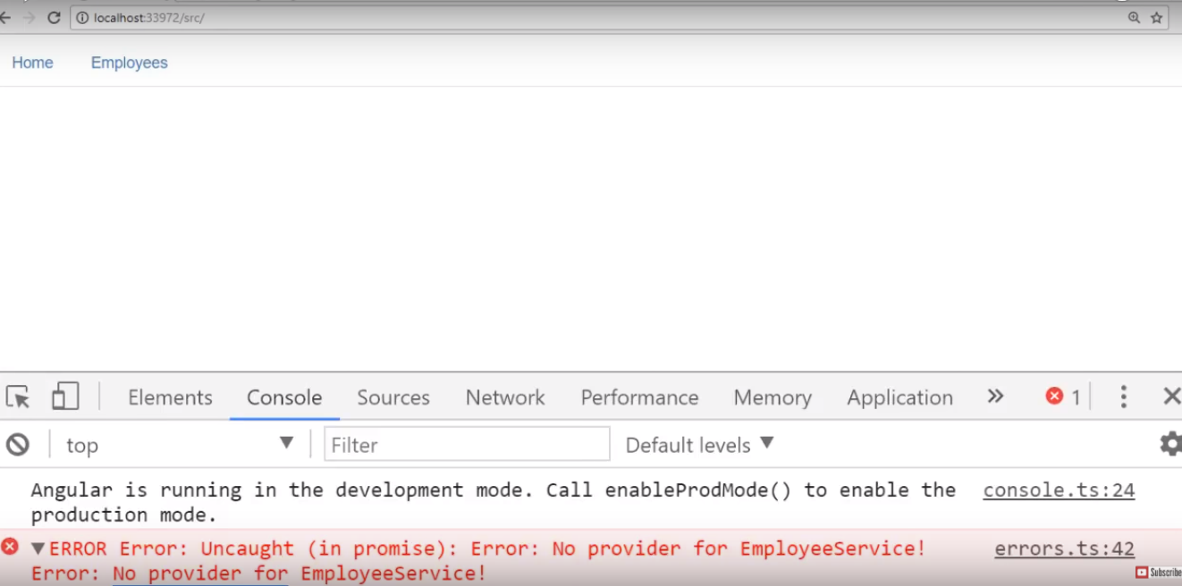

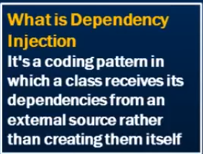

**Angular Singleton Service:-**

One of the benefits of dependency injection is that it allows us to share data and functionality easily as the angular injector provides a **Singleton**i.e a single instance of the service.



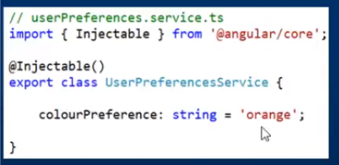

how we can use Angular services and dependency injection to create a **Singleton**i.e a single instance of the service which enables us to share data and functionality across multiple components in our application

Create a simple UserPreferencesService. Add a new file to the "employee" folder. Name it "userPreferences.service.ts". Copy and paste the following code 

import { Injectable } from '@angular/core';

@Injectable()

export class UserPreferencesService {

    colourPreference: string = 'orange';

}

Notice this service has a single property "colourPreference" which is defaulted to "orange". We want to retrieve and use this colour in both "HomeComponent" and "EmployeeListComponent". Notice the textbox displays the default colour (orange) and background is also set to orange. Also both these components should have the ability to set the "colourPreference" property of the service to a different value using the textbox.

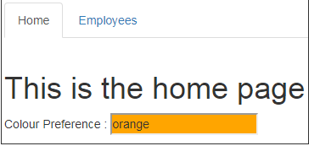

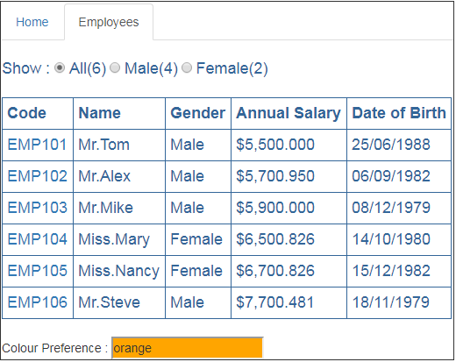

Modify the code in home.component.ts file as shown below. The code is commented and self-explanatory.

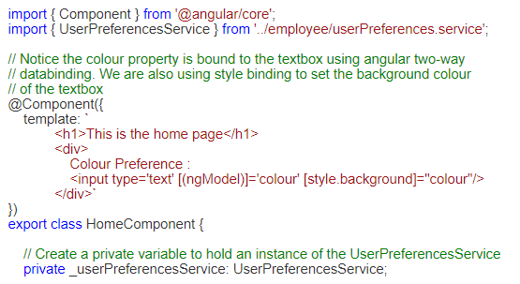

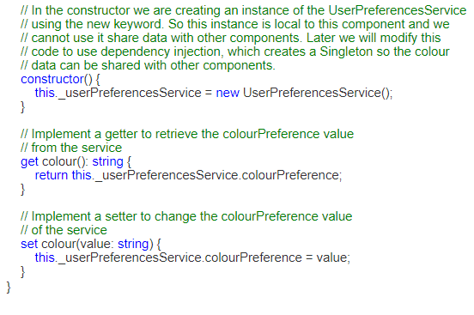  
Now we need to make similar changes in "employeeList.component.html" and "employeeList.component.ts" files. First make the following change in "employeeList.component.html"   
  
Include a <div> element after the table in the file. These are the similar changes we made in the inline view template of HomeComponent.   
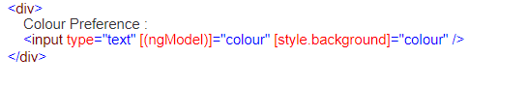

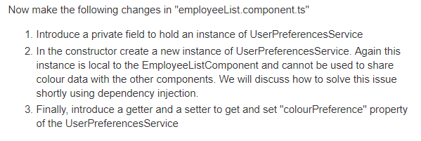

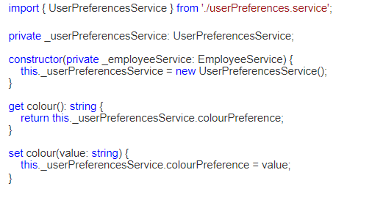s

Now run the application and notice that on both "HomeComponent" and "EmployeeListComponent" you will see the service colourPreference property default value "orange" displayed in the textbox. The background colour of the textbox is also set to "orange" as expected.  
  
It looks like the "colourPreference" property of the service is being shared by both the components. But that is not true. Since we are using the new keyword to create an instance of the UserPreferencesService, the instance created in each component is local to that component. Let's prove this.  
  
Introduce a constructor in UserPreferencesService. Notice in the constructor we are logging a message to the console stating that a "New Instance of Service Created".

Here is the code in "userPreferences.service.ts"

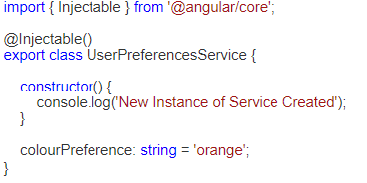  
Run the application again and launch browser developer tools and click on the Console tab. Notice in the Console you will see the message - "New Instance of Service Created"  
  
Now click on "Employees" menu. This will take you to EmployeeListComponent. Take another look in the "Console" tab, you will see "New Instance of Service Created"logged second time. So this proves each component is creating an instance that is local to that component and sharing data using these local instances is not possible.

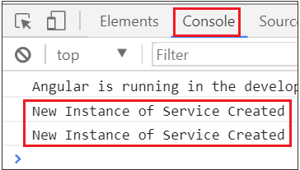

Now let us see what happens when each of the components change the "colourPreference" property value of the UserPreferencesService. Navigate to the "HomeComponent" and type "yellow" in the textbox. Notice the background colour of the textbox is changed to yellow as expected.

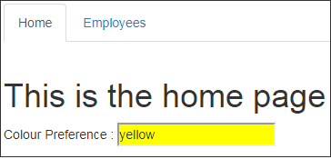

Now navigate to "EmployeeListcomponent" by clicking on the "Employees" tab. Notice the "colourPreference" property value is still orange. This is beacuse when we navigate to EmployeeListComponent it has created a new local instance of UserPreferencesService and the default value "orange" is being used.

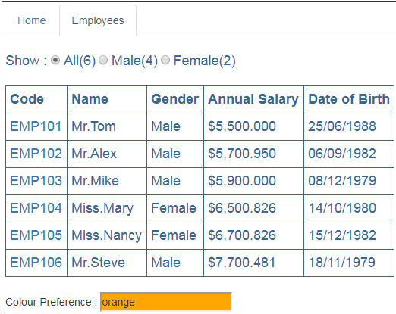

At this point navigate back to the HomeComponent, notice the "colourPreference" property value on the HomeComponent is also "orange" now. This is because when we navigated away from the HomeComponent the previous local instance of the UserPreferencesService it has created is destroyed and when came back to the HomeComponent it created another new local instance of the UserPreferencesService and we got it's default colourPreference property value which is orange.

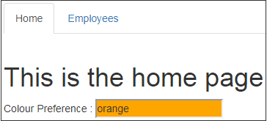

So bottom line, because each component is creating a local instance of the UserPreferencesService we are not able to share data i.e we are not able to see the changes made by one component in the other component.  
  
Now let us see **how to create a Singleton** i.e a single instance of the UserPreferencesService and use that single instance to share data (colourPreference property value) between the 2 components (HomeComponent & EmployeeListComponent) using dependency injection.  
  
Remember the 2 steps to use dependency injection.   
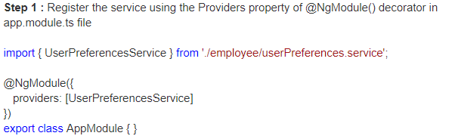

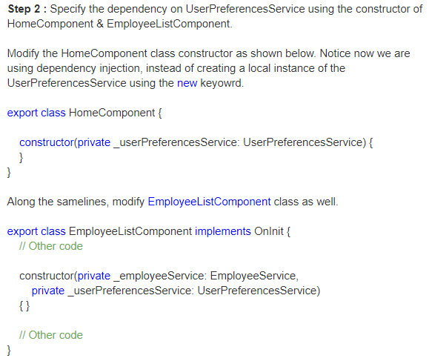  
With all these changes in place, run the application one more time and navigate to HomeComponent. Notice we have the default "colourPreference" property value orange. At this point change the colour in the textbox to yellow. Notice the background colour changes to yellow as expected.

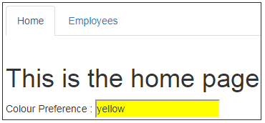

Now navigate to the EmployeeListComponent. Notice we see the yellow colour which the HomeComponent has set. Also notice in the "Console" table of the browser developer tools, this message (New Instance of Service Created) is logged only once when we navigate between HomeComponent and EmployeeListComponent which proves that only a single instance of the service (ie. a singleton) is created. This singleton enables data sharing between both the components. That's how we are able to see the changes made by one component in the other component.

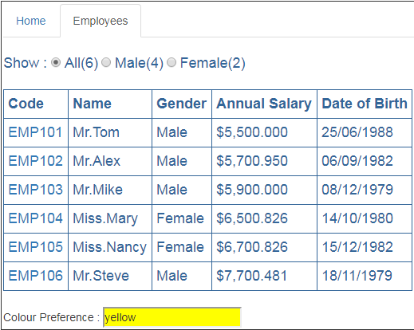

So bottom line, with dependency injection it is easy to share data and functionality as the angular injector provides a Singleton i.e a single instance of the service.

**Angular Injector: -**

Lets have a component which have dependency on a service and needs a instance of it.

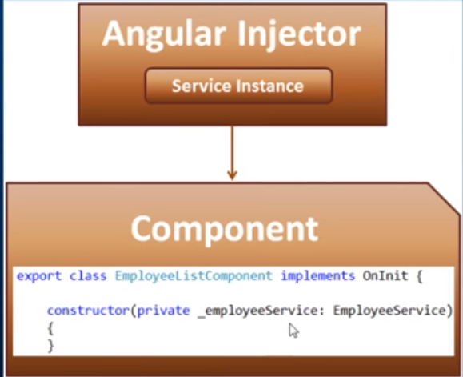

In the above screenshot , it has the EmployeeListComponent over here which has the dependency over employee service .Now to use dependency injection .To use dependency injection first register our service i.e.employee service to angular injector and then within the component we specify a dependency over service using constructor parameter like this.When an instance of this component is created the the angular injector is going to inject an instance into this component.In angular 1 we only have one global injector but in angular 2 we have hierarchy of injectors tree as shown in the below screenshot.

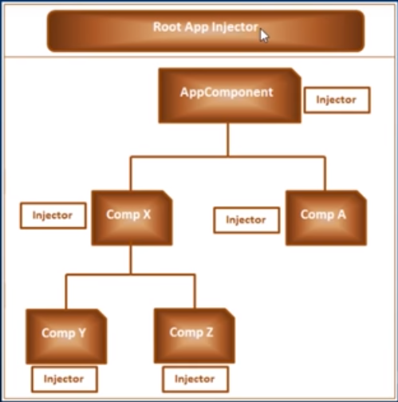

We have root injector at the root application level and tree that parallels the application tree components. We have root injector and injector at every component level.Now for these injectors to be able to inject an instance of a service dependency , we will first register our service with these injectors.The availability of the service for injection depends on to which injector we have registered our service.For example , if we register our service for root injector then the service will be available for all components across our entire application including the lazy loaded module component.If we register our service with the injector at the app component level i.e.root component level then that service is available for injection to all components except lazy loaded module components.If we register our service with the injector at component A level then that service is available for injection only to component A and not to x, y and z.If we register our service with the injector at component x then that service ia available for injection x,y and z and not to component A.These are shown in the below figure.

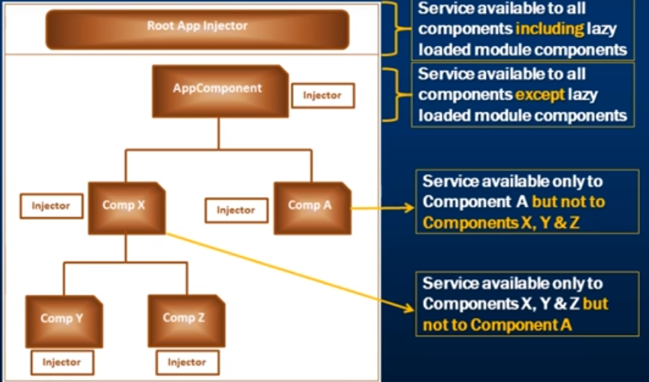

We have our service register at component x level and lets say component z need an instance of that service .So first angular is going to check the service registered at z and the answer is no.So that request is going to bubble up with parent component x.

**How we can register our service for dependency injection with these injectors in Angular**

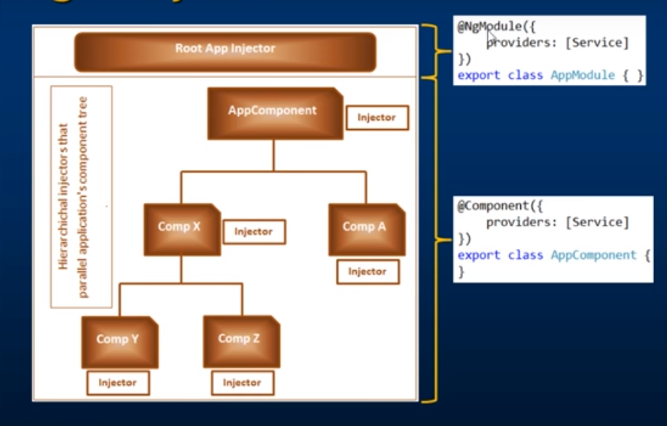

To register our service with the root app injector just use the provider property of ngModule decorator .We know every angular module will have a corresponding class and that class will be decorated with ngModule decorator to turn it into an angular module. So , just use the provider property of ngModule decorator to register your service with root app injector. On the other hand , if you want to register your service with an injector at a specific component level then just use the providers property of the component decorator. Now , we know every angular component has the corresponding class and that class will be decorated with @Component decorator. Just use the provider property of @Component decorator to register your service within injector at its specific component level. Let’s look at all these in action now.

Now, the userPreferencesService to be available in both home component and employee list component we registered it within root app injector by using the provider property of ngModule decorator.

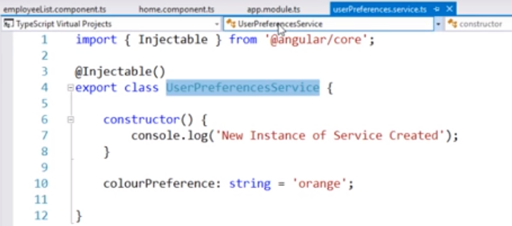

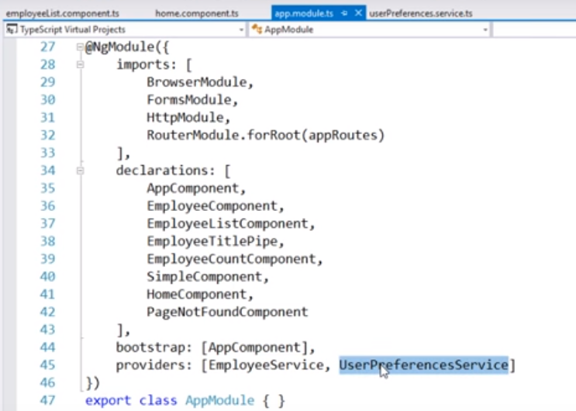

So , if we look at our root module which is app.module.ts using the provider property to register our userPreferencesService with the root app injector.So , whenever the home component or employee list component needs an instance of it the root app injector is going to provide that.Therefore , everything works as expected.Now , lets try to register our UserPreferencesService with home component and to do that we can use the provider property of the @Component decorator of that component class.Lets do that.

First , remove the provider from the root module as shown in the below screenshot and then go out home component and includes the provider property within the @Component decorator.

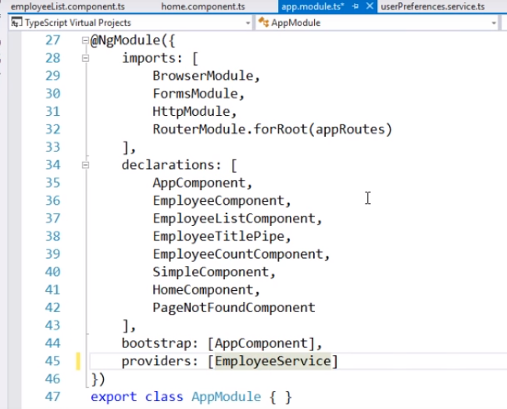

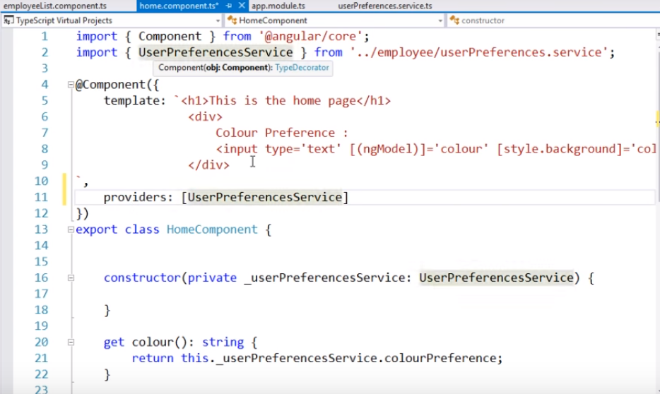

And if we look at the employee list component which is not having the provider property as shown in the below screenshot.So at the moment we have registered our service with the injector at the home component level.Therefore , the service will be available at the home component and not for the employee list compoenent.And , when we navigate to the employee list component we will get the famous error i.e. no provider for user preferences service.

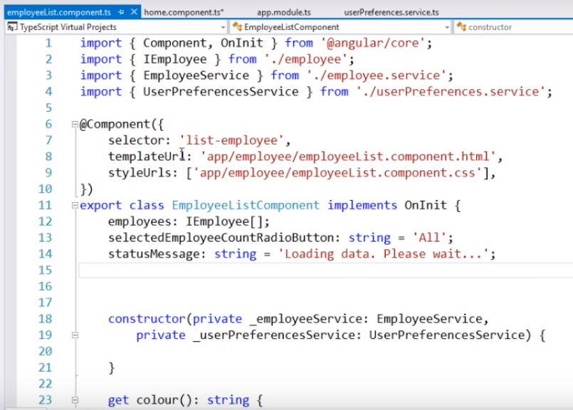

Now , save our changes and reload our web page and see the home component works as expected and when we navigate to employee list component it does not display anything .

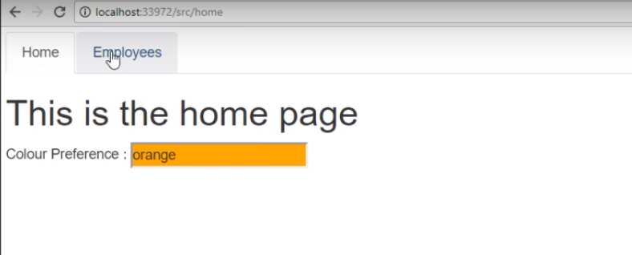

When we open the developer console , we will see the famous error i.e.no provider for user preferences service and we know the reason .

At the moment user preferences service registered with the injector at home component level.Now , our employee list component needs an instance of that service . So , angular is going to first ask its injector , do you have the user preferences service registered with you and the answer is no.So the request bubbles up to its parent i.e . the injector at the root compenent level which is app component and the answer again here is no.So the request further bubbles up to its parent and again here the answer is no.So , we get the famous error i.e.no provider for user preferences service.

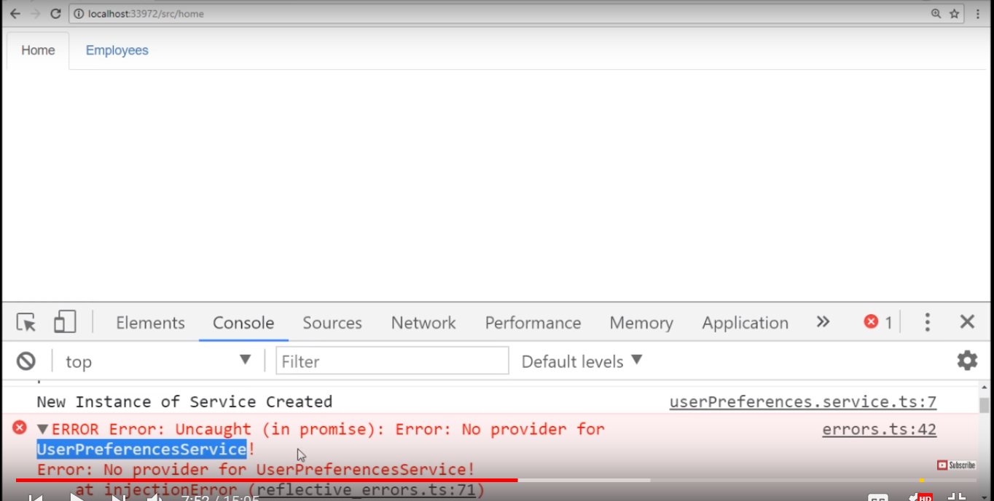

One way to fix this error is by registering its service again with the injector at our employee list component but that’s not very good thing to do because by doing so we are affectively regostering our service twice i.e. one with the injector at the home component level and second with the injector at our employee list component level.By registering the service more then one we no longer get singleton i.e. the single instance of the service .We don’t have a singleton then we wont be able to share data between these components.Thats actually prove that.So , we already have the user preferences service registered at the home component level and now lets registered that with the injector at employee list compoent as well by including the provider property with in the component decorator of our employee list component class as shown in the below screenshot and lets save our changes.

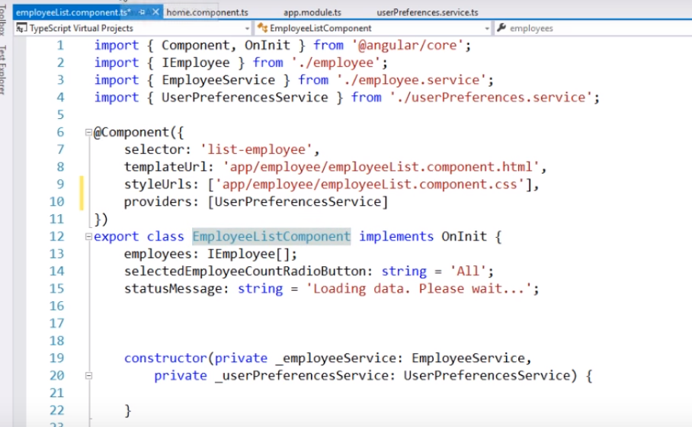

Now , reload our web page , see the home component works and employee list component also works as well.

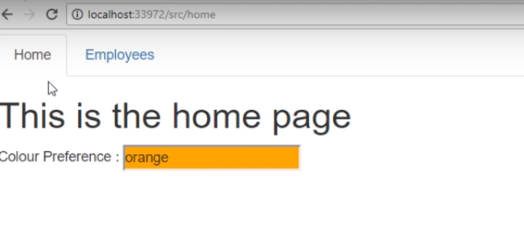

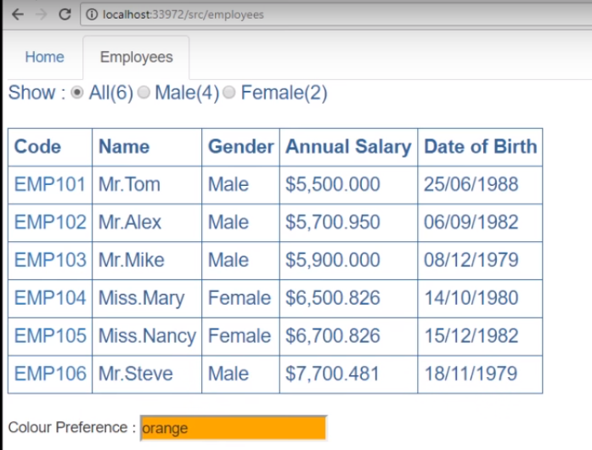

But the problem at the moment is we no longer get the single instance of the service as the service registered twice i.e.one with the injector at the home component level and second time with the injector with employee list component level.And this how it works.

The home component requires an instance of the service , under it is going to check with the injector at the home component do you have the service registered with you and the answer is yes.So , this injector is going to create an instance of the service and inject that into the home component and the same thing happen with the employee list component and this employee list component creates an instance of the service and first going to check with the injector at that component level , do you have the service registered and the answer in this case is yes.So , this injector is going to create a new instance of the service and inject that to the employee list component. Now we have two instances one is created by the home component level and another instance is created by the injector at employee list component level because we don’t have the singleton, so will not be able to share data. Thats actually proves that.

At the moment we are at the employee list component and we see the default colour which is orange as shown in the below screenshot.

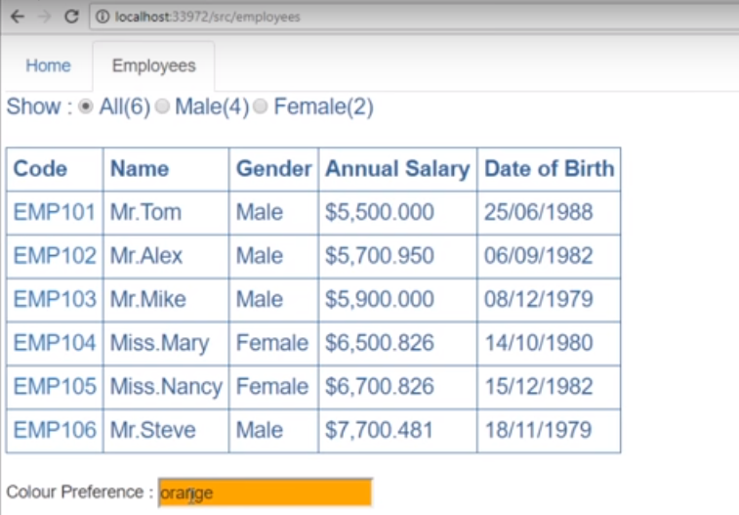Now , change this to yellow and if we have a single instance between home and employee list component then we navigate the home component and see this yellow colour and not the orange .But when we go to the home page we see the default colour orange .

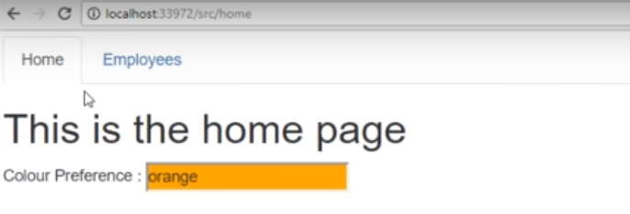

That’s because we have two instances of the user preferences service. One instance is provided by the angular injector at home component level and second instance if provided to the employee list component by the injector at that employee list component level. To properly fix this we may register our service with the injector at the parent component level. In our case , the parent for home component and employee list component is the root component i.e.app component.When we register our service at the root component then that service is available for injection to all components except lazy loaded module component .If you want your service to be available for all component including the lazy loaded module component the register your service with the root app injector. The general guidance for service registration is if you want to restrict your service availability to a specific component then register your service with the injector at the component level. And if you want your service to be available for all components then registerate with the root app injector using the provider property of @NgModule decorator.

Now , lets register our service with root injector .So , first remove our service registration from our employee list component by removing the provider’s property as shown in the below screenshot.

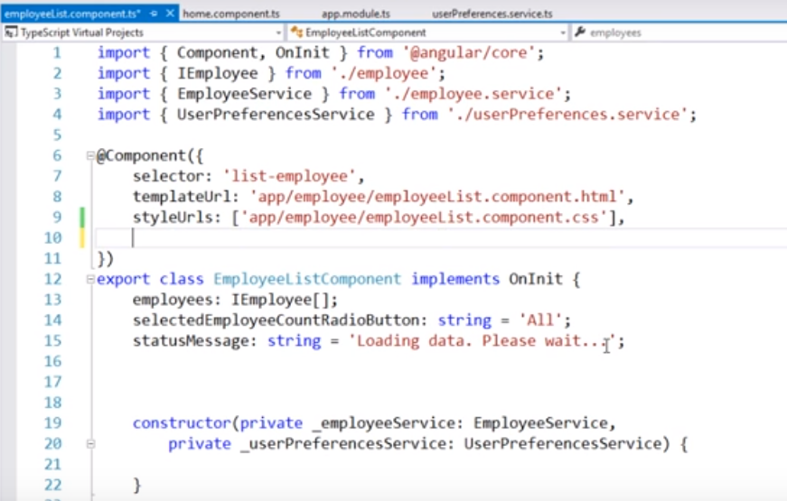

Lets do the same at our home component as well

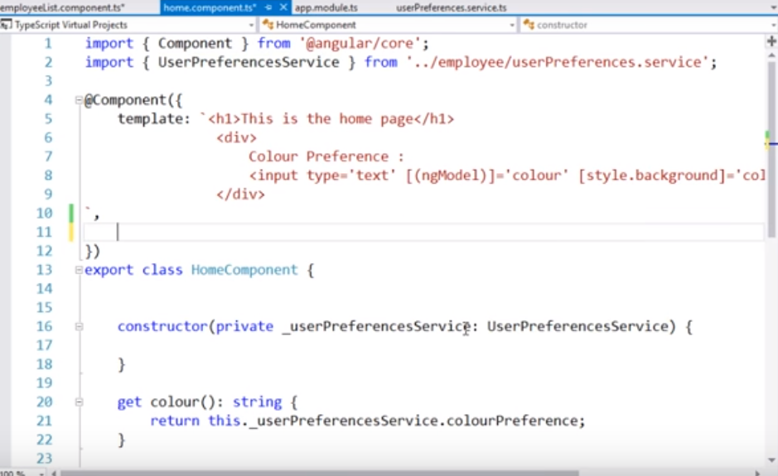

Lets register our service with the root injector.

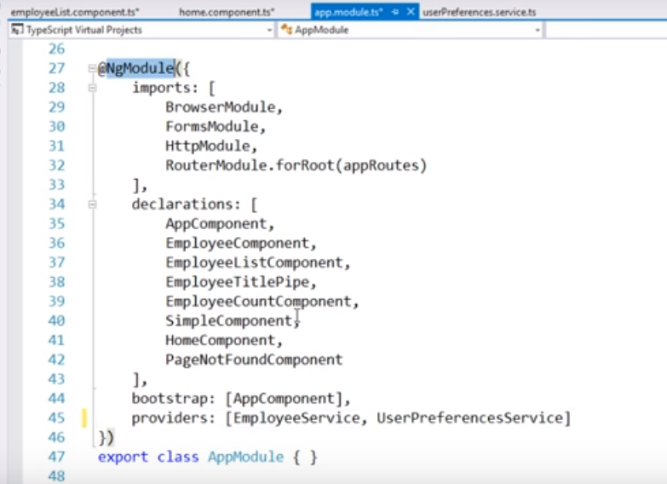

So , at the moment we have service registered with the root injector.So lets save all these changes and reload our web page . We will notice that at the home component we see the default colour which is orange as shown in the below screenshot.

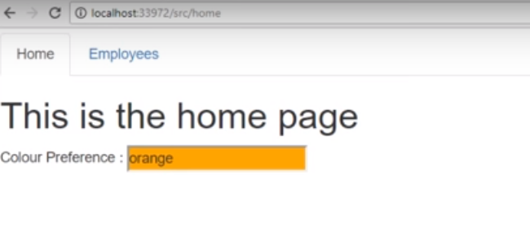

Now, change this to yellow as shown in the below screenshot

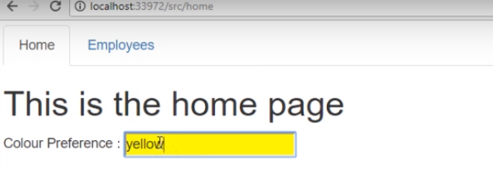

Now if we have a single instance being shared between home component and employee list component and when we navigate to employee list component we should see this yellow colour as shown in the below screenshot.

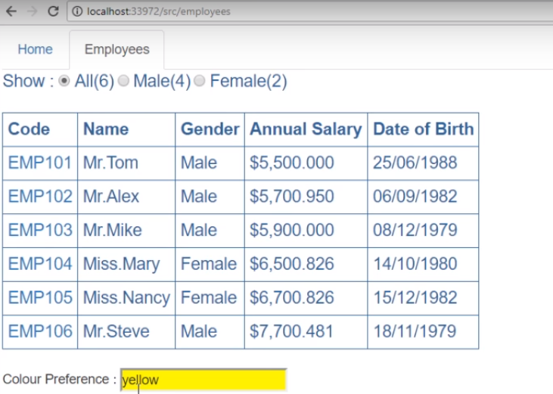

Now, if we come back to home then we see the same yellow colour.

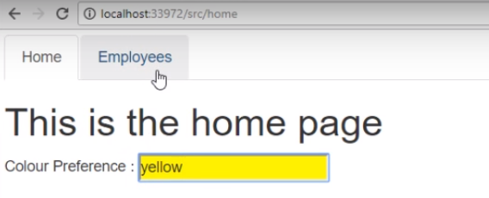

In the above case, a single instance is shared between home and employee list component.

**Angular Root Injector: -**

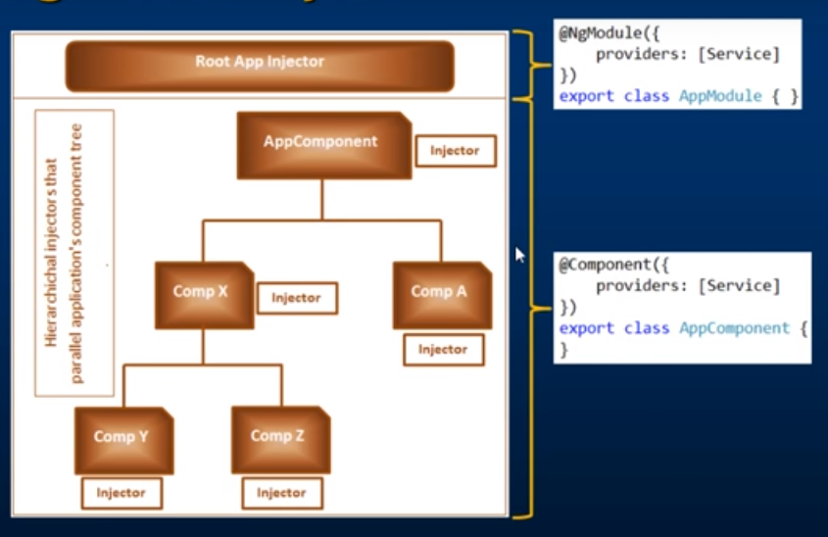

We have an root injector at application level and injector at any component level.To register our service with the root injector we use the provider property of @NgModule decorator and to register our service with the injector at specific component level we use the provider property of @Component decorator of that specific component class.

In real world application, it is obvious to have more than one module.

For example, take HR management system as shown in the below screenshot

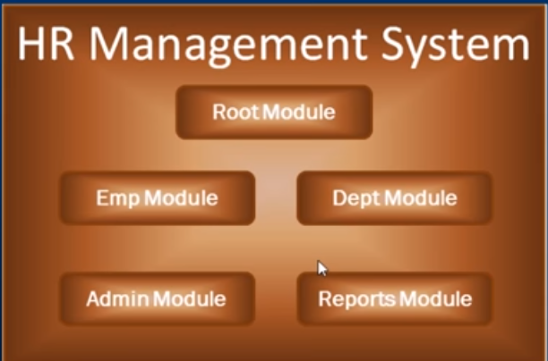

Create a test module and use that module @ngModule decorator to register our service with the root injector.

Add a new typescript file in the app folder and name the module as test.module.ts.

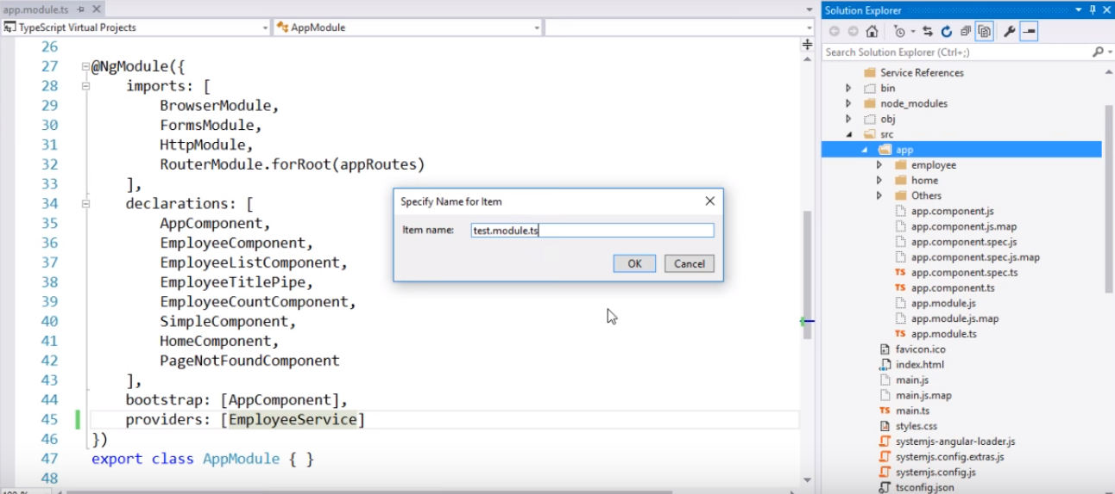

The below screenshot shows the test module created just like the component.

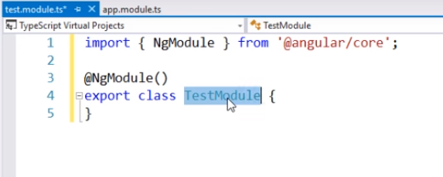

To turn this module as angular class we decorate this module with @ngModule decorator.

Now, let’s use the provider property of @ngModule decorator of this test module to register our user preferences service with the angular root injector. First, import the user preferences service and then we pass a object to the @ngModule decorator and set the provider property and to the array we pass our service which is user preferences service as shown in below screenshot.

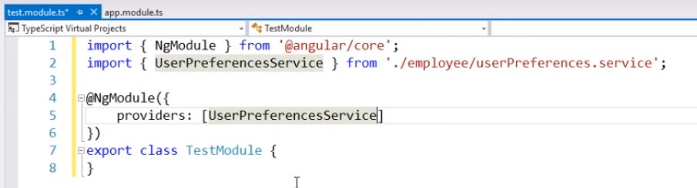

Let’s save all these changes and reload the web page. Notice the application is still not working and if we look at the error message we found the same error as shown in the below screenshot.

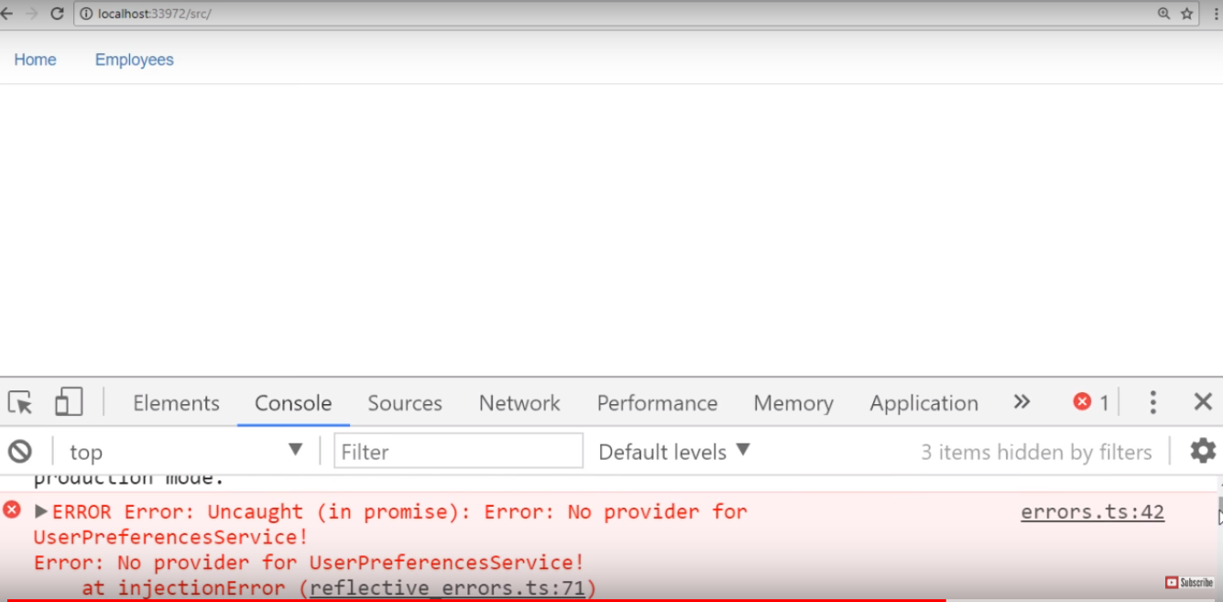

This is because we have just created the test module, but we are not using it anywhere. So, to make this use in the application import test module in the root application module.

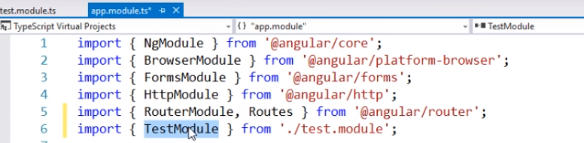

And, then just like how we have made this angular system module part of imports array. We also want to make our test module part of this imports array as shown in the below screenshot.

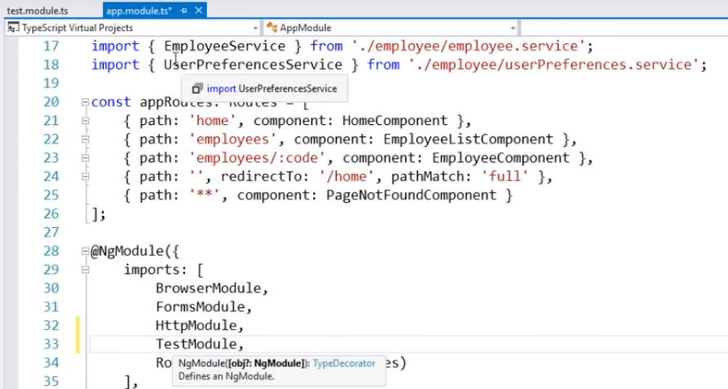

Let’s save this changes and reload the web page again.

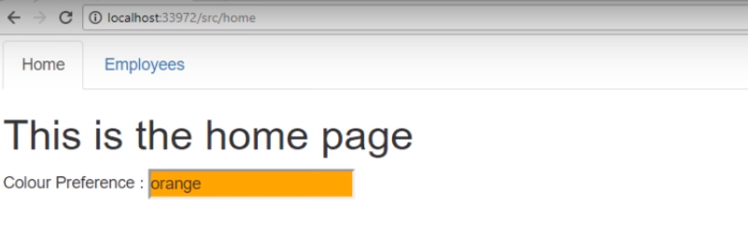

Here, our home component is working as expected.

**Promises in Angular 2: -**

In angular either we use promises or observables. In angular build in http service by default returns an observable. The angular built in http service by default returns an observable.

Notice, we have a method getEmployeeByCode() and this method is going to return that specific employee and to make a call to web server we are using the build in angular http service. We are using the get method for get request and look at what does the get method returns from the intelligence i.e. it returns an observable.

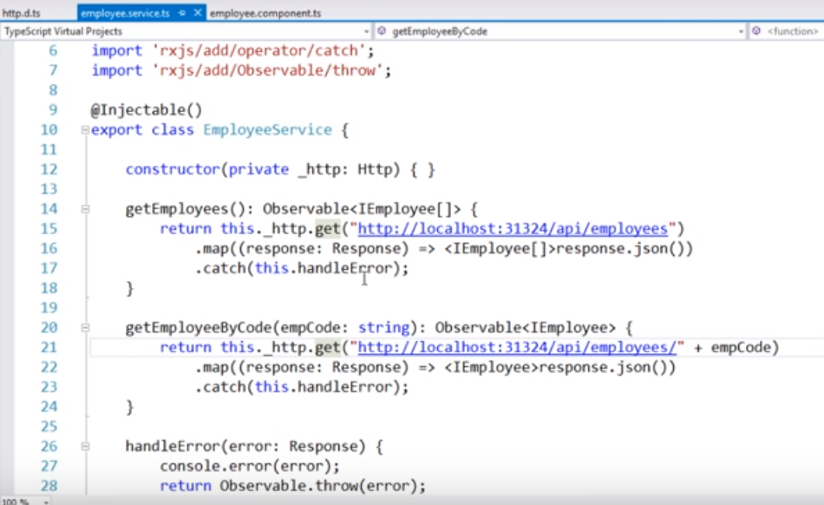

In order to return promises instead of observable, we have to modify getEmployeeByCode() method. The changes that we have to do is very straight forward. Please see the below screenshot.

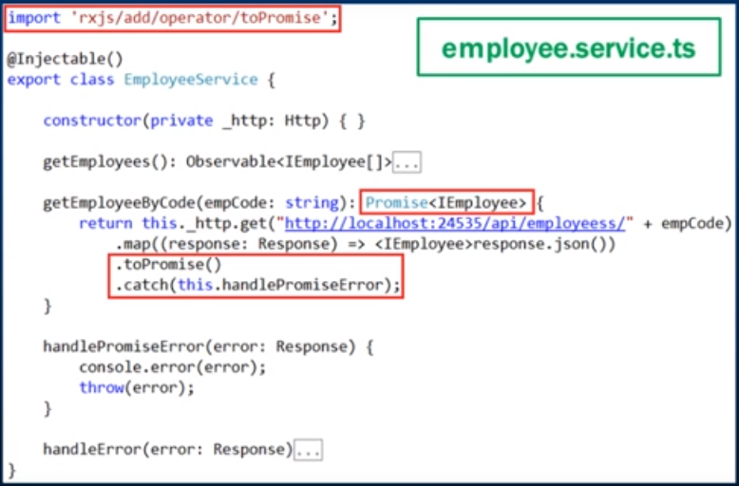

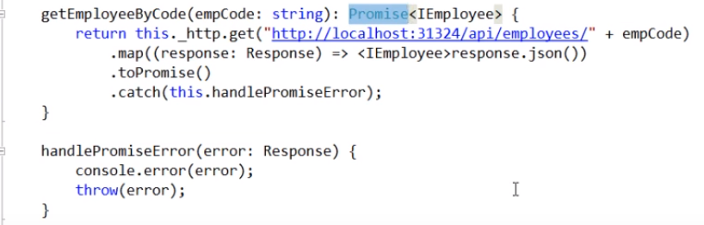

Now , let check the changes required with in the client code i.e. within our employee component where we are consuming employee service as shown in the below screenshot.

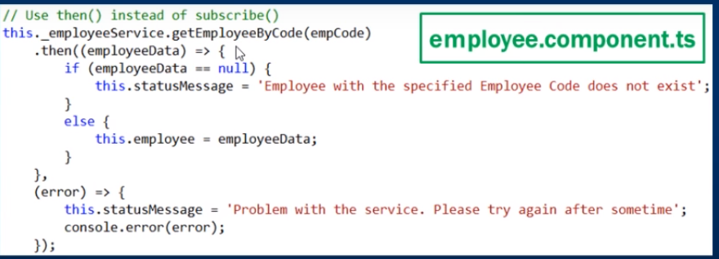

Notice here , we are calling getEmployeeByCode() method of the employee service.This method was returning an observable .But now we have changed it to return a promise.Within observable we use subscribe method to subscribe to the observable.Now , this method is returning a promise , so instead of using subscribe we use then() method i.e. the only change we have to do within our employee component where we are consuming getEmployeeByCode() method that returns a promise instead of observable.

Here, is our employee component where we are consuming getEmployeeByCode() method of the employee service.

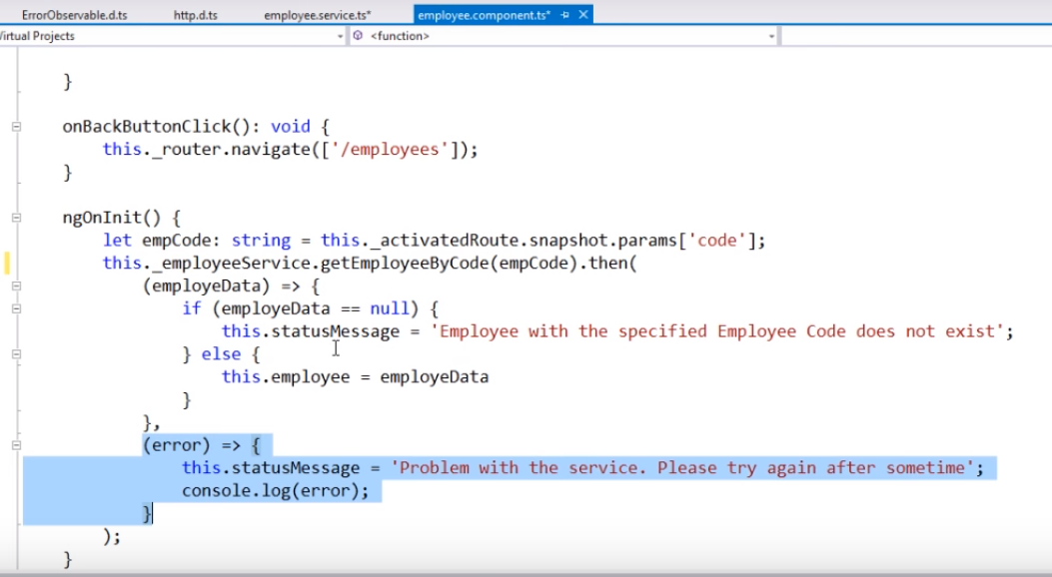

This is one way of doing this. There is another way as well. Instead of passing both the success and error call back functions to then() method like this we can use the catch method instead. Cut the error call back function and specify only success call back function to then method and use catch() method at the closing of then() method .

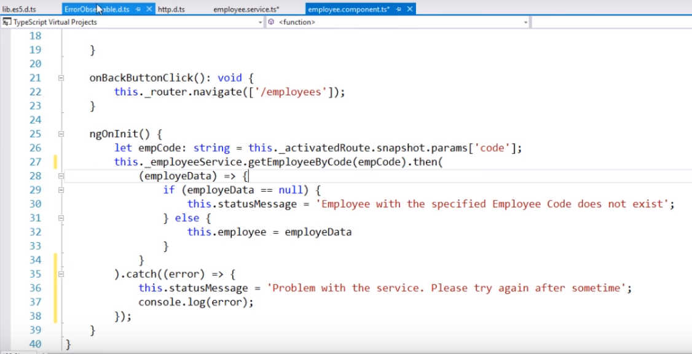

Lets save all these changes and reload the web page

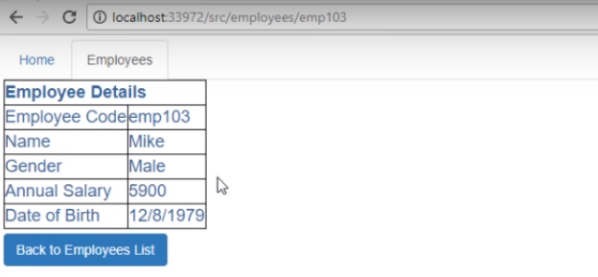

Now, we request for a employee whose employee code does not exit then we expect to see the below message as shown .

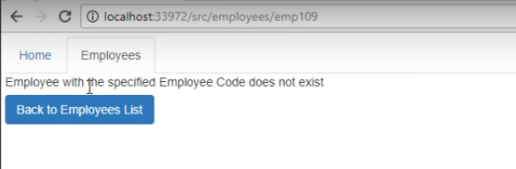

On the other hand, if there is any error processing the request then we will see the below message as shown and to raise an error we are going to use extra s in the url.

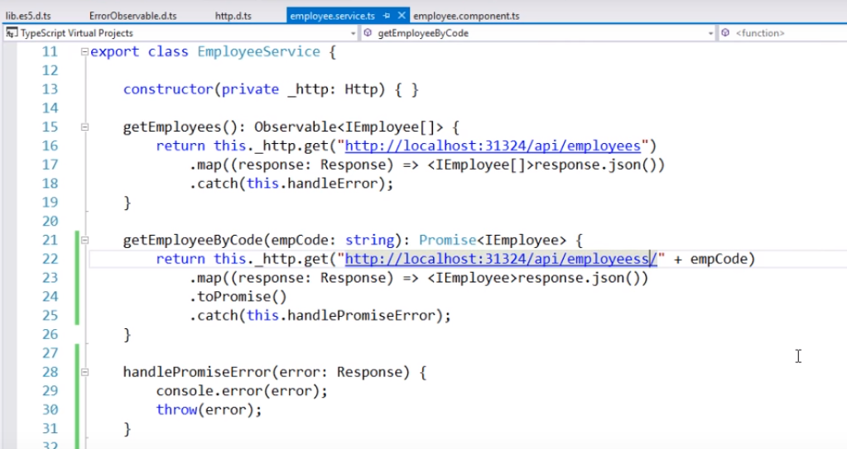

Reload the web page one more time and see the below message.

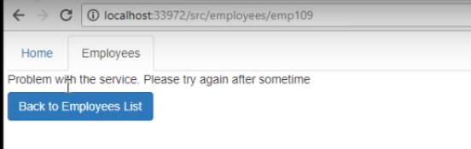

So, using a promise we can able to do all that an observable can do .

**Angular 2 Promises Vs Observables**

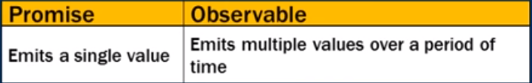

We can think as an observable like a stream which emits multiple values over a period of time and the same call back function is called for the each item emited.So , within observable we can use same API to handle a synchronize data whether that data emited as a single value or multiple values over a period of time.

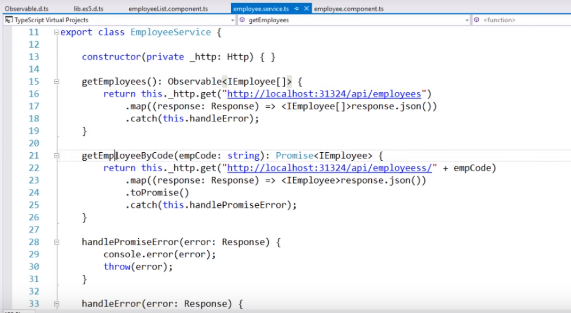

Notice that , this is the service which has got two methods get Employees() method which returns an observable and getEmployeesByCode() method which returns a promise. We are assuming getEmployeeByCode() method within our employee compoenent.

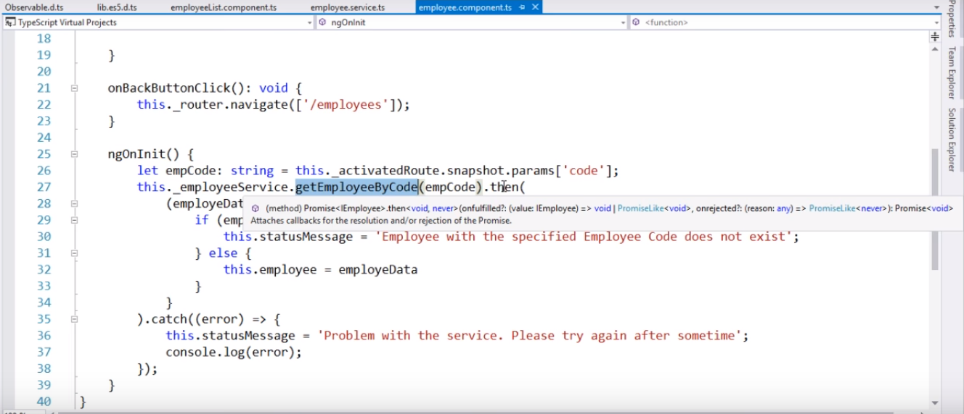

Notice, here we are calling getEmployeeByCode() method and to handle the promise we are using this then() method. Just go the definition of then() method and look at the definition right here as shown in the below screenshot.





It has got two parameters. The first parameter specifies the call back function to call when the promise is fulfilled i.e. when the request is completed successfully. And the second call back function is called when the promise is rejected. So, the promise we just have two parameters whenever the request is made. If the request is successfully completed, then the call back function that we have specified using the first parameter is called. If there is a problem, then the call back function is specified using the second parameter is called. Now, look at the other method that we have i.e.getEmployees() method which returns an observable. We are consuming this method within our employee list component and to subscribe to the observable we are using the subscribe method as shown in the below screenshot.

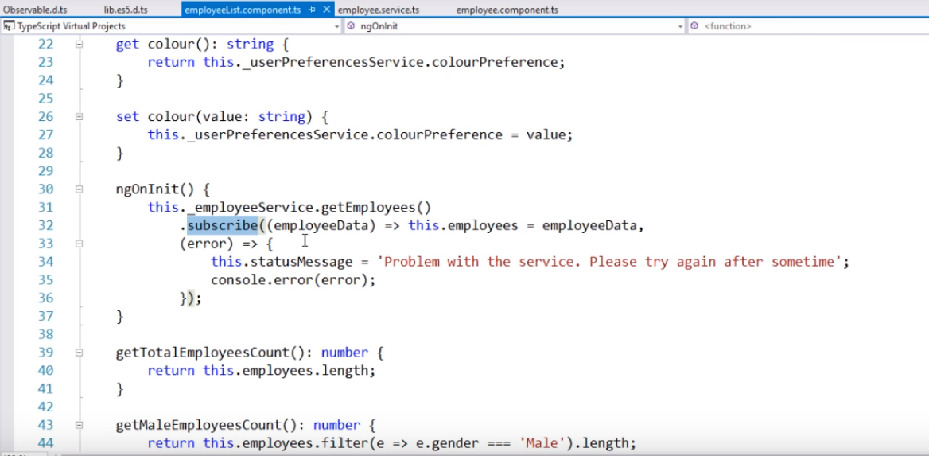

Lets go to the definition of subscribe method as shown below



It has got three parameters i.e.next,error and complete.Remember an observable and its multiple items for a period of time .So , for each item which is successfully emitted by an observable this is call back function that is called .



We have this next method and when the last item is emmited and again the next method is called .And once the last item is handled indicate that the observable is complete the above complete call back function is called.Thats why we have two parameters here i.e.next and complete .With a promise we only have one call back function which is onfullfilled.



And , if there is an error processing observable or the promise in a whether onrejected method is called and the observable this error method is called.In our case , the observable just emits a single item but if you have an observable emits multiple values over a period of time then the same call back function next is called for each item emitted.And when once the last item is emitted then the complete method is called to indicate that the observable is complete.



A promise is not lazy where as an observable is lazy. By lazy we mean the observable is not called until we subscribe to the observable.

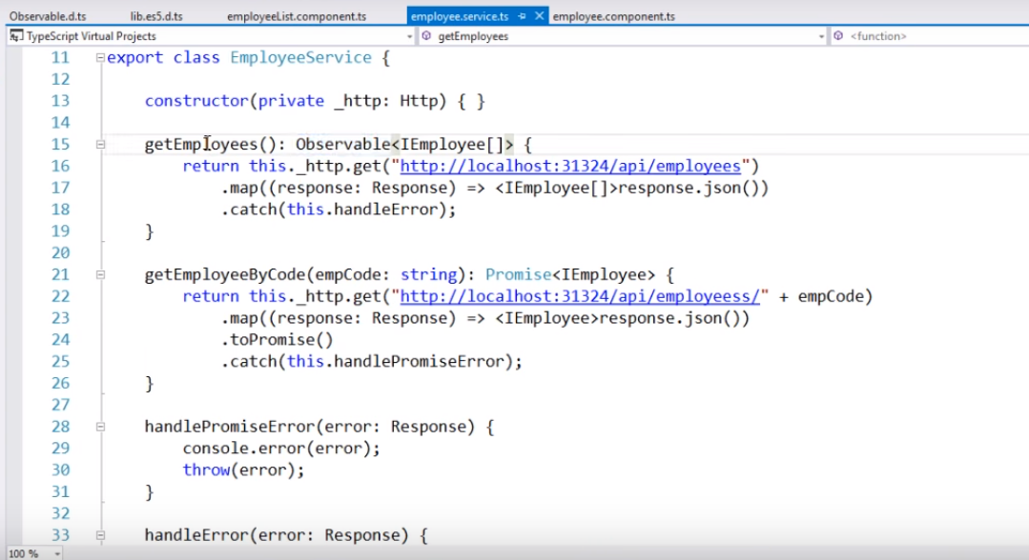

Within our employee we have getEmployees() method which returns an observable and we are consuming this method within our employee list component as shown in the below screenshot.

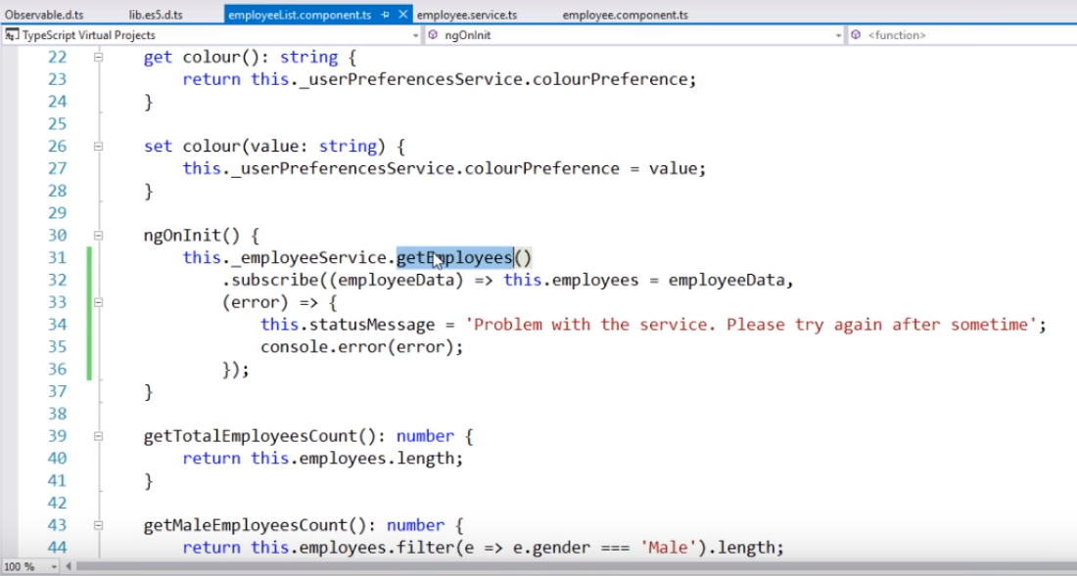

Notice, we are also subscribe to the observable using the subscribe() method. Since , we are subscribed we expect a call to be issued to our employee service over the network.

Lets , flip over to the browser and lunch browser developer tool by pressing f12 shown in the below screenshot.

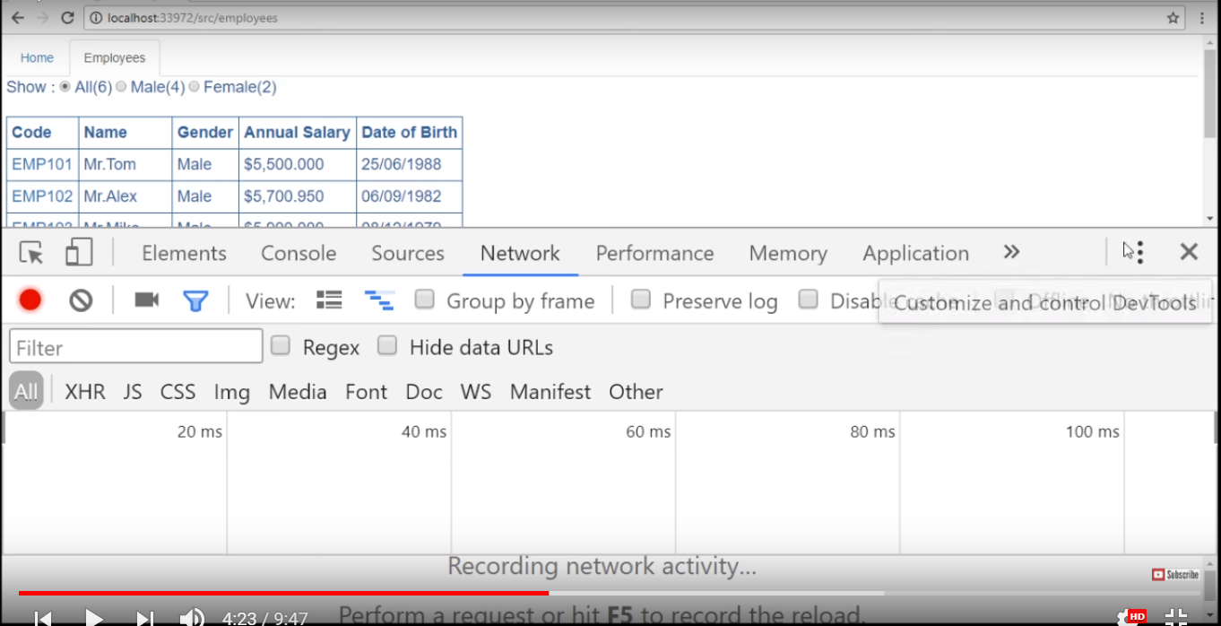

Lets dock the above window

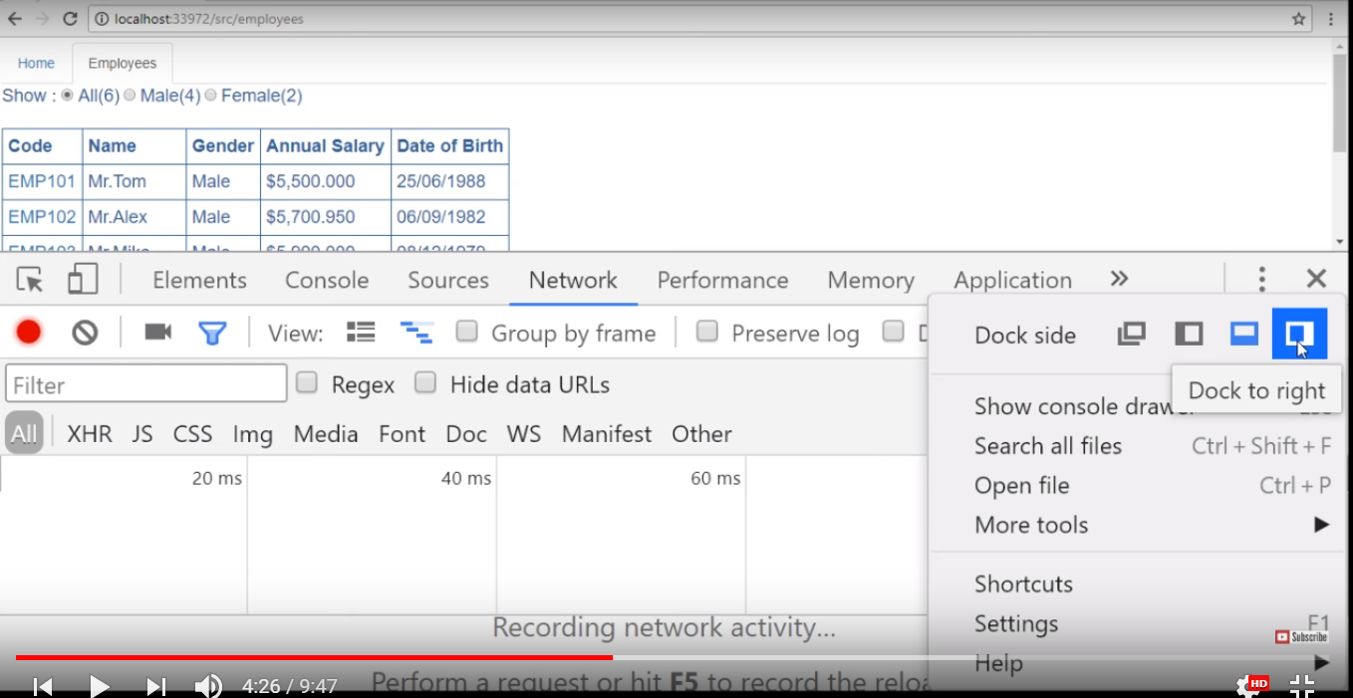

Dock the window to the right hand side and then re issued the request

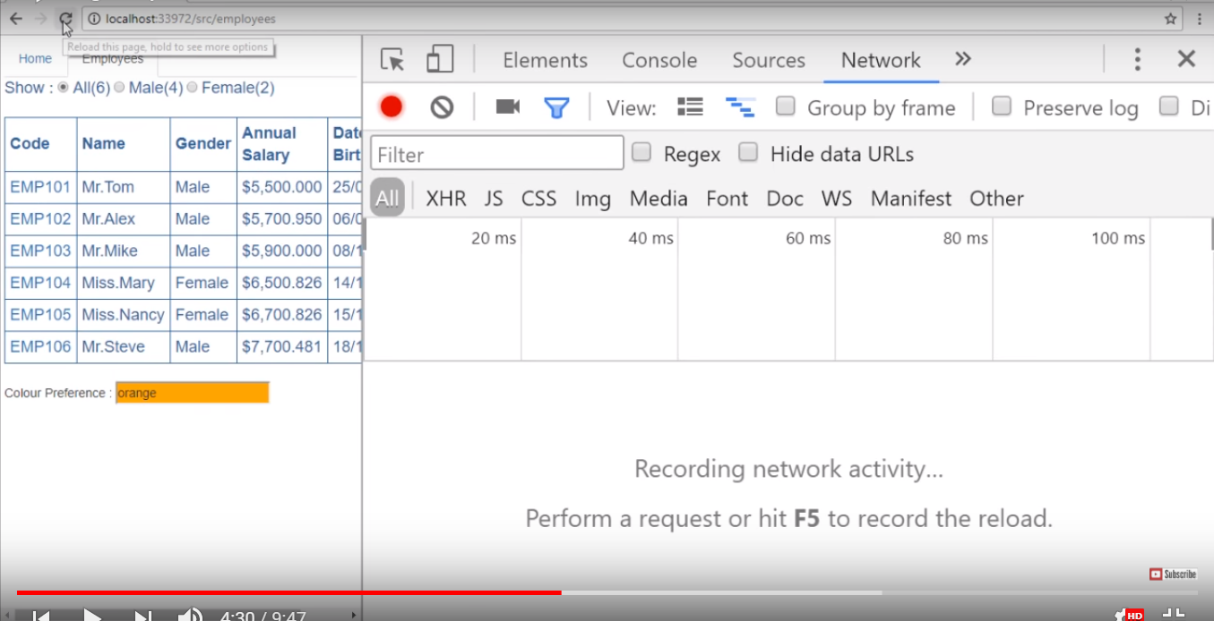

Notice , in the below screenshot we have several issued

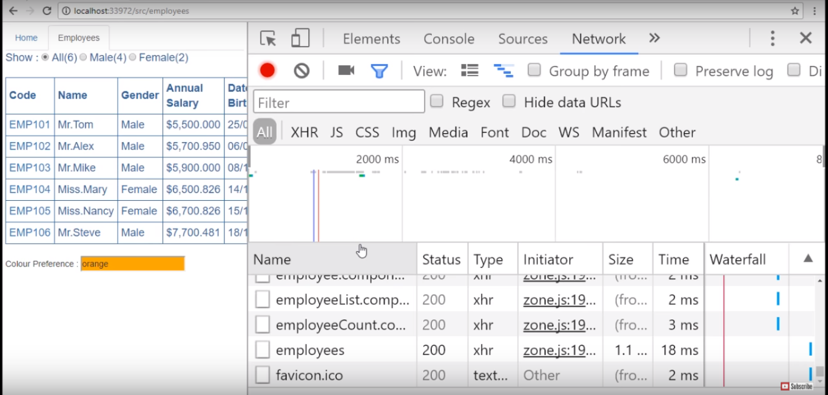

And , we know our web api service is at api/employees url

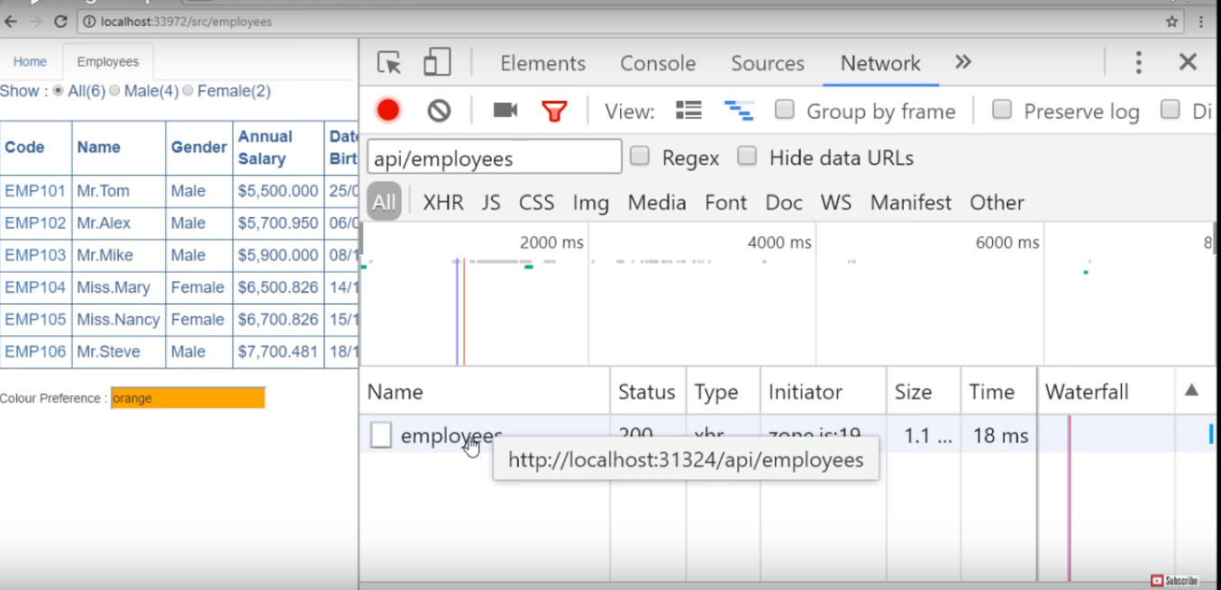

Once we click on the employees that is issued and click the preview tab to see the data returned by web api service and the this data is shown in the browser as well as shown in the below screenshot.

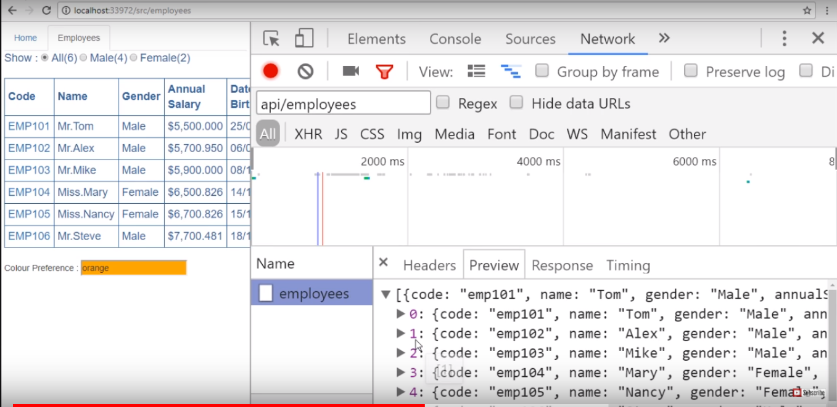

All this is happening because we are subscribed to the observable. Now, let’s comment the call as shown in the below screenshot.

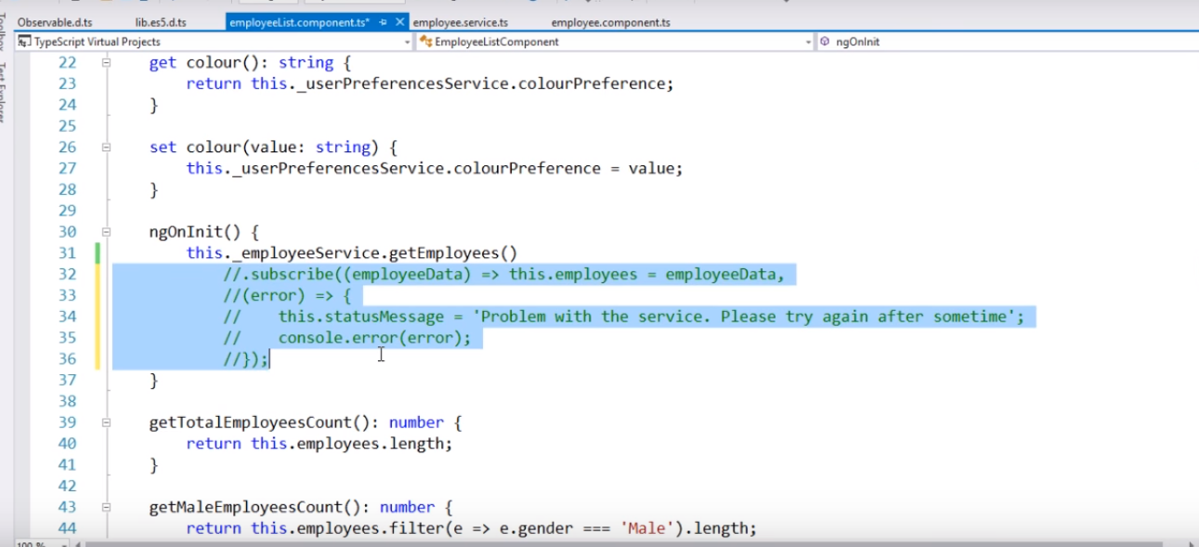

So , when we comment this as shown above then we are no longer subscribed to the observable. Notice that we still have the call to getEmployees() method of employee service. But since , we are not subscribed the call to that service will not issued. Lets flip over to the browser and still have a filter i.e.api/employees right there and then lets reload the web page.Notice , the request being issued but the records are not loaded because of the filter i.e.api/employees as the request are not issued to api/employees and we don’t see the employees data on the web page as shown in the below screenshot.

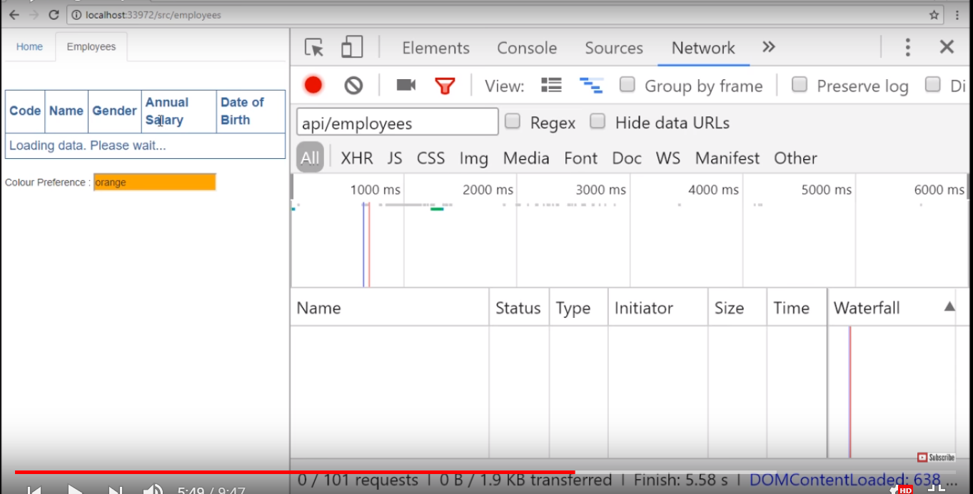

This proves the observable is lazy .On the other hand the promises are not lazy.

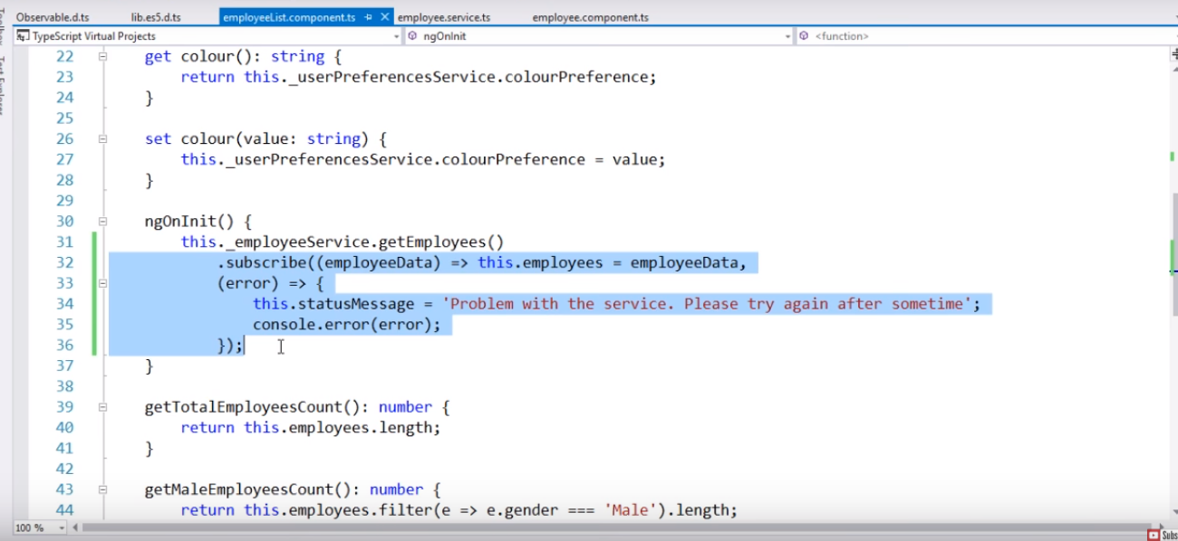

Lets uncomment the changes and save changes and then reload the web page we should see the list of employees on web page as shown in the below screenshot.

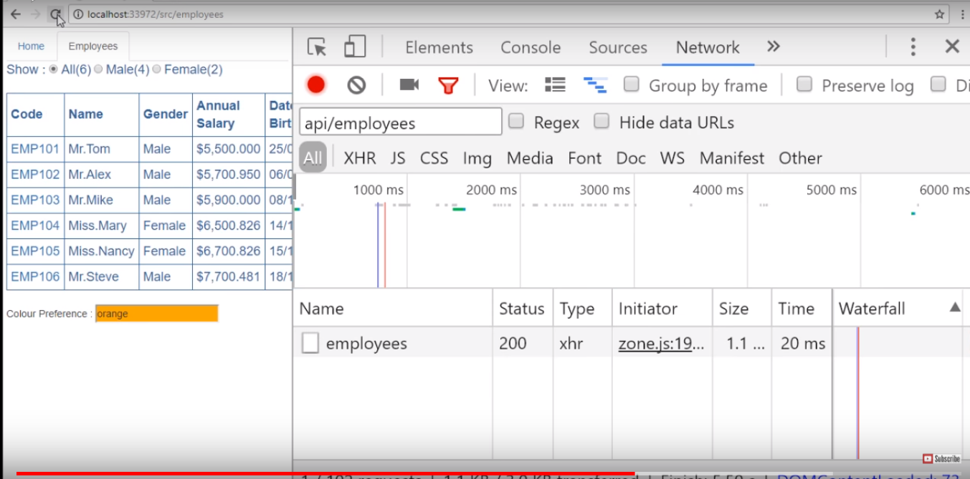

Now , within our employee service we have this method getEmployeeByCode() that returns a promise as shown in the below screenshot.

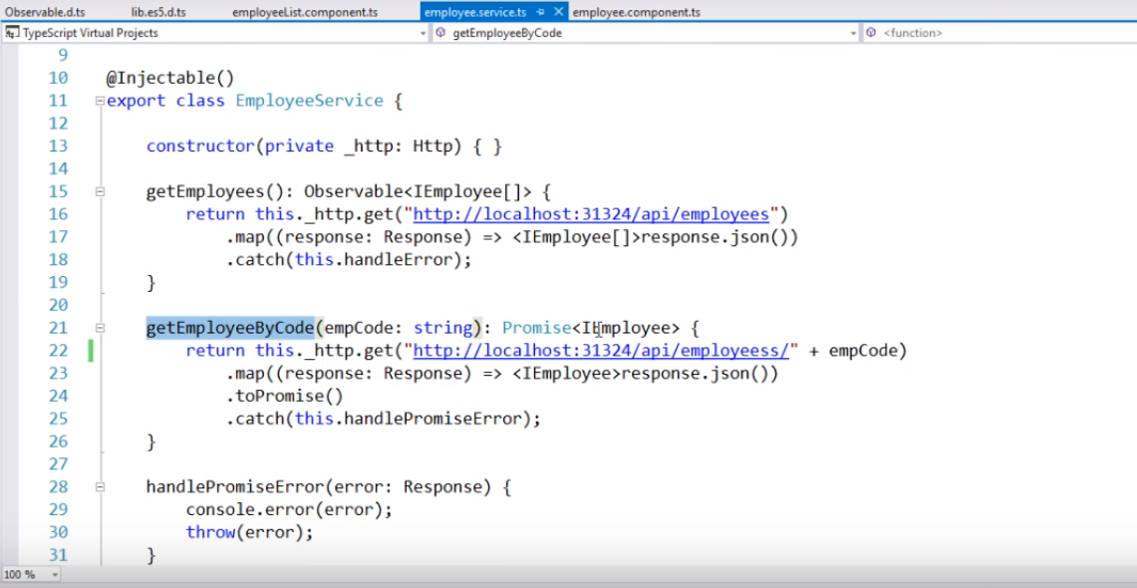

And we are consuming getEmployeeByCode() method within our employee component

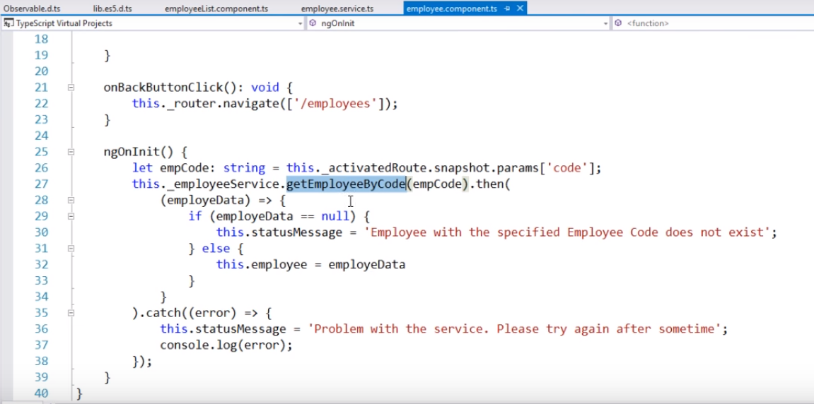

Now , we just navigate to one of the employee details by clicking the employee id as shown in the below screenshot.

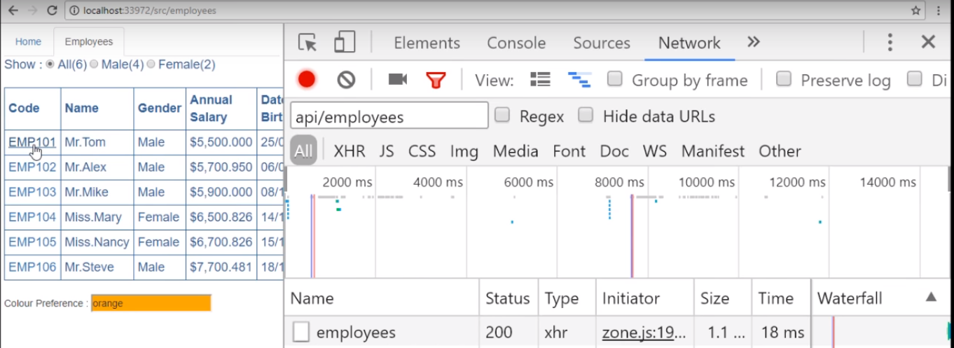

Now , we have the problem with the service that’s because the change we have done in the code and lets undo the change.Within our employee service right here we have an extra s and lets delete that and save our changes and reload our web page.Now , we should see specific employee details in this case i.e. emp101 details displayed on the web page as shown in the below screenshot.

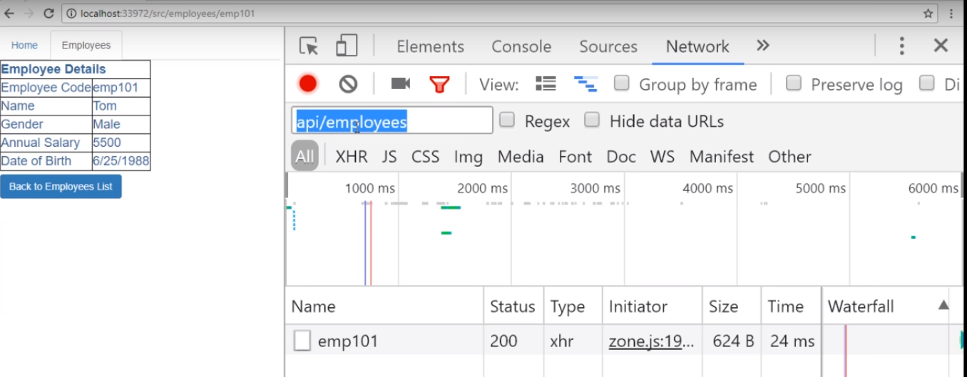

Notice , we still have a filter available right there and we also a service issued over the network to api/employees for emp101.While click on emp101 we should see the specific employee details as shown in the below screenshot.

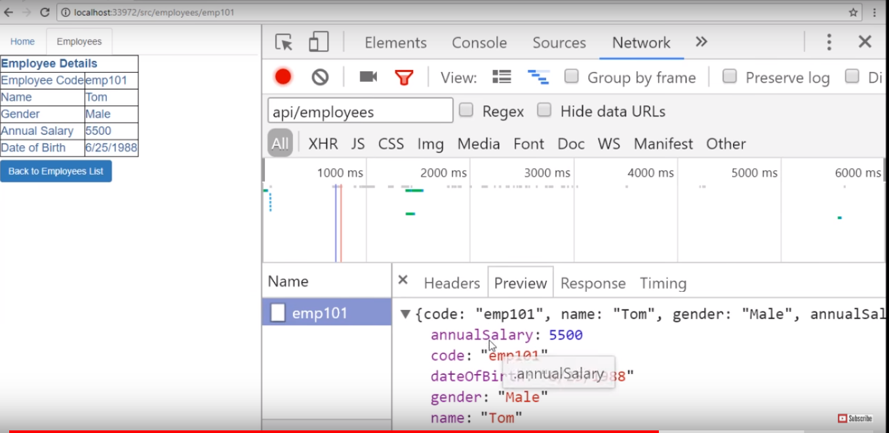

Because the promise is not lazy irrespective if you have then() method or not a service call is always issued over the network. In the case of an observable if you don’t have subscribe method because an observable is lazy the service will not be called.So a promise is not lazy whereas an observable is lazy.

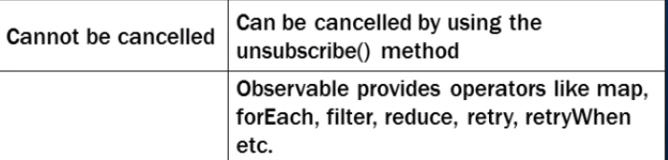

**Angular JS 2 Observable Retry On Error**

Please change **getEmployeeByCode()** method in employee.service.ts file to return an Observable instead of a Promise as shown below. 

getEmployeeByCode(empCode: string): Observable<IEmployee> {

    return this._http.get("http://localhost:24535/api/employees/" + empCode)

        . map((response: Response) => <IEmployee>response.json())

        . catch(this.handleError);

}

To cause an error, stop the Web API Service. At this point if you navigate to http://localhost:12345/src/employees/emp101, the application display a message stating - Problem with the service. Please try again after sometime. In the "Console" tab of the "Browser Developer Tools" you will see - ERR_CONNECTION_REFUSED.

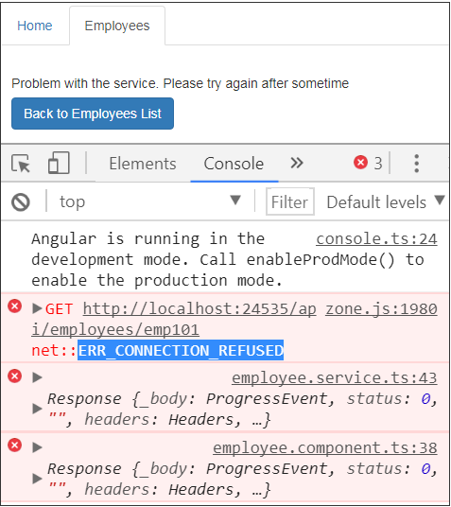

To resubscribe to the Observable and retry, use the rxjs retry operator. The changes in employee.component.ts file are commented and self explanatory.

import { Component, OnInit } from '@angular/core';

import { IEmployee } from './employee';

import { EmployeeService } from './employee.service';

import { ActivatedRoute } from '@angular/router';

import { Router } from '@angular/router';

// Import rxjs retry operator

import 'rxjs/add/operator/retry';

@Component({

    selector: 'my-employee',

    templateUrl: 'app/employee/employee.component.html',

    styleUrls: ['app/employee/employee.component.css']

})

export class EmployeeComponent implements OnInit {

    employee: IEmployee;

    statusMessage: string = 'Loading data. Please wait...';

    retryCount: number = 1;

    constructor(private _employeeService: EmployeeService,

        private _activatedRoute: ActivatedRoute,

        private _router: Router) { }

    ngOnInit() {

        let empCode: string = this._activatedRoute.snapshot.params['code'];

        this._employeeService.getEmployeeByCode(empCode)

            // Chain the retry operator to retry on error.

            .retry()

            .subscribe((employeeData) => {

                if (employeeData == null) {

                    this.statusMessage =

                        'Employee with the specified Employee Code does not exist';

                }

                else {

                    this.employee = employeeData;

                }

            },

            (error) => {

                this.statusMessage =

                    'Problem with the service. Please try again after sometime';

                console.error(error);

            });

    }

    onBackButtonClick(): void {

        this._router.navigate(['/employees']);

    }

}

The downside of this approach is that the application keeps on retrying forever. If we start the Web API service, the call succeeds and the observable completes with employee data displayed on the web page.  
  
Now if your requirement is not to retry forever, but only retry for a specific number of times if there is an error then we can use another variation of retry as shown below. Notice in this case we are passing number 3 to the retry opertaor indicating that we only want to retry 3 times. After the 3rd attempt the observable completes with an error.

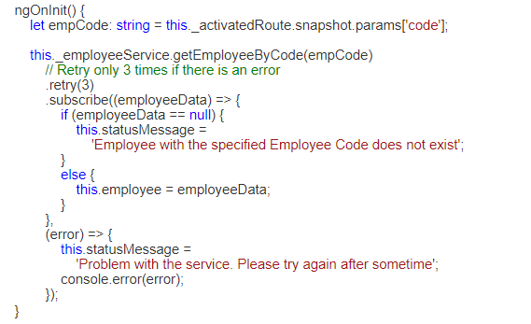

The problem with the retry operator is that, it immidiately retries when there is an error. In our case it is a connection issue with the service. Retrying again immediately in our case does not make much sense, as most likely it might fail again. So in situations like this we may want to retry after a short delay, may be after a second or so. This is when we use the retryWhen rxjs operator. retryWhen operator allows us to specify delay in milli-seconds and can be used as shown below. Please donot forget to import retryWhen and delay operators.

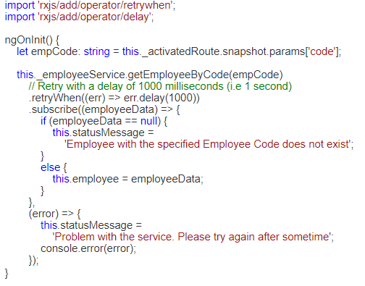

Now if you are wondering can't we use delay operator with retry operator, the answer is NO, we can't. The delay operator in the following example will not work as expected. As you can see from the browser console, it immediately retries instead of waiting for 5 seconds before a retry attempt.

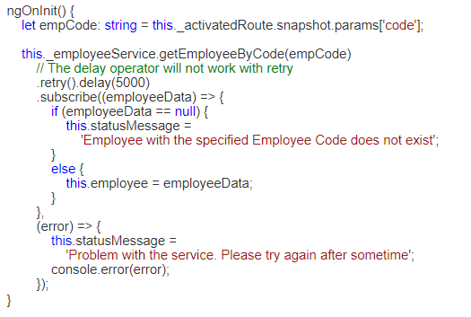

If you want to retry every 1000 milli-seconds only for a miximum of 5 times then we can use rxjs scan operator along with the take operator. While retrying we also want to show the retry attempt number to the user on the web page as shown below.

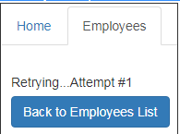

After all the retry attempts are exhausted, the application should stop retrying and display the error message to the user as shown below.

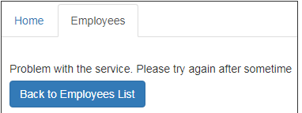

If the connection becomes available between the retry attempts, the application should display employee data.

**Here is the complete code.**

import { Component, OnInit } from '@angular/core';

import { IEmployee } from './employee';

import { EmployeeService } from './employee.service';

import { ActivatedRoute } from '@angular/router';

import { Router } from '@angular/router';

import 'rxjs/add/operator/retrywhen';

import 'rxjs/add/operator/delay';

import 'rxjs/add/operator/scan';

@Component({

    selector: 'my-employee',

    templateUrl: 'app/employee/employee.component.html',

    styleUrls: ['app/employee/employee.component.css']

})

export class EmployeeComponent implements OnInit {

    employee: IEmployee;

    statusMessage: string = 'Loading data. Please wait...';

    retryCount: number = 1;

    constructor(private _employeeService: EmployeeService,

        private _activatedRoute: ActivatedRoute,

        private _router: Router) { }

    ngOnInit() {

        let empCode: string = this._activatedRoute.snapshot.params['code'];

        this._employeeService.getEmployeeByCode(empCode)

            // Retry 5 times maximum with a delay of 1 second

            // between each retry attempt

            .retryWhen((err) => {

                return err.scan((retryCount, val) => {

                    retryCount += 1;

                    if (retryCount < 6) {

                        this.statusMessage = 'Retrying...Attempt #' + retryCount;

                        return retryCount;

                    }

                    else {

                        throw (err);

                    }

                }, 0).delay(1000)

            })

            .subscribe((employeeData) => {

                if (employeeData == null) {

                    this.statusMessage =

                        'Employee with the specified Employee Code does not exist';

                }

                else {

                    this.employee = employeeData;

                }

            },

            (error) => {

                this.statusMessage =

                    'Problem with the service. Please try again after sometime';

                console.error(error);

            });

    }

    onBackButtonClick(): void {

        this._router.navigate(['/employees']);

    }

}

**Angular 2 Observable Unsubscribe**

Let us understand this with an example. Here is what we want to do. When the request to the server is in progress we want to display "Cancel Request" button.

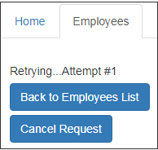

The "Cancel Request" button should only be visible to the user when there is a request in progress. When the request fails permanently after exhausing all the retry attempts the button should disappear.

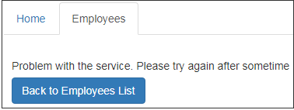

Along the same lines if the request completes successfully, then also the button should disappear.

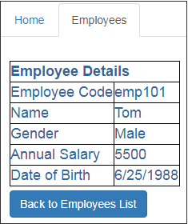

When the user cancels the request, by clicking the "Cancel Request" button, the request should be cancelled and button should disappear.

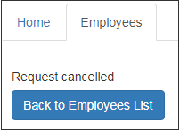

To achieve this, include the following HTML in employee.component.html file. This HTML is for the "Cancel Request" button. Please pay attention to the structural directive ngIf on the [div] element that contains the button. As you can see we are showing the "Cancel Request" button only if the subscription is not closed (!subscription.closed), meaning only when there is a request to the Observable is in progress.

The ngIf directive will take care of showing and hinding the [div] element depending on whether the subscription is closed or not. We are also binding the click event of the button to "onCancelButtonClick()" method. We will create both the subscription object and the "onCancelButtonClick()" method in the component class.

[div style="margin-top:5px" *ngIf="!subscription.closed"] [input type="button" class="btn btn-primary" value="Cancel Request" (click)="onCancelButtonClick()" /] [/div]

Now modify the code in employee.component.ts file as shown below. The relavant code is commented and self-explanatory.

import { Component, OnInit } from '@angular/core';

import { IEmployee } from './employee';

import { EmployeeService } from './employee.service';

import { ActivatedRoute } from '@angular/router';

import { Router } from '@angular/router';

import 'rxjs/add/operator/retrywhen';

import 'rxjs/add/operator/delay';

import 'rxjs/add/operator/scan';

// import ISubscription.

import { ISubscription } from "rxjs/Subscription";

@Component({

    selector: 'my-employee',

    templateUrl: 'app/employee/employee.component.html',

    styleUrls: ['app/employee/employee.component.css']

})

export class EmployeeComponent implements OnInit {

    employee: IEmployee;

    statusMessage: string = 'Loading data. Please wait...';

    retryCount: number = 1;

    // Create a class property of type ISubscription

    // The ISubscription interface has closed property

    // The ngIf directive in the HTML binds to this property

    // Go to the difinition of ISubscription interface to

    // see the closed property

    subscription: ISubscription;

    constructor(private _employeeService: EmployeeService,

        private _activatedRoute: ActivatedRoute,

        private _router: Router) { }

    ngOnInit() {

        let empCode: string = this._activatedRoute.snapshot.params['code'];

        // Use the subscription property created above to hold on to the

        // subscription.We use this object in the onCancelButtonClick()

        // method to unsubscribe and cancel the request

        this.subscription = this._employeeService.getEmployeeByCode(empCode)

            .retryWhen((err) => {

                return err.scan((retryCount, val) => {

                    retryCount += 1;

                    if (retryCount < 4) {

                        this.statusMessage = 'Retrying...Attempt #' + retryCount;

                        return retryCount;

                    }

                    else {

                        throw (err);

                    }

                }, 0).delay(1000)

            })

            .subscribe((employeeData) => {

                if (employeeData == null) {

                    this.statusMessage =

                        'Employee with the specified Employee Code does not exist';

                }

                else {

                    this.employee = employeeData;

                }

            },

            (error) => {

                this.statusMessage =

                    'Problem with the service. Please try again after sometime';

                console.error(error);

            });

    }

    onBackButtonClick(): void {

        this._router.navigate(['/employees']);

    }

    // This method is bound to the click event of the "Cancel Request" button

    // Notice we are using the unsubscribe() method of the subscription object

    // to unsubscribe from the observable to cancel the request. We are also

    // setting the status message property of the class to "Request Cancelled"

    // This message is displayed to the user to indicate that the request is cancelled

    onCancelButtonClick(): void {

        this.statusMessage = 'Request cancelled';

        this.subscription.unsubscribe();

    }

}

**Angular 2 Interfaces: -**

If you have experience with any object oriented oriented programming language like C#, Java or C++, then you know an interface is an abstract type. It only contains declarations of properties, methods and events. The implementation for the interface members is provided by a class that implements the interface.

If a class that implements the interface fails to provide implementation for all the interface members, the language compiler raises an error alerting the developer that something has been missed.  
  
In general, an interface defines a contract (i.e the shape or structure of an API), that an implementing class must adhere to. Even in TypeScript we use the interface for the same purpose.

We know TypeScript is a strongly typed language. This means every property we define in a TypeScript class has a type associated with it. Similarly every method parameter and return type has a type. As you know by now, TypeScript has several built-in pre-defined types like string, number, boolean etc.  
  
However, the business objects that we usually create in real-world applications like Employee, Customer, Order, Invoice etc, does not have a pre-defined type. In this case, we can use an interface to create a custom type for our business object.  
  
Let us understand this with an example.

Notice the below line of code in EmployeeListComponent class. The property **"employees"** is defined as an array of any type.  
employees: any[];   
  
Since we do not have a Type for employee object, we specified the type as any.

There are 2 problems with the above line of code  
1. For the object properties in the array we do not get intelligence

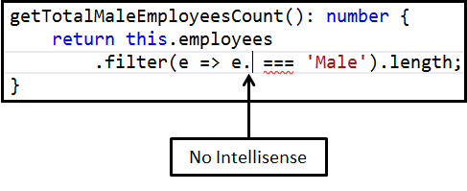

2. Since we do not get intellisense, we are prone to making typographical errors and the compiler will not be able to flag them as errors. We will come to know about these errors only at runtime.   
  
Let's create a Type for employee using an interface as shown below. Add a new TypeScript file to the employee folder. Name it **employee.ts**. Copy and paste the following code. 

export interface IEmployee {

    code: string;

    name: string;

    gender: string;

    annualSalary: number;

    dateOfBirth: string;

}

With this IEmployee interface in place, we can now import and use the interface type as the type for "employees" property. The code in EmployeeListComponent class is shown below. 

import { IEmployee } from './employee';

export class EmployeeListComponent {

    employees: IEmployee[];

}

Since we have specified a type for the "employees" property, we now get intelligence for the object properties in the array

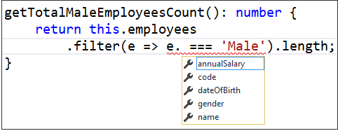

If we make any typographical errors with the property names, we will get to know these errors right away at compile time.   
  
While we are here, let's discuss some of the concepts related to TypeScript interfaces. Consider the following interface. The code is commented and self-explanatory.

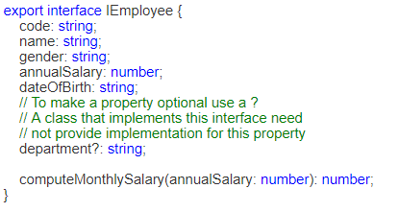

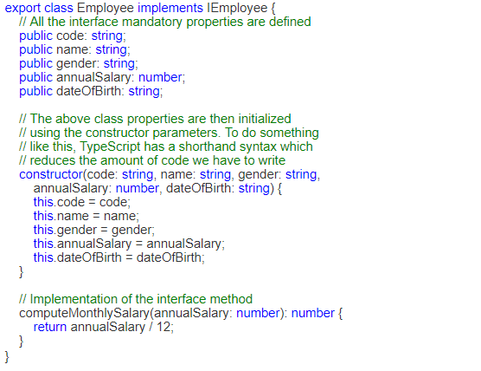

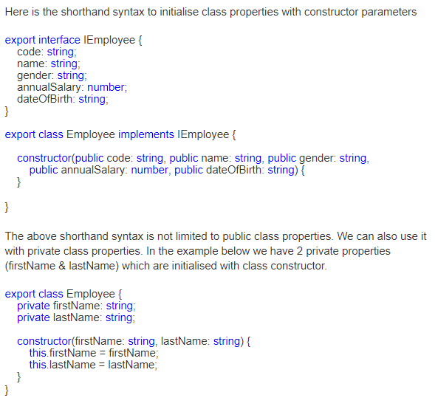

We can rewrite the above code using shorthand syntax as shown below. In both the cases the generated JavaScript code is the same. 

export class Employee {

    constructor(private firstName: string, private lastName: string) {

    }

}

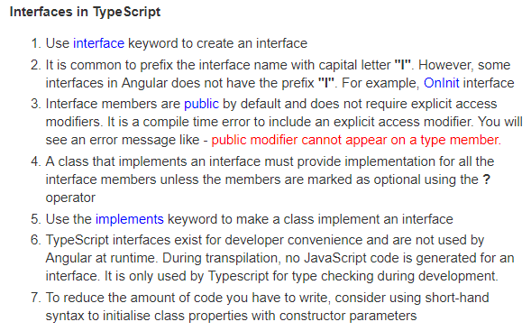

**Using Bootstrap With Angular 2: -**

There are several ways to install Bootstrap. One way is by using Node.js command prompt.

**Step 1 :** Open node.js command prompt window. (Click windows start button, expand Node.js folder and right click on "node.js command prompt" and select "Run as administrator" from the command prompt)

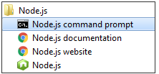

**Step 2:** In the command prompt navigate to the folder that contains your angular project and type the following command and press enter key. As Bootstrap has a dependency on jQuery, we are installing jQuery as well.  
npm install bootstrap@3 jquery --save

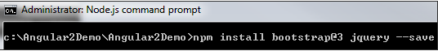

This installs both Bootstrap and jQuery for use with our Angular project. Notice from the screenshot below, Bootstrap version 3.3.7 and jQuery version 3.2.1 are installed.

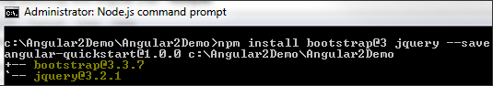

The required Bootstrap and jQuery files are copied into the **node_modules** folder within the project directory.

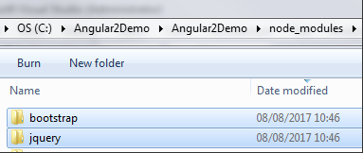

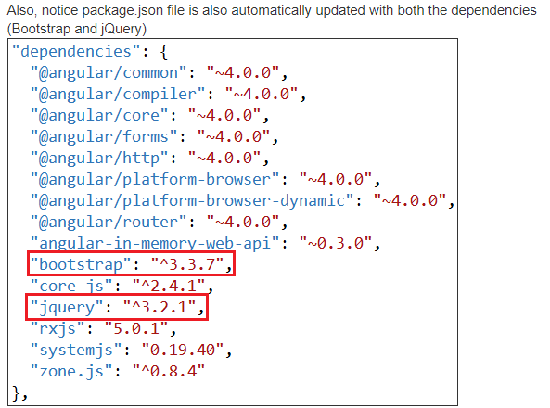

**Step 3 :** Finally in index.html file add the following script and link elements to reference the required CSS and JS files. As you can see, these files are being served from the node_modules folder. 

<script src="/node_modules/jquery/dist/jquery.min.js"></script>

<link href="/node_modules/bootstrap/dist/css/bootstrap.min.css" rel="stylesheet" />

<script src="/node_modules/bootstrap/dist/js/bootstrap.min.js"></script>

The problem at the moment is intellisense for Bootstrap CSS classes is not working in index.html, or any of the components html or stylesheet files.

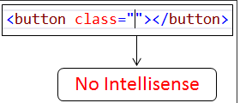

**How to enable intellisense for bootstrap in Visual Studio :** Use the following workaround to enable intellisense for bootstrap in Visual Studio.  
**Step 1 :** In Visual Studio, click to select the Angular project and then click on "Show All Files" icon. You will then see "node_modules" folder.

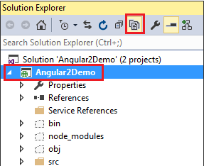

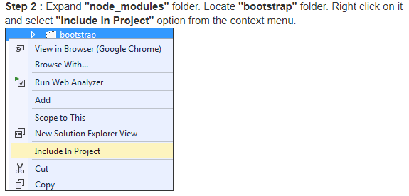

At this point you should get bootstrap intellisense in index.html and all angular component html files. If you still do not get bootstrap intellisense, please restart Visual Stduio and you will get intellisense.

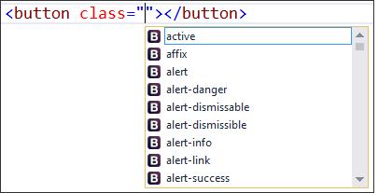

As I said before, there are several ways to install bootstrap. One way is by using Node.js command prompt. The other way is by using Visual Stduio NuGet package manager. To install Bootstrap using NuGet package manager follow these steps.

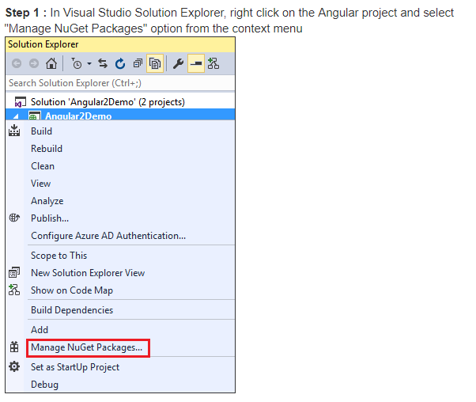

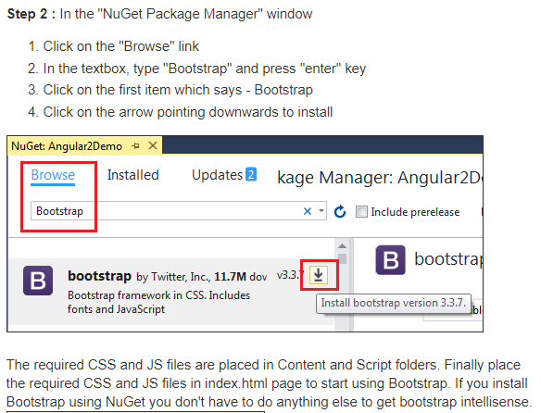

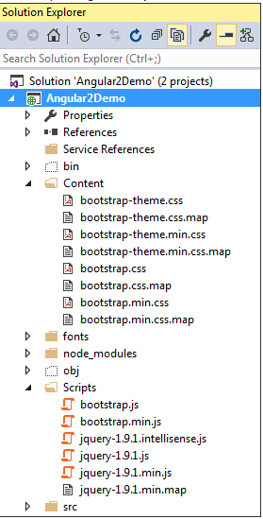

If you do not want to download bootstrap, you can use their CDN links. You can find the official Bootstrap CDN links at the following page.  
<http://getbootstrap.com/getting-started/>

Besides these 3 ways, there are other ways of installing Bootstrap. Which way to use depends on your project needs.